Investigating Alternatives to the WIMP GUI

Evan Williams

*School of Systems Engineering, The University of Reading, UK*

Abstract – This document examines modern operating system user interfaces, assesses their usefulness and efficiency, and considers how they could be augmented or replaced by zooming and command-based user interfaces, as proposed in Raskin’s “The Humane Interface” (Addison-Wesley, 2000). It does this in three stages. First, the psychology of how people interact with systems was examined; second, a number of existing systems were analysed to see how well they utilised what was learned about people in step 1; and finally a prototype of a new system based on Raskin’s ideas was built. After examination and analysis it was found that the constructed prototype outperformed existing systems across a number of objective measures of usability.

“The way to advance the interface is not to develop ever-more-faithful imitations of the desktop, but instead to escape the limitations of the desktop especially as computers themselves become ubiquitous and are used away from the desk.”

-Gentner & Nielsen, Anti-Mac Interfaces

Communications of the ACM, August 1, 1996

Table of Contents

1 Introduction 1

1.1 Purpose of the project 1

1.2 Concerns in building a humane interface 1

1.2.1 Consider user input as sacred 1

1.2.2 Do not require more of the user than is necessary 1

1.2.3 Locus of attention 1

1.2.4 Monotony 1

1.2.5 Habit formation 1

1.2.6 Amodalism 2

1.3 The WIMP GUI 2

2 Analysis 2

2.1 Flaws in the WIMP GUI 2

2.1.3 Stagnation 2

2.1.4 The filesystem 3

2.1.5 Application-centric design 3

2.1.6 Inefficiency 4

2.2 Analysis of existing systems 4

2.2.1 Analytical techniques 4

2.2.1.1 GOMS Analysis 4

2.2.1.2 Informational efficiency 4

2.2.1.3 Fitts’ Law 4

2.2.1.4 Hick’s Law 5

2.2.2 Tasks 5

2.2.3 The systems 5

2.2.3.1 Windows 7 “Aero” 5

2.2.3.1.1 System Overview 5

2.2.3.1.2 Tasks 6

2.2.3.1.2.1 Enter text & Spell check 6

2.2.3.1.2.2 Save, close, and open the above document 7

2.2.3.1.2.3 Translate the above text to Spanish 8

2.2.3.1.2.4 See what the next calendar event is 8

2.2.3.1.2.5 Create a calendar event every Friday at 1pm for the next 6 weeks 8

2.2.3.1.2.6 Find the cube root of 25 9

2.2.3.1.2.7 Search for the ITNG wiki page 10

2.2.3.2 Windows 8 “Metro” 10

2.2.3.2.1 System Overview 10

2.2.3.2.2 Tasks 10

2.2.3.2.2.3 Translate the text to Spanish 10

2.2.3.2.2.4 See what the next calendar event is 11

2.2.3.2.2.7 Search for the ITNG wiki page 11

2.2.3.3 Raskin for Mac 11

2.2.3.4 Cortana for Windows Phone 8.1 11

2.2.3.4.1 System overview 11

2.2.3.4.2 Tasks 11

2.2.3.4.2.4 See what the next calendar event is 11

2.2.3.4.2.5 Create a calendar event every Friday at 1pm for 6 weeks 11

2.2.3.4.2.6 Find the cube root of 25 11

2.2.3.4.2.7 Search for the ITNG wiki page 11

2.2.3.5 Canon Cat 12

2.2.3.5.1 System Overview 12

2.2.3.5.2 Tasks 12

2.2.3.5.2.1 Enter, then spell check the below paragraph 12

2.2.3.5.2.6 Find the cube root of 25 13

3 Design 13

3.1 Components 13

3.1.3 Universal command interface 13

3.1.4 Spatial filesystem 14

3.2 Requirements 14

3.2.1 Exit criteria 14

4 Social, legal, ethical, and health and safety considerations 15

4.1 Social 15

4.2 Legal 15

4.3 Ethical 15

4.4 Health and Safety 15

5 Development 15

5.1 Process 15

5.2 Tools used 15

5.2.1 .NET 15

5.2.2 Piccolo.NET 16

5.3 Prototypes 16

5.3.1 Prototypes 0.x 16

5.3.1.1 Prototype 0.1 16

5.3.1.2 Prototype 0.2 17

5.3.1.3 Prototype 0.3 17

5.3.1.4 Prototype 0.4 20

5.3.1.5 Prototype 0.5 21

5.3.1.6 Prototype 0.6 21

5.3.1.7 Prototype 0.7 24

5.3.1.7.1 Nearest node selection 24

5.3.1.7.2 Next nearest node selection 24

5.3.1.7.3 Absolute ordering 24

5.3.1.7.4 Absolute ordering with clustering 24

5.3.1.8 Prototype 0.8 26

5.3.1.9 Prototype 0.9 26

5.3.1.10 Prototype 0.10 29

5.3.1.11 Prototype 0.11 29

5.3.1.12 Prototype 0.12 29

5.3.1.13 Prototype 0.13 29

5.3.2 Prototypes 1.x 32

5.3.2.1 Prototype 1.1 32

5.3.2.1.1 Features 32

5.3.2.1.2 Development 32

5.3.2.1.3 Analysis 32

5.3.2.2 Prototype 1.2 32

5.3.2.2.1 Features 32

5.3.2.2.2 Development 32

5.3.2.2.3 Analysis 32

5.3.2.3 Prototype 1.3 33

5.3.2.3.1 Features 33

5.3.2.3.2 Development 33

5.3.2.3.3 Analysis 33

5.3.2.4 Prototype 1.4 34

5.3.2.4.1 Features 34

5.3.2.4.2 Development 34

5.3.2.4.3 Analysis 34

5.3.2.5 Prototype 1.5 – Minimum Viable Product 34

5.3.2.5.1 Features 34

5.3.2.5.2 Development 34

5.3.2.5.3 Analysis 35

5.3.3 Prototypes 2.x 35

5.3.3.1 Prototype 2.1 35

5.3.3.1.1 Features 35

5.3.3.1.2 Development 35

5.3.3.1.3 Analysis 36

5.3.3.2 Prototype 2.2 36

5.3.3.2.1 Features 36

5.3.3.2.2 Development 36

5.3.3.2.3 Analysis 36

5.3.3.3 Prototype 2.3 37

5.3.3.3.1 Features 37

5.3.3.3.2 Development 37

5.3.3.3.3 Analysis 37

5.3.3.4 Prototype 2.4 38

5.3.3.4.1 Features 38

5.3.3.4.2 Development 38

5.3.3.4.3 Analysis 39

5.3.3.5 Prototype 2.5 – Final product 39

5.3.3.5.1 Features 39

5.3.3.5.2 Development 40

5.3.3.5.3 Analysis 40

5.4 Piccolo.NET Development 40

5.4.1 PStyledText (**See D.1**) 41

5.4.2 Model (**See D.4**) 41

5.4.2.1 Understanding the document model 41

5.4.2.2 Handling user interaction 42

5.4.3 RunInfo (**See D.5**) 42

5.4.4 SegmentInfo (**See D.6**) 42

5.4.5 Selection (**See D.7**) 42

5.4.6 PSelectionEventHandler (**See 0**) 42

5.4.7 Carat (**See D.3**) 42

5.5 Issues in development 42

6 Testing and Quality 44

6.1 Requirements 44

6.1.1 “Must” Requirements 44

6.1.2 Should” Requirements 44

6.1.3 “Could” Requirements 45

6.1.4 Requirements Review 45

6.2 Code Quality 45

6.3 Tasks 46

6.3.1 Enter text & spell check 46

6.3.2 Save, close, and open the document containing the above text 46

6.3.3 Translate the above text to Spanish 46

6.3.4 See what the next calendar event is 46

6.3.5 Create a calendar event every Friday at 1pm for 6 weeks 47

6.3.6 Find the cube root of 25 47

6.3.7 Search for the ITNG wiki page 47

6.3.8 Review of tasks 47

7 Summary, Conclusions and Critique 48

7.1 Costings 48

7.2 Fulfilment of aims 48

7.2.1 Academic objectives and outputs 48

7.2.1.1 To learn and apply the objective measures of interface design 48

7.2.1.2 To gain a better understanding of unit testing 48

7.2.1.3 To practice the process of iterative prototype design, and opportunity to practice iterative development 48

7.2.2 Personal objectives and outputs 48

7.2.2.1 Achieve a first-class classification for the project work 48

7.2.2.2 Present the project at events external to the department 48

7.2.3 System objectives and outputs 48

7.2.3.1 A comprehensive investigation in to current systems, assessing them against several objective measures 48

7.2.3.2 A series of prototypes building up to the final deliverable 48

7.2.3.3 A programmed interactive prototype of a system that could be implemented… 49

7.2.3.3.1 …Demonstrating ideas gained and developed through research and prototyping 49

7.2.3.3.2 …That outperforms currently implemented systems at a number of objective measures 49

7.2.3.3.3 …That is able to perform operations on multiple types of content 49

7.2.3.4 A series of non-interactive prototypes, including ones that demonstrate how functionality not-yet-supported would work. 49

7.2.3.5 Have over 90% unit test code coverage 49

7.2.4 Review of aims 49

7.3 Future work 49

8 Works Cited 51

Appendix A. Project Initiation Document 54

Appendix B. Additional Figures and Data Tables 65

B.1. Figures 65

B.2. Tables 69

Appendix C. Source Code of Final Product 71

C.1. Zoom.Commands 71

C.1.1. Zoom.Commands.ICommand 71

C.1.2. Zoom.Commands.CalculateCommand 71

C.1.3. Zoom.Commands.TranslateCommand 73

C.1.4. Zoom.Commands.AbstractStyleCommand 76

C.1.5. Zoom.Commands.ColorCommand 78

C.1.6. Zoom.Commands.SizeCommand 81

C.1.7. Zoom.Commands.StyleCommand 82

C.1.8. Zoom.Commands.ToggleStyleCommand 83

C.2. Zoom.Generator 84

C.2.1. Zoom.Generator.DocGenerator 84

C.2.2. Zoom.Generator.Section 86

C.2.3. Zoom.Generator.SectionSelector 88

C.3. Zoom.Interfaces 90

C.3.1. Zoom.Interfaces.AbstractInterface 90

C.3.2. Zoom.Interfaces.CommandInterface 92

C.3.3. Zoom.Interfaces.FindInterface 99

C.3.4. Zoom.Interfaces.InterfaceTextEntryHandler 109

C.3.5. Zoom.Interface.Location 110

C.3.6. Zoom.Interfaces.ShowInterfaceHandler 112

C.4. Zoom.WebServiceHelpers 114

C.4.1. Zoom.WebServiceHelpers.AzureServiceHelper 114

C.4.2. Zoom.WebServiceHelpers.AzureToken 115

C.5. Zoom 118

C.5.1. Zoom.DocCreateHandler 118

C.5.2. Zoom.DocDragHandler 120

C.5.3. Zoom.Document 120

C.5.4. Zoom.Error 121

C.5.5. Zoom.Page 122

C.5.6. Zoom.PageSize 125

C.5.7. Zoom.Style 127

C.5.8. Zoom.Window 128

Appendix D. Source Code of the changes to Piccolo.NET 132

D.1. UMD.HCIL.PiccoloX.Nodes.PStyledText 132

D.2. UMD.HCIL.PiccoloX.Events.PStyledTextSelectEventHandler 140

D.3. UMD.HCIL.PiccoloX.Util.PStyledTextHelpers.Carat 141

D.4. UMD.HCIL.PiccoloX.Util.PStyledTextHelpers.Model 142

D.5. UMD.HCIL.PiccoloX.Util.PStyledTextHelpers.RunInfo 149

D.6. UMD.HCIL.PiccoloX.Util.PStyledTextHelpers.SegmentInfo 149

D.7. UMD.HCIL.PiccoloX.Util.PStyledTextHelpers.Selection 151

Appendix E. Project work log 156

**Table of Figures**

Figure 5‑1 – Prototype 0.2 18

Figure 5‑2 –Prototype 0.3 19

Figure 5‑3 Prototype 0.4 20

Figure 5‑4 Prototype 0.5 22

Figure 5‑5 Refinements to prototype 0.5 23

Figure 5‑6 Prototype 0.6 23

Figure 5‑7 Nearest node selection 25

Figure 5‑8 Next-nearest node selection 25

Figure 5‑9 Absolute ordering 25

Figure 5‑10 Absolute ordering with clustering 25

Figure 5‑11 Inconsistent ordering in clustering solution 25

Figure 5‑12 A consistent ordering for the clustering solution 25

Figure 5‑13 Document-level search 27

Figure 5‑14 Section-level search 27

Figure 5‑15 A command written and highlighted 27

Figure 5‑16 The command has been compiled. Note the green dotted line indicating it is a command 28

Figure 5‑17 The command is pointed at showing a gear to show it’s a command 28

Figure 5‑18 A command with references written and highlighted 28

Figure 5‑19 The command has been compiled, note the green dotted line indicating it is a command 28

Figure 5‑20 The command is pointed at showing a gear to show it’s a command and arrows to show it has references 28

Figure 5‑21 The gear is clicked to reveal the original code 28

Figure 5‑22 The arrows are clicked to reveal the reference sources 28

Figure 5‑23 A naïve approach to playing audio 30

Figure 5‑24 Audio displayed with its wave form 30

Figure 5‑25 A basic video file 30

Figure 5‑26 Multiple drives 31

Figure 5‑27 A divided user view 31

Figure 5‑28 – Example of styled text 34

Figure B‑1 Catalogue of methods of launching applications in aero, likely options in italics 65

Figure B‑2 Finite State machine for procedural generation of documents 66

Figure B‑3 UML class diagram of the final product 67

Figure B‑4 UML class diagram of the changes to PStyledText 68

**Table of Tables**

Table 2-1 GOMS Analysis for Windows 7 task 1 pre-entry 6

Table 2-2 GOMS analysis for correcting a single word. Later words do not require the initial H 6

Table 2-3 Informational and time requirements for Windows 7 task 1 7

Table 2-4 GOMS analysis of Windows 7 Task 2 saving & closing 7

Table 2-5 Informational and time requirements for Windows 7 task 2 7

Table 2-6 GOMS analysis from Windows 7 Task 3 8

Table 2-7 Informational and time requirements for Windows 7 task 3 8

Table 2-8 GOMS analysis of Windows 7 task 4 8

Table 2-9 Informational and time requirements for Windows 7 task 4 8

Table 2-10 GOMS analysis of Windows 7 task 5 9

Table 2-11 Informational and time requirements for Windows 7 task 5 9

Table 2-12 GOMS analysis of Windows 7 task 6 9

Table 2-13 Informational and time requirements for Windows 7 task 6 9

Table 2-14 GOMS analysis of Windows 7 task 7 10

Table 2-15 Informational and time requirements for Windows 7 task 7 10

Table 2-16 GOMS analysis for correcting a single word. 12

Table 2-17 Informational and time requirements for Canon Cat task 1 12

Table 2-18 GOMS analysis of Canon Cat task 6 13

Table 2-19 Informational and time requirements for Canon Cat task 6 13

Table B-1 Typical timings for GOMS analysis 69

Table B-2 Properties of different methods of launching applications in Aero 69

Table B-3 Word List from prototype 0.1 70

Table B-4 Timings from testing prototype 0.1 70

Table E-5 – Project work log 156

# Introduction

## Purpose of the project

The aim of the project is to investigate whether there are better ways of interacting with a computer than the standard WIMP GUI (See 1.3) that most modern systems use. The focus of this work will be in exploring and implementing the problems and suggestions made by Raskin in [1].

## Concerns in building a humane interface

Raskin describes a “humane interface” as one that is “responsive to human needs and considerate of human frailties” [1]. In other words, it is an interface where the computer is built around the human, rather than forcing the human to adapt to the computer. The other approach was traditionally taken because the human is the more powerful and pliable partner in the human-computer relationship [2], however they are also the more important member, and the one that, as interface designers, we should be primarily concerned with.

While there are significant differences between any two humans, there are things that are generally true for all of them. By considering these in the design process it allows for an interface that is faster, more efficient, quicker to learn, and generally demands less of its user.

### Consider user input as sacred

Raskin’s first law of interface design states

“A computer shall not harm your work or, through inaction, allow your work to come to harm” [1]

The system should be built in such a way that user input is always considered meaningful (were it not, the user would not be inputting it) and should make every effort to preserve the work, even in the face of users’ attempts to destroy it (as they could be in error).

### Do not require more of the user than is necessary

Raskin’s second law of interface design states

“A computer shall not waste your time, or require you to do more work than is strictly necessary” [1]

The system should be built in such a way that it does not require the user to spend time, or produce input and/or decisions when they are not relevant to, or required by the task in hand.

### Locus of attention

A user can concentrate on exactly one thing at a time [3]. Multitasking is possible once an action has become habituated, and therefore no longer requires the attention (see 1.2.5). Therefore, interfaces should be designed such that the user is only required to focus on one thing at a time, and wherever possible that should be the task at hand.

### Monotony

A monotonous interface is one in which any task can be completed in precisely one way. An amonotonous interface draws the user’s locus of attention away from the work as they are forced to consider how they are doing something, rather than simply what they are doing.

### Habit formation

A habit is a sequence of actions performed together so frequently that they become one action, which can be performed without thinking about it [4]. Habit formation is very powerful because it enables the user to use the interface without moving their locus of attention. It is also an inevitable process that comes with persistent use of any system.

Great care, therefore, should be taken to ensure that only good habits are formed that could not inadvertently lead to the destruction or work, or other such negative effects.

### Amodalism

A consequence of 1.2.5 is that habits acquired in one context will be applied to other contexts. If in this new context the habit does not achieve the result that is expected, it is known as a “Mode error”. In the best case, these cause no effect on the work, thereby only creating user frustration that they are failing to achieve what they want. In the worst case they perform an unwanted action on the work, possibly harming it. [1]

An interface is modal if there are multiple states, each of which has its own set of gestures that work consistently within a given state but inconsistently across them (E.g. some applications use ctrl+y for redo, while others use ctrl+shift+z.); and the current state of the machine is not the user’s locus of attention.

It follows that mode errors can be reduced by either not having modes/states, or by making the current state the locus of the users’ attention [5]. Not only is the second not always effective, but it also draws the user’s focus away from the task at hand, so is undesirable. Therefore, for this project will attempt to eliminate as many modes from the system as is possible.

## The WIMP GUI

All OS (operating systems) provide an interface to the user, allowing them to perform the tasks they want the computer to perform. The de facto standard for user interfaces is the WIMP GUI (Windows Icons Menus Pointers Graphical User Interface) originally found in Xerox PARC’s (Palo Alto Research Facility) SmallTalk graphical development environment in 1976 [6] and released as a OS GUI with the Xerox Star in 1981 [7].

As the name suggests, the WIMP GUI provides four main features to the user:

* Windows – Moveable, overlapable containers for documents. In application-centric environments, one instance of an application will typically be one window.
* Icons – Graphical representations of documents, applications, and services
* Menus – Navigable lists of commands
* Pointer – An avatar for the 2D GID (Graphical Input Device, e.g. a mouse) that allows the user to directly interact with the graphical environment

Due to their universality in modern computing, it is assumed the reader will be familiar with such systems.

These have remained largely unchanged since 1976 [8], with only minor cosmetic and performance improvements in the intervening forty years. Stagnation is not inherently a bad thing, but in this case, the reasons for stagnation were, overall, poor; and the result we settled on does not work well with people.

# Analysis

## Flaws in the WIMP GUI

There are many flaws with the WIMP GUI, the more obvious of which are enumerated below

### Stagnation

Some common reasons for settling with the WIMP GUI, along with brief arguments for why these are poor, are listed below

* The momentum from having a large number of tools for developing traditional WIMP GUI systems makes them easier to develop [8]. This is a purely pragmatic concern, and while generally one should avoid reinventing the wheel if the tools available do not allow for the production of satisfactory systems, new tools are required.
* OS Producing companies need to maintain backwards-compatibility so that people continue to buy their software. This is, for example, why Microsoft needed to compromise when producing Windows 8 (see 2.2.3.2) Again, a mostly pragmatic concern: it is not concerned with optimum user experience. For as long as we are obsessed with staying the same, we cannot get better [1].
* Users are familiar with WIMP GUIs, therefore there is a learning cost associated with switching away from them. This is true, however for any sufficiently well designed system one would expect the learning time to be very short compared to the total operation time. [1] It is therefore justified to create a novel system that requires retraining so long as there are significant improvements.

### The filesystem

The filesystem is how the users interact with documents stored on disk. The present system uses a hierarchy of folders containing both other folders and files. This is a very narrow abstraction on how such files are stored on disk [9]. Ultimately, it is an anachronism co-opted without thought to the GUI, rather than ever having been designed with the GUI in mind [10].

The filesystem forces hierarchical thinking on the user, something they are notoriously bad at, particularly at the scale of thousands of files. Attempting to use someone else’s hierarchy presents further problems to the user as it probably will not match how they would structure the information.

The filesystem also fails to make use of the fact that the GUI is a 2-dimensial space presenting the structure as a series of arbitrarily ordered 1D lists. It is not uncommon for “inexperienced” users to simply store all of their documents on the desktop, and remember their physical location in this space; however, this solution cannot scale beyond the reaches of the screen without requiring folders, and is fundamentally working against the system as it was designed.

Finally, each file requires a filename, a locally unique handle to refer to it by. Again, this is poor design, as it requires the user to shift their locus of attention away from the work towards a short description of the work. It is also a difficult and entirely superfluous task when the document can stand as its own description [1].

### Application-centric design

Application-centric design is a heavily modal system. Each application creates its own window, with its own set of commands Müller-Prove argues that in having overlapping windows eliminates a mode, as the window provides a visual cue for the current state of the machine [10]. This is incorrect, however, because the current application and its set of gestures should not be the user’s locus of attention, the work should.

Application-centric design is also amonotonous, as each application has overlapping areas of concern [8]. For example, an image editor needs to have some basic text processing facilities, while a document editor needs to be able to handle images. This not only creates wasted development effort, as each application development team needs to create the facilities separately, but it forces the user to decide how they are going to perform a task based on the additional capabilities of the applications.

### Inefficiency

Whenever a user closes an application, or turns on the machine, it dumps them to the operating system. The operating system serves primarily as an application-launcher and cannot itself cannot achieve anything. Attempting to type directly on to the desktop achieves nothing as it simply ignores such user input. It can be considered a 0% efficient system (see 2.2.1.2).

## Analysis of existing systems

There are many operating systems in existence today. Most of them use the WIMP GUI or a minor variation on it. Where possible the defining example of each major variation has been chosen for study.

For each system, an initial exploration will be made, describing some of the key features of the system, after which a set of standard tasks will be performed to assess the system’s performance at several key activities.

### Analytical techniques

Below are listed several techniques that will be used in the analysis of the systems. Additionally some of these may be used to analyse the prototypes once in development.

#### GOMS Analysis

GOMS (Goals, Operators, Methods, and Selection rules) analysis is a tool for estimating the time it would take to perform a task on a given interface. It provides a useful objective measure by which to compare two interfaces [11].

It works by cataloguing all the actions that constitute the task, assigning a time to each one, and summing the total time. The times can be derived experimentally, and will vary between users and individual computer setups, but for the purposes of comparing two interfaces one can simply use a list of typical times [1] . For the purposes of this project the times listed in [1] will be used (see Table B-1 Typical timings for GOMS analysis).

#### Informational efficiency

Informational efficiency is a measure of the minimum amount of information required to perform a task against the amount of information required of the user. Information is measured in Shannon bits, with 1 bit representing a choice between two equally likely options [12]. In general the information contained in a choice between $n$ equally likely options is $\log_{2}{n}$. If the probability of each option is not equal, then the information contained in the choice is $p\left(i\right)\log_{2}\left(\frac{1}{p(i)}\right)$ [1].

#### Fitts’ Law

Fitts’ law is a way of measuring the time it takes to navigate a GID to a given region on screen. It states

$T_{pos}= c_{1}+ c_{2} ∙ \log_{2}\left(2\frac{d}{w}\right)$ [13]

Where

* $T_{pos}$ is the time taken to navigate the GID
* $c_{1}, c_{2}$ are constants
* $d$ is the distance from the original position of the GID to the edge of the region
* $w$ is the width of the region in the direction being navigated

As with GOMS analysis so long as the values of the constants remains constant it allows for valid comparisons between different interfaces. For the purposes of the project, the values $c_{1}=50, c_{2}=150$ suggested in [1] will be used.

#### Hick’s Law

Hick’s law is a tool for estimating how long it will take a user to make a choice from a list of $n$ equally likely options. It takes the form

$Time (in msec)=a+b \log_{2}{(n+1)}$ [14]

Where constants $a,b > 0$

### Tasks

The below tasks were chosen because they are examples of common tasks that are reasonably complex and often require multiple components. They also demonstrate a wide range of possible activities on a computer.

1. Enter, then spell check the below paragraph

"During our spring break from school I plan to visit my grandmather. She lives in Indiana so it is a traet to be able to spend time with her. Granmather always has tons of activitys planned for us. We visit the Childrenn’s Museum and attend a play at the community center. Last year grandmother invited the neighborhood grils to a tea party at her home. We all dressd up in hats and furs. My week with grandmother is always very specail.” [15]

For the GOMS analysis step, this will not be mapped out in full unless the system in question requires some arcane input method other than simply typing the requisite keys. Instead an average input time of 110 seconds will be assumed (437 characters times average typing speed of 4 characters per second [16]). Additionally, the paragraph is deemed to contain 2622 bits of information (437 characters times 6 bits per character).

1. Save, close, and open the document containing the above text
2. Translate the above text to Spanish
3. See what the next calendar event is
4. Create a calendar event every Friday at 1pm for 6 weeks
5. Find the cube root of 25
6. Search for the ITNG wiki page

### The systems

#### Windows 7 “Aero”

Aero has been chosen as an example of a standard WIMP GUI, because it currently holds 47.93% market share of desktop OS [17].

##### System Overview

When first turned on Aero presents the user with a lock-screen. This is a security necessity, but it stands in the way of the user achieving their task. There may be some way to replace this process with an automated way of detecting the user, such as computer vision, biometrics, or some physical token; such that the computer enters a usable state as soon as the user sits down to operate it. Such thoughts, however, are outside of the scope of this project.

Once the user has signed in, they are presented with a 0% efficient interface that ignores all input they try to make. The only purpose of the desktop is to navigate the user to applications, which allow them to achieve their tasks. This is also the state the user is returned to when they close an application.

The system has amonotony baked right in to it at every level. For example, not only are there multiple applications that achieve a common set of functions, but there are a multitude of ways to launch those applications, each of which has different properties (See Table B-2).

With brief examination, 24 methods of launching an application were found using only the desktop, start menu, and quick-launch bar (See Figure B‑1). One could be mean and add to this number using each of these methods to launch one of the two different command prompts and launching applications from there, or using the scheduled processes menu to launch programs; but these are increasingly unlikely scenarios so will be ignored.

Making a few assumptions, many of the options can be dismissed as unlikely. The user less likely to be aware of ctrl+esc than the start button, so any options that include that can be dismissed. Additionally the user is unlikely to switch between keyboard and mouse, or use the keyboard to navigate the desktop. This leaves eight likely ways the user will launch a program. Even giving the system the benefit of the doubt like this, it adds a 3-bit decision every time the user wants to launch an application.

##### Tasks

###### Enter text & Spell check

The user must first decide which application they are going to launch. This list will vary between any two installs, and could be quite extensive given that almost every program has some text entry functionality. The system is given the benefit of the doubt by considering only the standard Microsoft package of Windows + Office, and of those only programs, whose primary function is text entry. This gives a list of Word, Publisher, PowerPoint, and Notepad, **a 2-bit choice**. This will also add 1 M to the start of the GOMS. Word matches the desired functionality most closely, so is the one that will be chosen. The user must also decide how to open the program, as stated in 2.2.3.1.1 **a 3-bit choice**. The user will choose the most efficient option: start, followed by entering the name of the program.

The user then enters the text. As text is entered, Word automatically begins the spell-checking process. Some mistakes are automatically corrected (though in the given task only 1 of 9 mistakes were autocorrectable) the rest were flagged with red squiggly lines to alert the user immediately to the mistake. The user can then choose between right clicking on each mistake and selecting a correction, or pressing F7/ Review->Spelling and Grammar to bring up the spell-check menu. **A 1.6-bit choice**. The user will choose to right-click mistakes. Each word appears on screen to have a target size of about 0.5 * 2cm (average 1cm), and are an average of 3.5cm apart (this is much closer than is expected in standard text). Giving an average navigating time according to Fitts’ Law (see 2.2.1.3) of $50ms+150ms \log_{2}\left(2\frac{3.5cm}{1cm}\right)=471ms$. The user is presented with an average of four options per mistake, each **a 2-bit choice**.

A full GOMS and informational efficiency analysis can be found below.

Table 2-1 GOMS Analysis for Windows 7 task 1 pre-entry

|  |  |  |  |  |  |  |  |  |
| --- | --- | --- | --- | --- | --- | --- | --- | --- |
| **Task** | What Program? | What Method? |  | W | O | R | D | ↵ |
| **Action** | M | M | K | K | K | K | K | K |
| **Time** | 1.35 | 1.35 | 0.2 | 0.2 | 0.2 | 0.2 | 0.2 | 0.2 |

Table 2-2 GOMS analysis for correcting a single word. Later words do not require the initial H

|  |  |  |  |  |  |  |  |
| --- | --- | --- | --- | --- | --- | --- | --- |
| **Task** | Change to Mouse | Which Word? | Point at word | Right click | Which replacement? | Point at replacement | Left Click |
| **Action** | H | M | P | K | M | P | K |
| **Time** | 0.4 | 1.35 | 0.5 | 0.2 | 1.35 | 1.1 | 0.2 |

Table 2-3 Informational and time requirements for Windows 7 task 1

|  |  |  |  |  |
| --- | --- | --- | --- | --- |
| **Section** | **Bits required** | **% Total** | **Time Required** | **% Total** |
| **Pre-entry** | 5 | 0.2% | 4s | 3% |
| **Entry** | 2622 | 99.1% | 110s | 72% |
| **Post-entry** | 17.6 | 0.7% | 38s | 25% |
| **Total** | 2690.6 | 100% | 152s | 100% |

This does appear to be a very informationally efficient system with over 99% of the bits entered being the content, though there are still elements that force the user to think about things outside of the content. The pre-entry section, while a small percentage of the input time and information serves as a barrier to entry, with no meaningful content able to be produced before it happens.

###### Save, close, and open the above document

From Word there are four obvious ways to save a document (ctrl+s, file->save, file->save as, click the save icon). This is a **2-bit choice**. The user will choose ctrl+s. The user is then shown a dialog and forced to choose both a location and name of the file to be saved. There are many permutations of possible user choice here, so assumptions will be made. The modal file is stored seven folders deep [18], with the mean folder containing 10.64 other folders [19]. The “My documents” folder is already four folders deep, meaning the user will have to make 3 decisions from a groups of 10.64 items. Each of these is **a 3.4-bit choice**, and each time adding MPK, or 2.65s to the GOMS. The default title (a clipping from the first line) will be accepted. The user will then use the mouse to save the document and close the window.

There are several ways to find the document again: if the user remembers the exact file name they can press the windows key and type the name, otherwise if they remember where in the file structure it was they can navigate folders, finally if it was a recent file they can open Word and use the “file->recent” menu. If none of these are true, then the user is stuck browsing the file tree, opening random files until they find it. This is **a 1.6-bit choice**. The user will navigate the file structure, incurring the same time and efficiency costs as saving did, with addition of needing to open “my documents” to begin with, and open the file at the end of the tree (from an average of 11.82 files [19], making it **a 3.6-bit choice**).

A full GOMS / Informational efficiency analysis is listed below

Table 2-4 GOMS analysis of Windows 7 Task 2 saving & closing

|  |  |  |  |  |  |  |  |  |  |  |  |  |
| --- | --- | --- | --- | --- | --- | --- | --- | --- | --- | --- | --- | --- |
|  |  |  |  |  | Three times | | |  |  |  |  |  |
| **Task** | How to save? | Ctrl | S | Move to mouse | Choose folder | Point at folder | Left Click | Next action | Point at save | Left Click | Point at close | Left click |
| **Action** | M | K | K | H | M | P | K | M | P | K | P | K |
| **Time** | 1.35 | 0.2 | 0.2 | 0.4 | 1.35 | 1.1 | 0.2 | 1.35 | 1.1 | 0.2 | 1.1 | 0.2 |

Table 2-5 Informational and time requirements for Windows 7 task 2

|  |  |  |  |  |
| --- | --- | --- | --- | --- |
| **Section** | **Bits required** | **% Total** | **Time Required** | **% Total** |
| **Open save dialog** | 1.6 | 5% | 1.75s | 7% |
| **Navigate filesystem** | 10.2 | 33% | 8.35s | 32% |
| **Save + close** | 0 | 0% | 2.6s | 10% |
| **Open** | 18.8 | 62% | 13.3s | 51% |
| **Total** | 30.6 | 100% | 26s | 100% |

Given that none of these actions are creating or modifying content, this is a 0% efficient system, which has high likelihood of causing users to lose files.

###### Translate the above text to Spanish

Word has this functionality built in. The user selects the relevant text, right clicks, and selects “translate”. This opens a pane, which gives the user the option of what language they want. They select the language, and press go. The system opens a web browser with the translated text in it.

Table 2-6 GOMS analysis from Windows 7 Task 3

|  |  |  |  |  |  |  |  |  |  |  |
| --- | --- | --- | --- | --- | --- | --- | --- | --- | --- | --- |
| **Task** | Next Action | Point at start of text | Left click down | Point at end of text | Left click up | Next action | Right click | Choose menu item | Point at menu item | Left click |
| **Action** | M | P | K | P | K | M | K | M | P | K |
| **Time** | 1.35 | 1.1 | 0.2 | 1.1 | 0.2 | 1.35 | 0.2 | 1.35 | 1.1 | 0.2 |
| **Action** | Next Action | Point at language menu | Left click | Choose language | Point at language | Left click | Next action | Point at go | Left Click | Wait for response |
| **Time** | M | P | K | M | P | K | M | P | K | R |
| **Time** | 1.35 | 1.1 | 0.2 | 1.35 | 1.1 | 0.2 | 1.35 | 1.1 | 0.2 | 11 |

Table 2-7 Informational and time requirements for Windows 7 task 3

|  |  |  |  |  |
| --- | --- | --- | --- | --- |
| **Section** | **Bits required** | **% Total** | **Time Required** | **% Total** |
| **Launch Translate menu** | 3.9 | 42% | 8.15s | 30% |
| **Translate** | 5.3 | 58% | 18.95 | 70% |
| **Total** | 9.2 | 100% | 27.1s | 100% |

###### See what the next calendar event is

This needs to be performed in outlook, so the cost of choosing how to launch an application applies, but there is no cost in choosing an application (unless the user has installed additional applications). When outlook opens, the default home screen shows the agenda for the next 5 days, including the next appointment.

Table 2-8 GOMS analysis of Windows 7 task 4

|  |  |  |  |  |
| --- | --- | --- | --- | --- |
| **Task** | Choose method |  | “Outlook” | ↵ |
| **Action** | M | K | KKKKKKK | K |
| **Time** | 1.35 | 1.1 | 1.4 | 0.2 |

Table 2-9 Informational and time requirements for Windows 7 task 4

|  |  |  |  |  |
| --- | --- | --- | --- | --- |
| **Section** | **Bits required** | **% Total** | **Time Required** | **% Total** |
| **Launch Outlook** | 3 | 100% | 4.05s | 100% |

###### Create a calendar event every Friday at 1pm for the next 6 weeks

The user must first open Outlook, incurring the same costs as task 4.The user must then switch outlook to Calendar mode (from a choice of 7 modes, **a 2.8-bit choice**). Unless it is currently a Friday, the user needs to make sure they are in next 7 days, week, workweek, or month mode. This is **a 2.6-bit choice**.

The user can then either double click on the time of the appointment, or click “new appointment”. This is **a 1-bit choice**. The user will double click. Given a workweek of 40 hours, choosing the time is **a 5.3-bit choice**. This opens the “new appointment” dialog, where the user needs to click “recurrence” followed by “end after” then type “6” in the appropriate box. The user then presses “OK” followed by “Save and close”. This adds **a further 5.6 bits**.

Table 2-10 GOMS analysis of Windows 7 task 5

|  |  |  |  |  |  |  |  |  |
| --- | --- | --- | --- | --- | --- | --- | --- | --- |
| **Task** | Choose method |  | “Outlook” | ↵ | Move to mouse | Choose Mode | Point at Calendar | Left Click |
| **Action** | M | K | KKKKKKK | K | H | M | P | K |
| **Time** | 1.35 | 1.1 | 1.4 | 0.2 | 0.4 | 1.35 | 1.1 | 0.2 |
| **Task** | Choose Mode | Point at Week | Left Click | Choose method | Point at time | Double Left click | Next Action | Recurrence |
| **Action** | M | P | K | M | P | KK | M | P |
| **Time** | 1.35 | 1.1 | 0.2 | 1.35 | 1.1 | 0.4 | 1.35 | 1.1 |
| **Task** | Left Click | Next Action | End After | Left Click | Next Action | Point at box | Left Click | Move to Keyboard |
| **Action** | K | M | P | K | M | P | K | H |
| **Time** | 0.2 | 1.35 | 1.1 | 0.2 | 1.35 | 1.1 | 0.2 | 0.4 |
| **Task** | 6 | Move to mouse | Next Action | “OK” | Left Click | Next Action | “Save & Close” | Left Click |
| **Action** | K | H | M | P | K | M | P | K |
| **Time** | 0.2 | 0.4 | 1.35 | 1.1 | 0.2 | 1.35 | 1.1 | 0.2 |

Table 2-11 Informational and time requirements for Windows 7 task 5

|  |  |  |  |  |
| --- | --- | --- | --- | --- |
| **Section** | **Bits required** | **% Total** | **Time Required** | **% Total** |
| **Launch Outlook** | 3 | 15% | 4.05s | 14% |
| **Get to correct view** | 5.4 | 27% | 5.7s | 20% |
| **Create appointment** | 11.9 | 58% | 19.05s | 66% |
| **Total** | 20.3 | 100% | 28.8s | 100% |

At 26%, this is an incredibly inefficient process, taking a very long time and forcing many modes and different dialogs on the user.

###### Find the cube root of 25

This must be done in the “Calculator application”, so the same costs apply as for launching Outlook in task 4. The calculator must then be set to scientific mode in “view->scientific” This is one of four modes, making it **a 2-bit choice**. The user then enters 25 and presses the cube-root button, one of 32 possible functions making it **a 5-bit choice**.

Table 2-12 GOMS analysis of Windows 7 task 6

|  |  |  |  |  |  |  |  |  |
| --- | --- | --- | --- | --- | --- | --- | --- | --- |
| **Task** | Choose method |  | “Calculator” | ↵ | Next Action | Move to Mouse | View | Left Click |
| **Action** | M | K | KKKKKKKKKK | K | M | H | P | K |
| **Time** | 1.35 | 1.1 | 2 | 0.2 | 1.35 | 0.4 | 1.1 | 0.2 |
| **Task** | Scientific | Left Click | Next Action | Move to Keyboard | 25 | Move to Mouse | Cube Root | Left Click |
| **Action** | P | K | M | H | KK | H | P | K |
| **Time** | 1.1 | 0.2 | 1.35 | 0.4 | 0.4 | 0.4 | 1.1 | 0.2 |

Table 2-13 Informational and time requirements for Windows 7 task 6

|  |  |  |  |  |
| --- | --- | --- | --- | --- |
| **Section** | **Bits required** | **% Total** | **Time Required** | **% Total** |
| **Launch Calculator** | 3 | 30% | 4.65s | 31% |
| **Get to correct mode** | 2 | 20% | 4.35s | 29% |
| **Calculate** | 5 | 50% | 5.85s | 39% |
| **Total** | 10 | 100% | 14.85 | 100% |

###### Search for the ITNG wiki page

This must be done in internet explorer. Once internet explorer has launched, type “INTG Wiki” and press enter.

Table 2-14 GOMS analysis of Windows 7 task 7

|  |  |  |  |  |  |  |  |
| --- | --- | --- | --- | --- | --- | --- | --- |
| **Task** | Choose method |  | “Internet Explorer” | ↵ | Next Action | “ITNG Wiki” | ↵ |
| **Action** | M | K | KKKKKKKK KKKKKKKKK | K | M | KKKKK KKKK | K |
| **Time** | 1.35 | 1.1 | 3.6 | 0.2 | 1.35 | 1.8 | 0.2 |

Table 2-15 Informational and time requirements for Windows 7 task 7

|  |  |  |  |  |
| --- | --- | --- | --- | --- |
| **Section** | **Bits required** | **% Total** | **Time Required** | **% Total** |
| **Launch Internet Explorer** | 3 | 5% | 6.25s | 74% |
| **Search** | 54 | 95% | 2.35s | 26% |
| **Total** | 57 | 100% | 8.6s | 100% |

#### Windows 8 “Metro”

Windows 8 features both a WIMP GUI and the “Metro” interface. Due to the WIMP’s similarities to Windows 7, only the Metro interface will be considered. In the case of the tasks, only the tasks that differ significantly from Windows 7 will be reviewed.

##### System Overview

Metro has two new design considerations that are notable here. The first is the desire to push more information to the user at earlier stages. This led to the creation of the start screen with live tiles that tell the user if that application requires the user’s attention (e.g. if an email has arrived) and tells them some basic information (such as calendar appointments), as well as a lock screen that provides similar information.

The other is the “share charm”. This is a universal interface, which allows applications to send messages to other applications in ignorance of each other. It only allows for simple text-based messages, but does allow for some interesting applications. For example, one can select text in any application, and share it to the Wikipedia application, which will then search for the selected phrase and show a relevant article. Alternatively, one could share straight to an email or social media profile.

That is not to say the system is a universal improvement on aero, rather there are several design flaws. The first is that the new interface is simply bolted on to the top of a WIMP GUI meaning that any improvements they might have made are hampered by the increased informational load of having an entire new way to do things, which doesn’t exactly match the feature set of the old way. The system also frequently throws the user between the two interfaces at points that are difficult to predict, breaking the user experience. Finally very little consideration was made for how to teach the users the new functionality, leaving users confused when the old way of doing things doesn’t work anymore, but they have no way of finding out how to use the new way.

##### Tasks

###### Translate the text to Spanish

The share charm moves the functionality of translating text out of any one application. Assuming they have the “Translate!” application [20], or similar, installed The user can now simply select the block of text, open the share charm, and send it to the application to be translated. In terms of informational/GOMS analysis this is almost exactly the same as the previous process, however it is notable for being a universal action now, rather than limited to one application.

###### See what the next calendar event is

As mentioned in 2.2.3.2.1 metro has a focus on pushing information to the user at earlier stages. Part of this is putting calendar information on the start and lock screen. This reduced the previous process to simply “Look at computer”. This process requires 0 bits of information and no time spent interacting with the computer, so GOMS/informational analysis is redundant.

###### Search for the ITNG wiki page

The previous functionality for launching applications and searching for documents of pressing the windows key and typing the name has been extended in Windows 8 to search online as well. Using this cuts the “Launch internet explorer” step from the process, saving 6 seconds and 3 bits of information.

#### Raskin for Mac

This is an attempt to implement a Zooming User Interface (ZUI) on to an existing system. As it is simply a file manager it does not make sense to attempt the tasks on it, and instead simply a system overview will be given.

As the name suggests, Raskin, like this project, attempts to implement ideas from [1], however it only works with surface elements, without considering the fundamental lessons of considering how people work, and how to build systems around that. As such, it remains stuck within the confines of many of the WIMP GUI’s failings. It has multiple ways of performing the same task, for instance zooming can be performed with a pinch gesture, or a mouse action. It also keeps the user tied to the application-centric model and the folder hierarchy. It doesn’t give position any semantic meaning, instead just providing a series of identically sized boxes for folders, arranged according to one of many schemes.

#### Cortana for Windows Phone 8.1

Cortana is a natural-language based interface for Windows Phone 8.1. It is designed to be operated by voice, which makes GOMS and informational analysis difficult, though the tasks can still be used to investigate how natural language can solve complicated problems. Not all tasks are achievable in Cortana, so only ones that are will be considered.

##### System overview

As previously stated, Cortana is a natural language interface. By using compound sentences with several clauses, complex commands can be built and executed easily. The best example of this is 2.2.3.4.2.5 In Aero this was a long, heavily modal process that used multiple interfaces, and took close to 30 seconds. In Cortana, it is a sentence. Just as a person would understand exactly what one meant if they were asked to meet every week at a given time for a period, so does the system.

##### Tasks

###### See what the next calendar event is

This is achieved by asking the question “What is my next appointment?”

###### Create a calendar event every Friday at 1pm for 6 weeks

This is achieved by saying, “Create an appointment every Friday at 1pm for 6 weeks”

###### Find the cube root of 25

This is achieved by asking, “What is the cube root of 25?”

###### Search for the ITNG wiki page

This is achieved by saying “ITNG Wiki”

#### Canon Cat

Many of the ideas discussed in [1] were first implemented in the Cat. The aim of the system was to abandon the idea of computers at all, and instead create an “information appliance” [21]. This was achieved by a mixture of custom hardware and software that presented a consistent, amodal interface to the user. For the most part, only the software will be discussed.

##### System Overview

The system is amodal to the extent that it does not have an “off” state. The keyboard is always accepting of user input, and always attempts to do something meaningful with it, thereby satisfying concerns 1.2.1 and 1.2.6. To begin using the system, therefore, one simply begins to use it, performing only the interactions required to achieve the task. The system invisibly and quickly wakes from a low power state, inserting any key presses in the last open document.

The Cat uses a document-centric design, meaning that the user can interact with any and all documents outside of the bounds of any application. The programs, instead, are small, lightweight tools that perform a single, atomic process on content. They are accessed through a universal command interface wherein a command is written, selected, and the “command” key is tapped. If the command requires arguments, it sequentially pops them from the selection history stack.

There is no such thing as “closing” a document on the Cat. All documents are always open, existing as a single, continuous loop. The border between documents is marked with a “new document” character. Multiple “new document” characters can be chained semantically to create groups, akin to the folders used in a WIMP GUI. The loop is navigated using the “leap” keys. Depressing one of these then typing a short string moves the cursor to the next (or previous) instance of that string.

Finally, the system has a universal undo/redo, which applies to every command issued to the Cat with the exception of undo/redo. This includes selection and navigation.

##### Tasks

###### Enter, then spell check the below paragraph

The user begins by simply entering the text. Nothing is required before that happens. No decisions need to be made. Once the text is entered, the user holds “Leap up” and taps “Spell Check leap”. This navigates to the previous misspelled word. The word must then be manually corrected. This is done by tapping both leap keys, then tapping erase, then retyping the word.

A full GOMS and informational efficiency analysis can be found below.

Table 2-16 GOMS analysis for correcting a single word.

|  |  |  |  |  |  |  |  |  |
| --- | --- | --- | --- | --- | --- | --- | --- | --- |
| **Task** | Next Action | Leap up key down | Spell check leap | Leap up key up | Both Leap Keys | Erase | Which word? | Retype word (length N) |
| **Action** | M | K | K | K | K | K | M | N * [K] |
| **Time** | 1.35 | 0.2 | 0.2 | 0.2 | 0.2 | 0.2 | 1.35 | N * 0.2 |

Table 2-17 Informational and time requirements for Canon Cat task 1

|  |  |  |  |  |
| --- | --- | --- | --- | --- |
| **Section** | **Bits required** | **% Total** | **Time Required** | **% Total** |
| **Pre-entry** | 0 | 0% | 0s | 0% |
| **Entry** | 2622 | 96.7% | 110s | 72% |
| **Post-entry** | 89.6 | 3.3% | 42.4s | 28% |
| **Total** | 2711.6 | 100% | 152.4s | 100% |

This process has eliminated the pre-entry step entirely, which eases a user’s mental burden greatly. The total time of the operation and bits required did increase however, thereby reducing overall efficiency. This is because the spell check system simple identifies errors, rather than providing corrections. If the user had the option of selecting from a list as with 2.2.3.1.2.1 this would be greatly reduced.

###### Find the cube root of 25

For this the user types “sqrt 25”, leaps up to “s”, taps both leap keys, then the calculate key. A complete GOMS analysis is below

Table 2-18 GOMS analysis of Canon Cat task 6

|  |  |  |  |  |  |  |
| --- | --- | --- | --- | --- | --- | --- |
| **Task** | Next Action | Type “sqrt 25” | Next action | Leap up “S” | Select | Calculate |
| **Action** | M | KKKKKKKK | M | KK | K | K |
| **Time** | 1.35 | 1.6 | 1.35 | 0.4 | 0.2 | 0.2 |

Table 2-19 Informational and time requirements for Canon Cat task 6

|  |  |  |  |  |
| --- | --- | --- | --- | --- |
| **Section** | **Bits required** | **% Total** | **Time Required** | **% Total** |
| **Launch Calculator** | 0 | 0% | 0s | 0% |
| **Get to correct mode** | 0 | 0% | 0s | 0% |
| **Calculate** | 2.6 | 100% | 5.1s | 100% |
| **Total** | 2.6 | 100% | 5.1s | 100% |

Again, any preliminary steps have been eliminated, reducing the user’s mental burden. The reduced information required in the calculate step is mainly a function of a reduced number of operations, so isn’t particularly relevant – a more functional calculator would require bits. The time of the calculate step is also reduced by nearly a second. This is a major improvement.

# Design

Because of the iterative prototyping model it is impossible to divorce design from development (see 5.1), as each is effectively the other. Much of 5.3.1 consists of what would traditionally be considered “design”, and the entire prototyping procedure is essentially design for a later system, the building of which is out of scope for this project.

That said, this section will still be used to present aims, objectives, and requirements as informed by the research and analysis steps of the project.

## Components

The two most promising components found in the research, and therefore the ones the prototypes will be built to explore are

1. A language-based universal command interface
2. A spatial filesystem

### Universal command interface

The universal command interface is a manner of running programs, passing arguments to them, and piping information between them. This should be harness the expressivity of language for describing complex, repeatable tasks. The programs should be able to take input from and transform the environment.

Victor describes a universal command interface that takes cues from the environment, history, and current context to inform the called program what the user wants to know about [22]. This would be the ultimate goal, but such a system would be a project unto itself, as such only selection and last-value predictors will be used.

### Spatial filesystem

A spatial filesystem presents the files to the user on a two-dimensional plane, as opposed to a traditional file system that presents the files to the user, as they are stored on disk. The relative location of files needs to be persistent so that the user can use their spatial memory to navigate the system.

The spatial system, once extended beyond the bounds of a single screen, needs to be navigated. The most scalable way of doing that is by implementing a zooming user interface. This allows a user to zoom out to gain context, move to the content they want to interact with, and zoom back in again. This maintains the user’s understanding of the spatial relationship between items while providing a fast manner of navigation.

## Requirements

Due to the iterative nature of the project, the exact requirements are expected to evolve over time. However, from the research and analysis some “MoSCoW” requirements can be established.

* Must
  + Never enter a state in which user input is ignored
  + Have no interfaces with zero informational efficiency
  + Be entirely amodal
  + Be document-centric
  + Use a universal command interface
  + Use a spatial filesystem
  + Allow the inputting and formatting of rich text
  + Have full-text search
* Should
  + Have commands that manipulate rich text (e.g. calculator/translator)
  + Have spell check
  + Have a calendar
  + Have a web browser
  + Have web search
* Could
  + Have spread sheeting
  + Have image manipulation
  + Allow command piping
* Won’t
  + Work on a tablet form factor
  + Play video or audio
  + Have an API for creating new commands

### Exit criteria

The project cannot be closed until all an interactive prototype exists that demonstrates all of the “Must” requirements. The first such prototype shall be referred to as the “Minimum viable product”.

The prototype that is chosen after these criteria are met shall be referred to as the “Final product”. Ideally, this should implement most, if not all of the “Should” requirements, and have made a start on the “Could” requirements.

# Social, legal, ethical, and health and safety considerations

## Social

The project aims to better people’s interactions with computers as a whole. If a real system built from the ideas discussed in this document is successfully implemented widely deployed, the system should reduce mental load on information workers allowing them to be more productive, and make computing in general less frustrating. This would be of great value to humanity as a whole.

## Legal

At the prototyping stage the project will be handling exclusively dummy-data, and therefore will not fall under and legal requirements for security. Should a real system be built from the ideas discussed in this document, then such concerns would arise.

All libraries used have been released under permissive licences that allow their incorporation in the project, for example, Piccolo.NET is released under BSD licence [23]. All non-library code is written by, and therefore owned by the student.

## Ethical

There are no ethical concerns in this project.

## Health and Safety

Consisting of research, design, and development, the project is entirely computer based. As such, there are few major health and safety concerns. The RA1 form was filled out and submitted as part of the project initiation document (See Appendix A). This mostly outlined the standard risks associated with extended computer use.

Of particular note is the risk of repetitive strain injury, as the student has a history of the condition. The faculty were made aware of this fact, and several measures were put in place to mitigate it, including maximum work hours, the use of anti-inflammatory medication, and protective wrist guards.

# Development

## Process

Development will be performed using an iterative rapid prototyping model, as recommended by Stanford [24], and used in the industry [25]. This allows both for each solution to be learned from and built upon frequently, nearing an optimal solution; and provides a better understanding of the problem trying to be solved.

The purpose of the prototypes at all stages is not to be a fully functioning system, rather a “touchable sketch” [25] that allows for better discussion of the relevant ideas. While each prototype may build off of the previous one, the end result will not be a marketable product, and it should be expected that a complete rewrite would be required before such a stage is reached.

## Tools used

### .NET

The .NET programming framework will be used to generate the interactive prototypes, in particular C# will be the primary language used. This is because it is at a very high abstraction level, solving many of common problems outside of the scope of this project.

### Piccolo.NET

The Piccolo.NET framework for developing ZUIs [23] will be used because it has solved many of the problems related to ZUIs already. This allows effort to be directed to the problems of the interface in question, rather than out-of-scope questions about how to render a ZUI.

## Prototypes

Prototypes will be grouped in to three major categories:

* Prototypes 0.x will be non-interactive or paper-based prototypes such as drawings of ideas. As the aim of the project is to discuss ideas for an interactive computer system, these will obviously not be sufficient on their own. They will, however be very useful for informing the later development process, so will be created until they are no longer able to perform this function.
* Prototypes 1.x will be largely interactive computer-based prototypes working towards the minimum viable product as identified in the PID (see Appendix A) and 3.2.1
* Prototypes 2.x will be building on the minimum viable product to see where the ideas can be extended from there.

### Prototypes 0.x

Prototypes 0.x are non-interactive, or paper-based prototypes designed to help flesh out the understanding of the problem, and what kinds of solutions are helpful and possible.

#### Prototype 0.1

Prototype 0.1 was a paper-based prototype of a spatial filesystem. It consisted of a series of index cards with words printed on them. The list of words can be seen in Table B-3. The user arranges the cards on a surface such that related words are close to each other and distant words are far apart.

For comparison, a similar prototype of a hierarchical file system was also created. This had similar cards arranged inside a series of nested envelopes representing folders. The prototype was then tested by giving the users using the below method

1. Ask the user to arrange the cards in a hierarchy
2. Ask the user to find 3 items from their hierarchy
3. Ask the user to arrange the cards spatially
4. Ask the user to find 3 items from their spatial system
5. Ask the user to find 3 items from another’s hierarchy
6. Ask the user to find 3 items from another’s spatial system

The full results are available in Table B-4. This showed that there was a significant time gain in using the spatial system. The spatial system is both mechanically faster – the user did not need to repeatedly open and close envelopes – and logically faster – the users were able to find items much faster. The second aspect is made particularly clear when searching in another user’s system – the hierarchy had a long first search cost that was not found in the spatial system.

Additionally, when the users were first presented with the hierarchical system and were not told that the spatial system would follow. Despite this they started by arranging the cards spatially before collapsing them into hierarchies. This shows that spatial thinking is more natural to the user than hierarchical thinking.

The spatial system has proved itself in this first prototype and will continue to be explored in future prototypes.

#### Prototype 0.2

Prototype 0.2 (See Figure 5‑1) is a non-interactive prototype that demonstrates a spatial document-centric system with a zooming interface. It is an attempt to project the continuous document loop from 2.2.3.5 Canon Cat to two dimensions.

Documents are the main thing in this prototype: there is only the documents, and the space they exist in. It is not icons arranged on a ZUI that go to open the documents inside applications like 2.2.3.3 Raskin for Mac.

The prototype has two frames. In the first the view is zoomed in to allow for easy editing. In the second it is zoomed out to provide context.

#### Prototype 0.3

Prototype 0.3 (See Figure 5‑2) shows how the ZUI can be navigated. It has five frames. The first shows an overview of the ZUI, showing the document that the user starts at, and the document they are aiming to reach. The next four frames show the user zooming out, moving, and zooming back in.

This navigation system has several advantages

* It relies on the user’s spatial memory to remember where files are
* It is fast – the user zooms out until there is not much distance to navigate then zooms back in again, rather than needing to drag the entire way at the fully zoomed in level or open a series of folders.
* If the user cannot entirely remember where a file is they can find it again quickly using a tight-loop of approximation and adjustment. i.e. they move to near where they think the file might be, zoom in, adjust closer, zoom in, adjust closer and so on

Figure 5‑1 – Prototype 0.2

Figure 5‑2 –Prototype 0.3

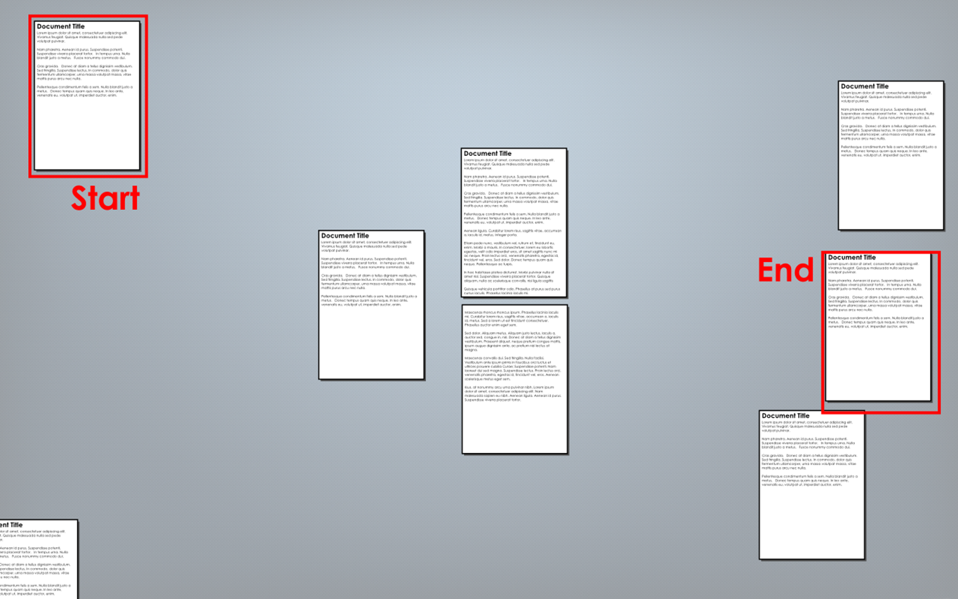

|  |  |
| --- | --- |
| Start | Zoom out |
| Move | Zoom in |

#### Prototype 0.4

Prototype 0.4 (See Figure 5‑3) shows how new documents are created. It has three frames: the first shows a single document, mid-flow. It then shows what happens if the user types when focus is on the document (frame 2) and when the focus is on the background (frame 3).

When the focus is on the document, the text enters the document. When the focus is on the background a new document is created, and all of the text that was entered is inserted into the new document. This system is consistent and amodal, as it makes focus always means “This where new input goes” even if focus is on a random spot of background, and input is never ignored because by default it is inserted in a new document.

Figure 5‑3 Prototype 0.4

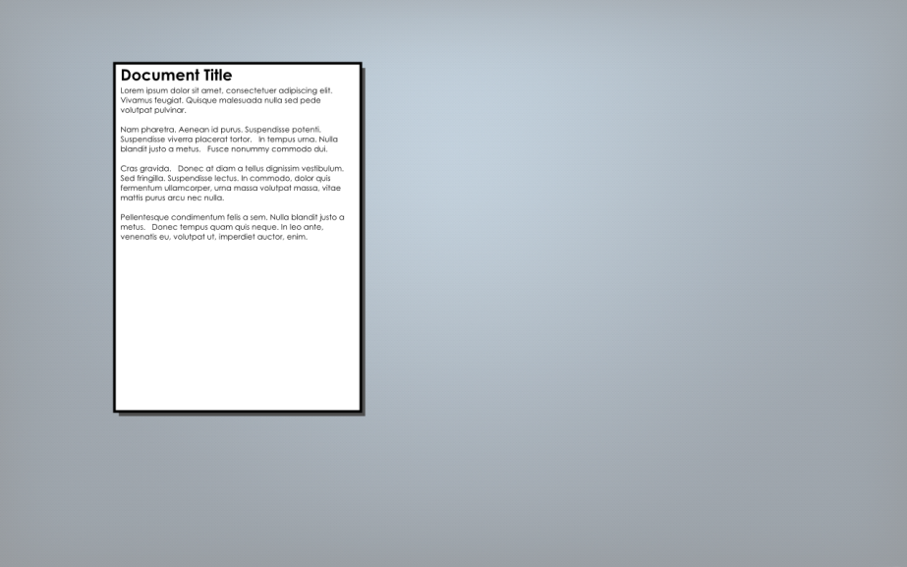

Focus on background

Focus on document

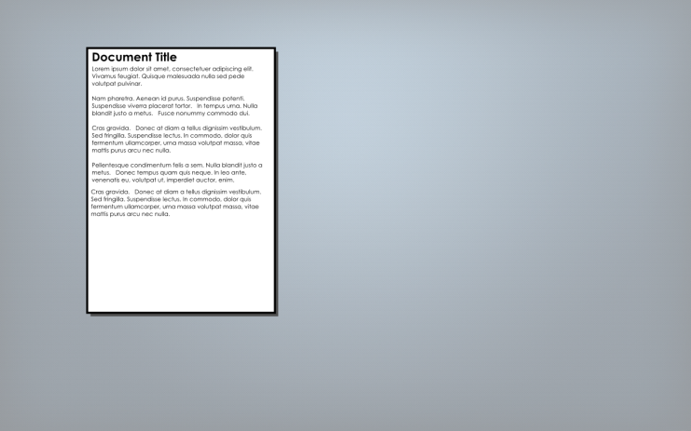 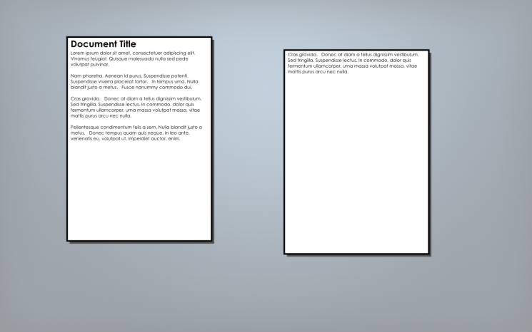

#### Prototype 0.5

Prototype 0.5 (See Figure 5‑4) begins exploring the idea of a universal command interface. It is heavily influenced by Mozilla’s Ubiquity [26] and Humanized’s Enso [27], which in turn are based on the Canon Cat (See 2.2.3.5).

The user first selects the text then depresses the command button; this opens the command window and shifts the focus to it. It also suggests the last few commands used. The user could select one of the suggestions. The user begins typing the name of the command. As the user types the command, the suggestions switch from the last few commands to the first commands alphabetically that match the text typed. Once the command is selected, the user taps tab to preview what output the command will have. They can then release the command button to perform the command, or press esc to cancel.

It uses a quasimode to launch the command bar (i.e. a button is held down to change state, keeping the change state as the locus of the user’s attention, thereby reducing the rate of mode errors [28]) to keep the system amodal. The system also uses last-value prediction to minimise the number of key presses required on average – a GOMS analysis of repeating the previous command is “K”.

The commands all use descriptive full natural language names. When combined with the suggestions this helps solve some of the discoverability issues of command lines, as the user will be exposed to more commands, and the name will give a good idea of what the command does. Additionally it helps the user remember what the command does, thereby increasing the learnability of the system. This is an excellent trade-off for the time saved by not pressing a couple of keys (e.g. cp to copy saves 0.4 seconds, but makes it entirely unclear what the command does).

It is not an ideal system, and has several flaws that will be corrected in future prototypes. The first suggestion is always in line with the suggestion bar slightly greyed out. This makes it clear to the user that tab will preview the first suggestion and releasing command will execute it. However, it introduces an interesting problem as to what happens if the user taps down: if the command is not introduced to the selections it cannot be returned to; if the command is added to the bottom of the suggestions it won’t make any sense – it was, after all, the first suggestion; and if it’s added to the top of the suggestions everything on screen will need to move which would be jarring.

The solution is to always display the first suggestion both inline and as the first item in the suggestions (as shown in Figure 5‑5). This also answers the question of how to display further suggestions that are selected, as they can now consistently be shown both in the command bar and suggestions list just as the first suggestion is.

The other problem is that when a command has become unambiguous it still requires a press of tab to move to preview. The suggestions bar no longer serves any purpose at this stage, and it should jump to preview immediately.

#### Prototype 0.6

Where 5.3.1.3 demonstrated the browsing model of navigation, prototype 0.6 (See Figure 5‑6) began exploring the searching model. It enables searching by having two commands “Find next” and “Find previous”. Once a command is entered, it can take input from selection (default), or the user can enter text. The preview screen then shows a high-level view of the document plane with all the documents that feature the phrase highlighted in red, and the current view outlined in blue. The user releases the command button to go to the next item. They can then tap the command button to repeat the command with the same arguments, finding the next next item, and so on.

Figure 5‑4 Prototype 0.5

|  |  |
| --- | --- |
| User selects text | User depresses command button, system suggests last 4 commands |
| User types “T”, suggestions change | User types “ran”, eliminates all other suggestions |
| User hits tab, preview appears | User releases command button, command executes |

Figure 5‑5 Refinements to prototype 0.5

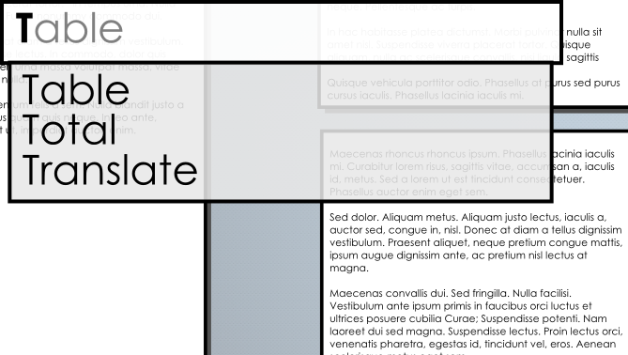

Figure 5‑6 Prototype 0.6

#### Prototype 0.7

Prototype 0.7 continues 0.6 by asking what is meant by the term “next item”. In 2.2.3.5 Canon Cat all documents were stored in a single, continuous, 1D loop meaning the “next item” was the next one you would reach continuing down the document. A 2D plane has no inherent ordering, making this significantly more difficult.

Prototype 0.7 explores several options for ordering. It abstracts the documents to nodes on a plane to make this easier.

##### Nearest node selection

The first possible solution is to always choose the node with the shortest Euclidean distance from the current node. This is shown in Figure 5‑7. The red node is the starting node; the blue node is the next nearest.

The problem is that it may not explore the full search space as it is certain that, in a given node set, there exists a pair of nodes where each is the other’s closest partner, as in the example. Nearest node selection will get stuck swapping between these two nodes.

##### Next nearest node selection

When a find command is first issued, next-nearest node selection creates an ordered list of all nodes based on distance from the first node. Repeated find commands move further down that list. This is shown in Figure 5‑8.

This introduces many problems. First, what does “Find previous” mean? It makes no sense to find the node furthest away, the user will likely want a node near to where they already are. If it means move backwards along the last “Find next” list created, then what if the user hasn’t used “Find next” yet?

The main problem is that it introduces modes. Because the node order depends on the start location, hitting “Find next” on any node could mean any number of things. If a user has habituated getting between two documents with a find action, this will be confusing. The order of the nodes must be absolute.

##### Absolute ordering

In absolute ordering (See Figure 5‑9) all nodes have a set order. If the order is A->B->C using “Find next” from B will always return C, and “Find previous” from B will always return A. In the case of the example to order chosen was to sort by Y first, then X, but the order is arbitrary and doesn’t particularly matter.

This solves the problems introduced by 5.3.1.7.2: find previous always has meaning, and finding is no longer modal. This comes at the cost of the search no longer exploring the area closest to the search origin (where the search target is most likely to be found), but rather jumps around the page in the arbitrary order chosen.

##### Absolute ordering with clustering

The problems of absolute ordering can be fixed by adding clustering (See Figure 5‑10), i.e. the nodes are grouped into subsets of geographically similar nodes. Each cluster is fully explored before leaving it to search other clusters. Clusters can be automatically generated by some clustering algorithm, or they could be created by the user.

Unfortunately, this reintroduced the modality problem. As shown in Figure 5‑11 different start points still generate significantly different orders. This can be fixed by removing the requirement to fully explore each cluster. Instead, the cluster is explored until the “last” node in it is reached. The next context is then explored, even if there exists nodes in this context that have not been visited, as they can be visited using the “Find previous” command. See Figure 5‑12.

Figure 5‑7 Nearest node selection

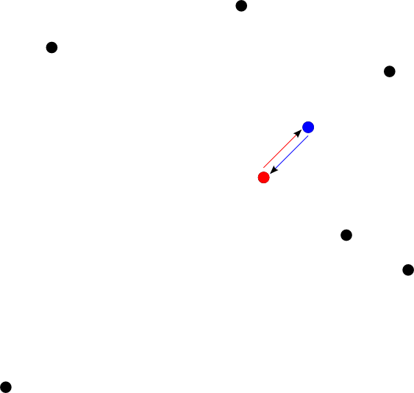

Figure 5‑8 Next-nearest node selection

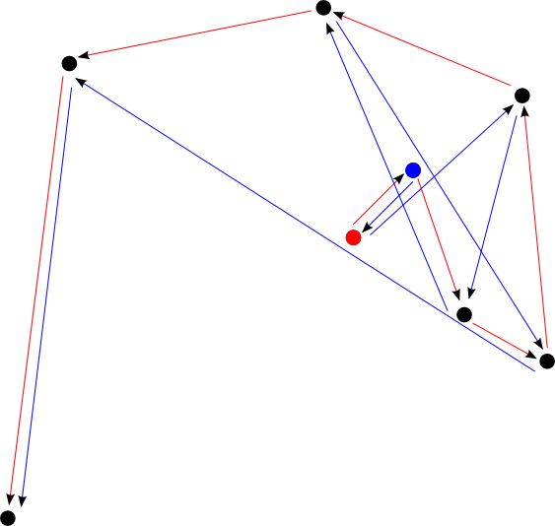

Figure 5‑9 Absolute ordering

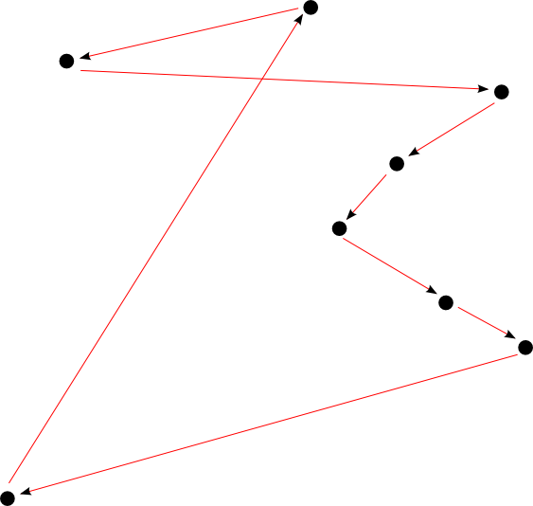

Figure 5‑10 Absolute ordering with clustering

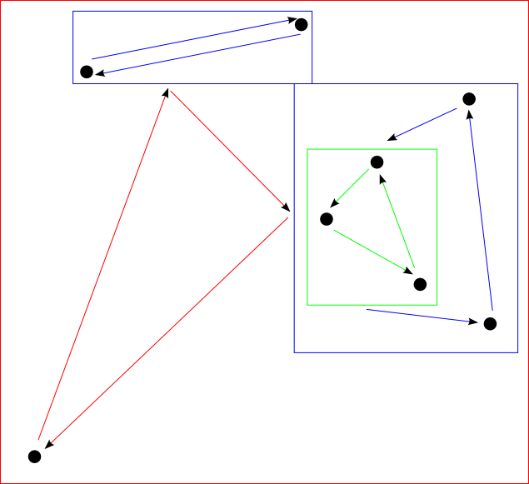

Figure 5‑11 Inconsistent ordering in clustering solution

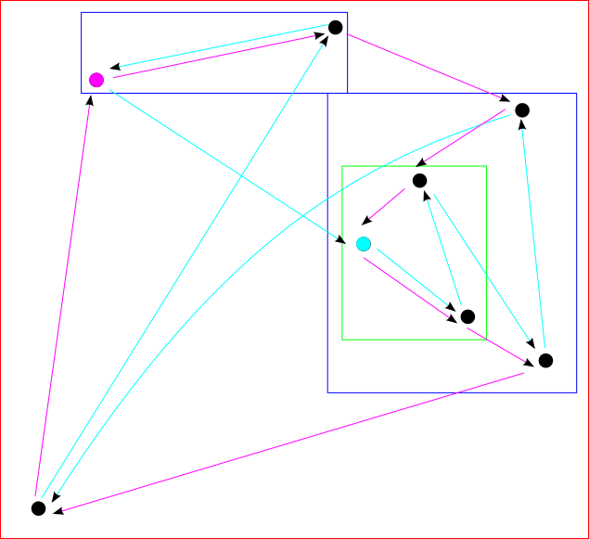

Figure 5‑12 A consistent ordering for the clustering solution

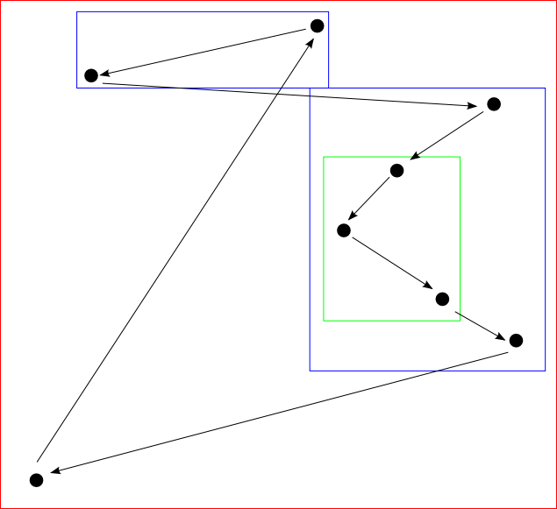

#### Prototype 0.8

Where 5.3.1.7 dealt with the underlying mechanics of how find will operate, prototype 0.8 deals with how the user will interact with the find interface. The clustering aspect in particular introduced interesting problems here. In particular: how can the user jump directly out of a cluster, and what happens when they enter a new sub-cluster?

For the purposes of this prototype, the idea of clusters was expanded into “contexts”. These can be groups of documents as in 5.3.1.7, it could be the text of a single document (the narrowest context), or it could be the entire content of the internet (the broadest context). By extending the contexts to the entire internet it makes searching online a natural extension of searching the computer.

This prototype (See Figure 5‑13) moved away from 5.3.1.6 by creating a separate interface for find, rather than making it a command. This is because there are more controls required for operating find than for regular commands, it is also a fundamental enough action for manipulating the operating system for it to be appropriate to give it its own interface.

There will be two keys on the keyboard primarily used to operate the find interface “Find next” and “Find Prev” – similar to 2.2.3.5’s LEAP forward and LEAP backward buttons. Each will bring up the respective find bar. The find bar is in the same location as the command bar so the user learns to always look in the same place for such things. It is visually distinct from the command bar by a change of colour and a small “Find next/prev” icon in the corner.

Typing anything immediately begins a search in the current context. It highlights all matches, and displays a list of them in the preview box along with a count of how many instances were found in each gradually broadening context. The user can tap a button to step out of their current context, or to explore one they would otherwise skip over. Interactive prototypes will be needed to hone this interface in particular.

#### Prototype 0.9

Prototype 0.9 explores spreadsheets, and how they can be liberated from the application framework. Spreadsheets have several parts:

* They are usually presented as tables
* They allow the user to reference data from another part of the document
* They allow the execution of short pieces of code and present the results inline

Tables are a simple concept and do not need to be explored thoroughly. As for the other two elements, there is no reason to restrict them to only being in tables. The calculate function shown in 2.2.3.5.2.6 is a good model for how this can work. The idea of a bespoke “calculate” key has been disposed of, replacing instead with a command.

When the inline code is executed, it is marked to make it clear that it is code, it can be edited, and it will be updated. Any references are also flagged and can easily be traced. The syntax used to represent references is example only. It particularly needs to be improved with how to reference items not in tables.

This model of references can be extended beyond spreadsheet functionality: it can be used to include pictures within documents, screen-scrape a web page, or pull data in from a web service. There is fundamentally no difference between all of these actions; this kind of referencing is an incredibly powerful tool.

If a reference points at a source that is not always available, it stores a cached value for the data, which it updates whenever the source is made available again.

Figure 5‑13 Document-level search

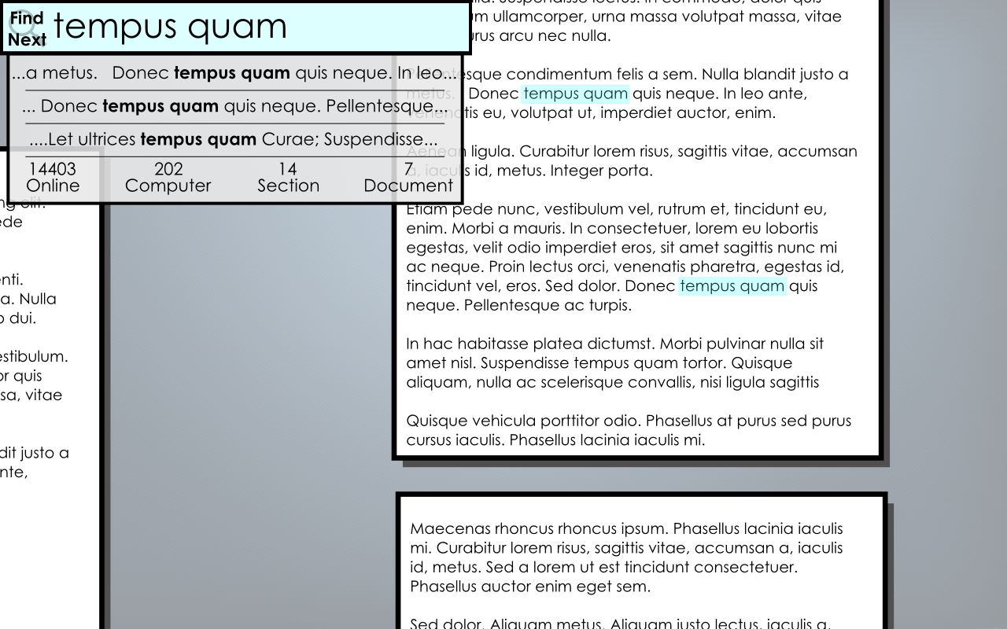

Figure 5‑14 Section-level search

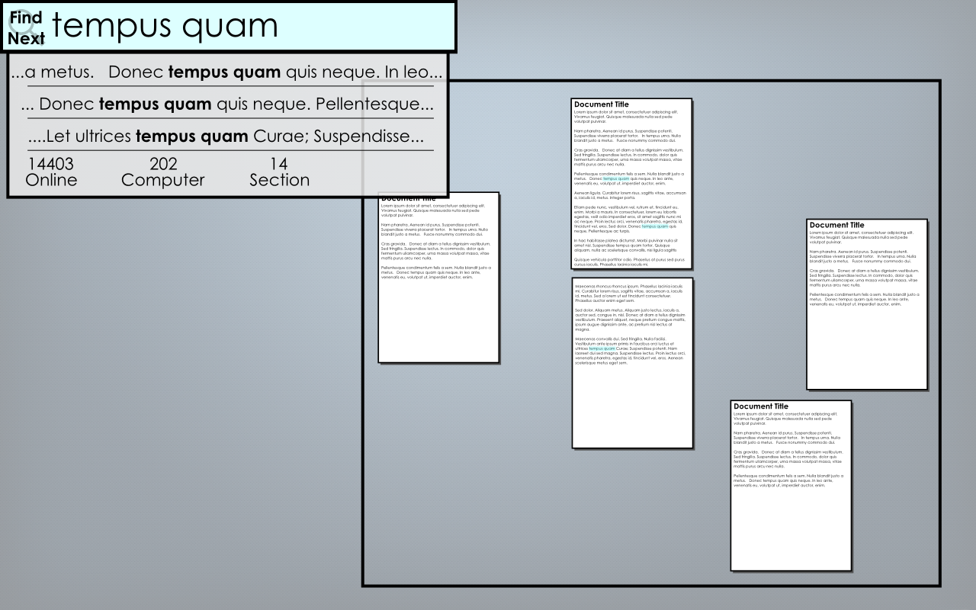

Figure 5‑15 A command written and highlighted

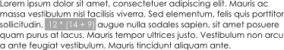

Figure 5‑16 The command has been compiled. Note the green dotted line indicating it is a command

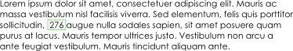

Figure 5‑17 The command is pointed at showing a gear to show it’s a command

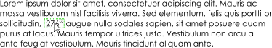

Figure 5‑18 A command with references written and highlighted

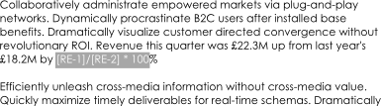

Figure 5‑19 The command has been compiled, note the green dotted line indicating it is a command

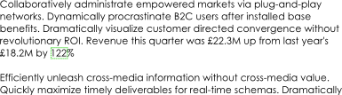

Figure 5‑20 The command is pointed at showing a gear to show it’s a command and arrows to show it has references

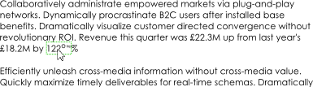

Figure 5‑21 The gear is clicked to reveal the original code

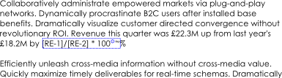

Figure 5‑22 The arrows are clicked to reveal the reference sources

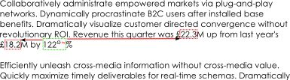

#### Prototype 0.10

Prototype 0.10 explores how audio can be displayed and interacted with. Figure 5‑24 shows a naïve approach to handling audio: the track is represented by its name, and album cover. This works, it gives the user something to interact with, the meta-data is searchable so the track can be found, and default images can be used where no album art is available, but could be dramatically better.

Figure 5‑24 recognises that audio is a 2D object – it is amplitude measured over time. It stills displays the album cover and useful metadata, but now displays the waveform directly alongside it. This entirely removes the artificial divide between listening to and editing audio. In an application-centric world, this divide has to exist because the tools required for each task are so different, but when the user rather than the programs own all the data it liberates them. The tools can still be different, the users can choose to buy different sets of commands based on their needs, but the data is the same therefore the data should look the same.

Even without advanced audio editing commands, combining the user seeing the waveforms with the referencing tool from 5.3.1.9 provides the user with some interesting options. First, say the user wants to create a playlist: they can reference each of the songs in order. As a natural extension of this, this user can only reference part of a track, rather than the whole thing. Even without any waveform manipulation tools the user is now performing basic audio editing. This is an excellent example of how providing the user a few basic tools and full ownership of their data can have very powerful emergent effects.

#### Prototype 0.11

Where 5.3.1.10 dealt with audio, Prototype 0.11 (See Figure 5‑25) explores video. Video is more complicated because it is a 3D object: it’s a series of 2D frames presented over time. Additionally there are audio components involved.

The prototype handles this by displaying the video track as a timeline with a single, moving viewport to show the content of the current frame. While watching a video either the user’s view will follow the moving viewport, or the viewport will stay still and the timeline will move – interactive prototypes will be required to see which feels more natural. The audio tracks are displayed beneath & in line with the video.

#### Prototype 0.12

Prototype 0.12 (See Figure 5‑26) looks at how the system handles multiple drives. A general principle of the system is that the user doesn’t care where a file is physically stored, so wherever possible multiple drives should be handled by a RAID-type system where the physical drives are abstracted into a single large storage volume. However, in a world of SANs, portable drives, and cloud storage this is not always possible.

The prototype shows how the 2D plane is subdivided into regions representing each drive. There is a rough relationship between the size of a file on disk and the size of it represented on the plane   
(large image -> more pixels, large document -> more words & more pages), therefore larger disks are represented by larger boxes. As the drive fills, the walls of the box bulge out. This both indicates to the user that the drive is running out of room, and allows the system to cover for the fact that there isn’t an exact 1:1 relationship between size on disk and size on display (empty space consumes nothing on disk, images have a higher size-on-disk : size-on-display ratio than text, etc.)

#### Prototype 0.13

Prototype 0.13 explores multitasking. How can a user work on one document when referring to another? A naïve approach would be to either force the user to move any reference documents next to their active document, or to force them to keep using find. An alternative approach, demonstrated in Figure 5‑27 is to allow the user to switch their screen to have multiple viewports, each an independent camera observing the same canvas.

Figure 5‑23 A naïve approach to playing audio



Figure 5‑24 Audio displayed with its wave form

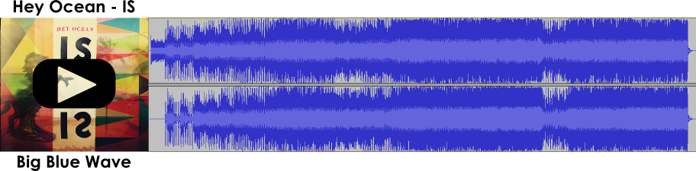

Figure 5‑25 A basic video file

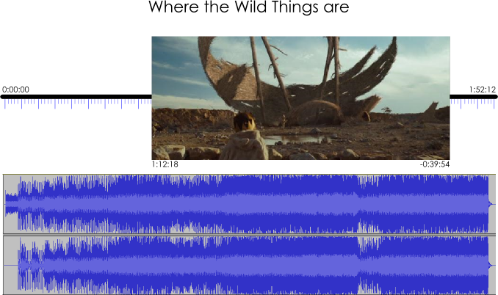

Figure 5‑26 Multiple drives

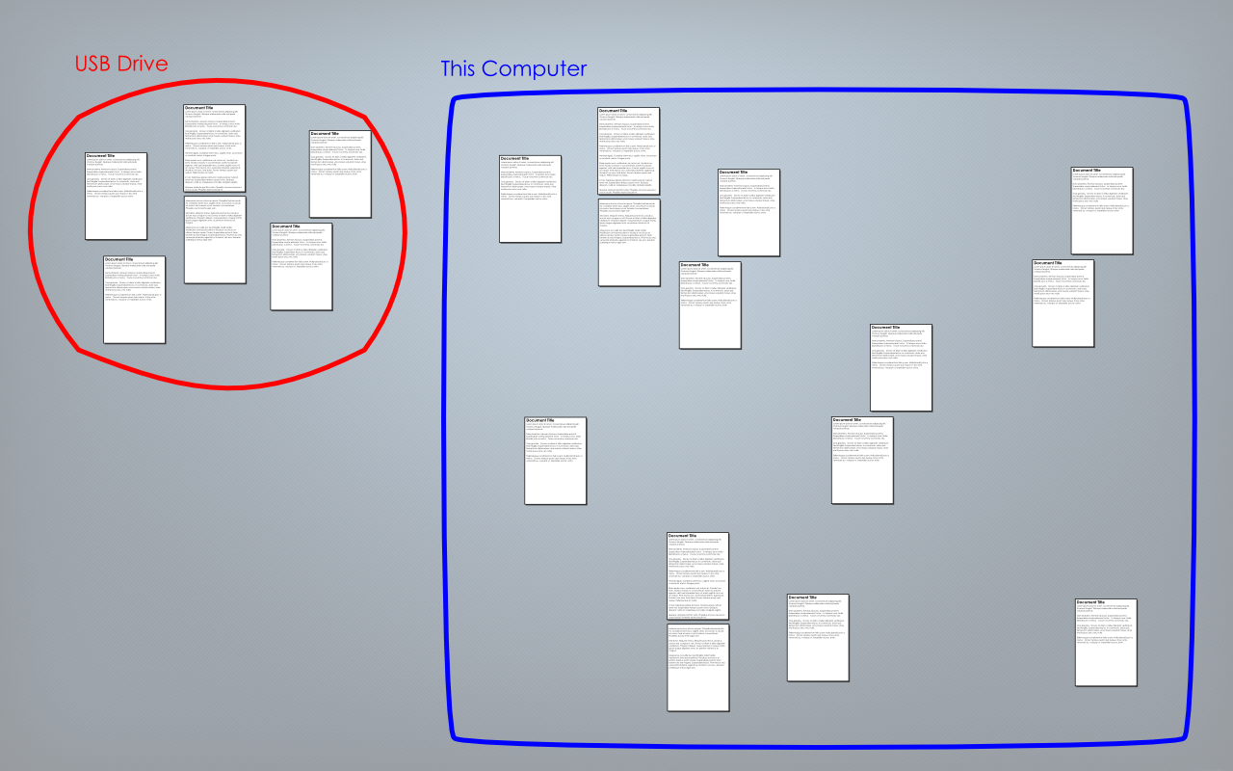

Figure 5‑27 A divided user view

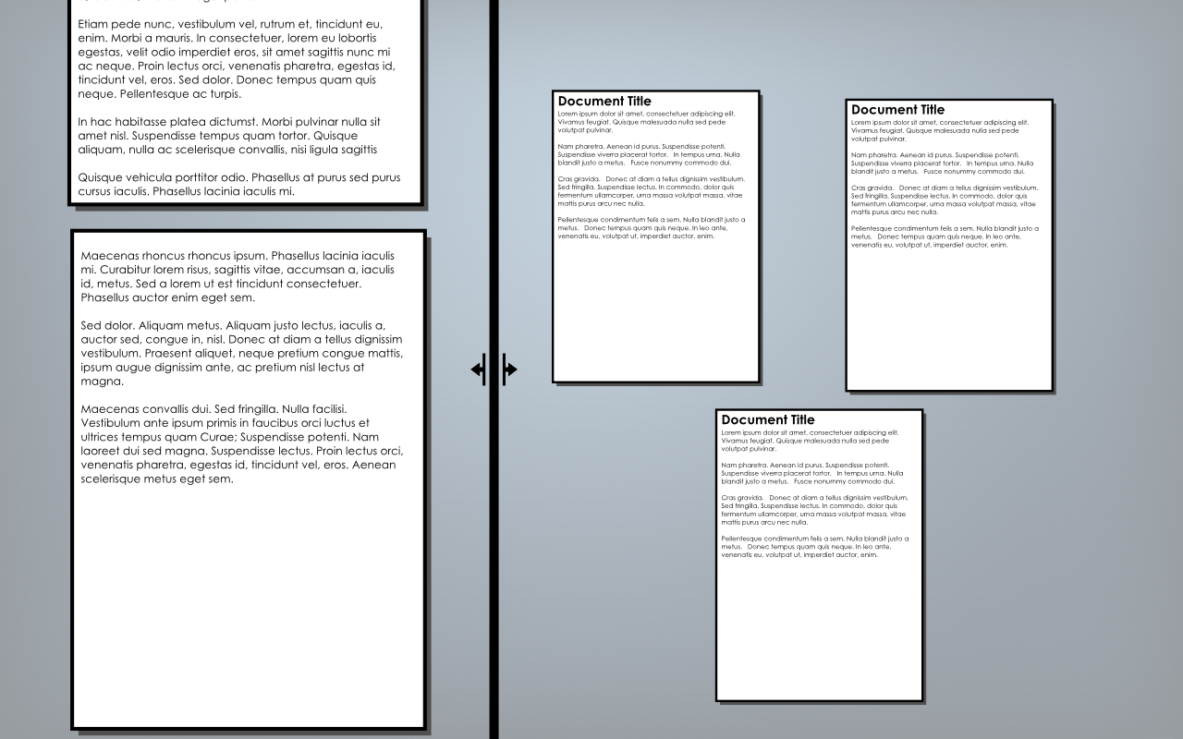

### Prototypes 1.x

Prototypes 1.x are interactive prototypes leading up to the minimum viable product as identified in the PID (see Appendix A) and 3.2.1

#### Prototype 1.1

Prototype 1.1 is designed to be the simplest possible way of demonstrating the core functionality of the system.

##### Features

This prototype features an infinite 2D plane that can be navigated by panning and zooming. If text is entered when focus is on the background, a new document is created to store the text. If text is entered when focus is on a document, it is appended to the document.

##### Development

Most of the functionality for this prototype was provided out of the box by the Piccolo.Net library. The PCanvas object provides a suitably navigable plane to which other objects can be attached. The documents were a combination of a PText node to contain the text, and a couple of event listeners handled all the text entry.

It was designed to be such a simple implementation so that the core ideas of the project could be tested as quickly as possible, to ensure that it was an idea worth pursuing before a great deal of time was spent on it.

##### Analysis

The basic functionality of the system – the zooming, and the ability to create documents simply by typing –feel excellent to use, and it capably shows what a system built from the ground up could be like; however, it is a very limited prototype. There is no way to change what has been written, the user can only add more text, and the user cannot move documents from where they were created. After using it for more than a few minutes the limitations become abundantly clear, and the illusion falls away.

#### Prototype 1.2

Prototype 1.2 is an attempt to flesh out 1.1 with features that help extend the user’s suspension of disbelief by making it seem more like a full functional system.

##### Features

Prototype 1.2 extends 1.1 with full plain text editing (rather than simply appending characters to a page), pagination (creating a new page to store text in when the current one is full), and the ability to move documents.

##### Development

Full plain text editing was achieved by replacing the PText that was previously used to store the text with the PStyledText node. As noted in 5.4, this did not exist in Piccolo.Net at the time and had to be built from scratch.

Pagination was achieved using a hook in PStyledText that informs a listening class when there is text that it cannot fit within its bounds, and either moves it to the start of the next page, or creates a new page to store it in, as appropriate. A simple event listener was added to handle moving the page when the user performed a drag action on it.

##### Analysis

Prototype 1.2 is significantly more fleshed out than 1.1, so maintains the feel of a “real” system much longer, as intended. However, fundamentally there is nothing different in how the user interacts with the system now than there was before.

#### Prototype 1.3

Prototype 1.3 introduces the other key idea the system will be built on: replacing applications with commands that can be executed on any content.

##### Features

The main new feature of Prototype 1.3, as previously mentioned, is the command bar. Additionally some basic rich-text editing (bold and italic) was added as commands that could be executed, and text selection was added so that the command bar would know what to manipulate.

##### Development

Most of the work on text selection happened in PStyledText, so is discussed in 5.4. In addition to that work, the system was set up such that only one active selection could exist at a time. This was achieved by hooking an event to the SelectionConfirmed event of the PStyledText that would update Window with the details of the newly created selection, and destroy any old ones wherever they were.

The CommandInterface (See C.3.2) is controlled by a ShowInterfaceHandler (See C.3.6), and displays when a user presses the appropriate button (at this stage control, but it would later be moved to caps lock), accepts text input, then when the button is released if the name entered exactly matches the name of a command it executes the command. Anything added after the name of the command is provided to the command as arguments.

Commands all implement the ICommand interface (See C.1.1), which provides the “Execute” method. When the command is fired, the “Execute” method is fired with the details of the current selection, and any arguments provided as input. The “Execute” method does not return, but is expected to perform its output by modifying the selection in some manner. In the case of Bold and Italic, this takes the form of changing the style of the text.

##### Analysis

The command bar shows some potential, but at this stage, the prototype is too basic to show its advantages. Holding control and typing “bold” takes objectively longer than pressing ctrl+b (1.2s vs 0.4s), and the requirement that the entered name exactly match the command name makes it more error prone too. Once commands that are more complicated are introduced it should better show the value of the command bar, and it may be worth moving the more trivial actions to well-signalled keyboard shortcuts (a la the Canon Cat’s “Use Front” option [1]).

One of the key features of the command bar is that it is activated on a quasimode, allowing the user switch contexts and access this very powerful tool without invoking mode errors. It is active only as long as the key is held down, meaning the user will not forget they have enabled the quasimode and inadvertently attempt to enter content in the command bar [28].

The introduction of the command bar means this is the first time the system meaningfully employs the noun-verb architecture. Traditionally word processing uses a combination of noun-verb and verb-noun design (i.e. either the user can engage a mode to change how all text will be output until the mode is changed, or they can enter the text and then style it later). Users frequently use noun-verb for major formatting, and verb-noun for minor in-line styling.

The system allows only noun-verb interactions, which will cause a significant break in users’ normal workflow and may increase the time taken to achieve tasks. It also raises the interesting question of how to handle text being inserted inside or next to styled sections. For example, see Figure 5‑28.

Lorem ipsum **dolor sit amet, consectetur adipiscing elit**. Donec nunc elit, efficitur eu gravida nec, consectetur at nunc. senectus et netus et malesuada fames ac turpis egestas. Sed ultricies placerat egestas. *Integer non mauris*

Figure 5‑28 – Example of styled text

If text were to be inserted between “**amet**” and “**consectetur**” in the first sentence it is clear that the user would want it to be bold and match the surrounding text. If they enter it at the end after “*non manus*”, however this is less clear. Standard behaviour for a word processor is to continue in the last style that was being used, this both provides consistency with the behaviour elsewhere in the document and reduces superfluous user input as the user is more likely to want to carry on than switch to the default. However, this implicitly allows the verb-noun design, and therefore introduces modes. The mode could be eliminated by adding some kind of formatting mark, but that comes at the cost of losing WYSIWYG editing.

#### Prototype 1.4

Prototype 1.4 fleshes out the system by adding additional commands with which to style the text.

##### Features

In addition to bold and italic commands, the system now has underline, strikethrough, change colour, change size, and change to a predefined style (title, h1, h2, normal, etc.)

##### Development

Because so much of the process in changing the style of text is the same between all the different commands, an AbstractStyleCommand (See C.1.4) was created to handle all the common logic.

Additionally the commands bold, italic, underline, and strikethrough all perform the same function, but for a different flag of the FontStyles enum, so these have been collapsed to a single class – ToggleStyleCommand (See C.1.8) - with the flag they should toggle declared when the object is instantiated.

##### Analysis

Much like 5.3.2.2, this prototype is mostly just fleshing out the one before it without fundamentally changing anything about the way the user interacts with the system. That said, the fact that the command interface is being used for commands that are more complicated helps demonstrate that it is worth having, and using it to interact with content does work well.

In particular, StyleCommand (See C.1.7) takes arguments from the CommandInterface, and could not easily be implemented as a simple keyboard shortcut. Additionally, commands like strikethrough are rarely used frequently enough to deserve their own shortcut, and end up being hidden behind several layers of menu. With the CommandInterface, the command is accessed in the same way as everything else, and given the same prominence as everything else, which stops rarely used features from being hidden and forgotten.

#### Prototype 1.5 – Minimum Viable Product

Prototype 1.5 implemented a full text search, therefore meeting the exit criteria specified in 3.2.1, making it the Minimum Viable Product.

##### Features

This prototype adds a very basic full text search.

##### Development

Because of the similarity between FindInterface (See C.3.3) and CommandInterface, AbstractInterface (See C.3.1) was created the handle the common logic of rendering a text box the user types in to before doing a thing.

FindInterface itself recursively takes every document in order and searches for the phrase within that document. If it finds the phrase, it selects it and terminates the search. There are a large number of methods involved in searching that interact in a complicated manner, making internal state very difficult to keep track of. Inspired by functional programming’s manner of sidestepping problems with state by removing it from the language; all the search methods were declared static, and handle any states by passing and returning objects to each other. This ensures that every function call is deterministic, making it much easier to test.

##### Analysis

The full-text search as it is, is very basic – it simply finds the first instance of the entered phrase (in order of document creation). This is obviously lacking in two regards: first while it helps find the phrase, the user still needs to manually search for the selection; secondly, it only returns the first instance of the phrase meaning the user needs to be very specific to find what they actually want. It mainly serves as a proof of concept of how a full text search would work.

### Prototypes 2.x

Prototypes 2.x build on the minimum viable prototype to see how the ideas can be extended.

#### Prototype 2.1

Prototype 2.1 builds on the full text search, attempting to make it a useful way of navigating the plane.

##### Features

The simple “Find the first instance of this phrase” method of searching has been replaced with the ability to search forwards or backwards from the current location. The system will then move the camera so that it is focusing on the found phrase. The user can also choose to select the last section they jumped over in a search by pressing both search buttons at once.

Finally, the interfaces now have visual cues to tell the user what they are doing: find and command both have different icons that are displayed, while find also has text to tell the user whether they are searching forwards, backwards, or highlighting.

##### Development

Extending the FindInterface provided some interesting challenges. First, chording is not natively supported in C#’s keyboard abstraction. Instead of firing an event registering both key presses at once, it fires two separate events. As such, a timer had to be created to wait a fraction of a second (20ms was chosen as an interval long enough to allow a user to depress both keys, but short enough that it would not be registered as a delay by the user) to see if multiple key events had been fired.

The problem now is that the timer starts its own thread when it expires, rather than firing an event on the UI thread, meaning that the timer’s event is unable to interact with the non-thread-safe interface at all. To solve this, the timer then invokes another method, this time back on the UI thread, which then executes the logic of the search logic. This repeated context switching can cause some delays if the processor is busy, but is usually not noticeable to the user.

Additionally, the navigation to the newly found phrase needed to be carefully balanced. It needs to be fast enough that the user will want to use the find interface as their primary method of navigation, but it also needs to be slow enough that the user understands how to get from where the search began to where the phrase was found, and cannot give the user motion sickness.

After much testing the animation that was decided on is to first zoom out and pan such that both the found page, and everything that was originally in view are now in view, and then zoom in to just the found page. In total, the animation takes 800ms, which according to our typical GOMS timings (See Table B-1) is the same as the time it takes for the user to move their hand to the mouse and back again.

This means the animation is objectively faster than navigating with the mouse, because on top of the two moves the user would then need to do lots of pointing and dragging. At the same time, the user is still able to keep track of where they have come from. This is further aided by the fact that the animation accelerates in and out of each motion, meaning it spends a lot of time at the apexes (beginning, middle, and end) which are the key points for understanding the transition.

##### Analysis

The visual clues do a lot to aid learnability and reduce the error rate of using the interfaces. This could potentially be improved further by adding a word to the icon for CommandInterface so that the user unambiguously knows what it does as soon as they see it, rather than just differentiating it from FindInterface.

The new way in which find works makes it a fast and effective way of navigating both inside of, and between documents. When combined with the highlighting feature it allows for a fast and very habituating way of calling commands and modifying content. E.g. to style some text as a title: simply type it, hold left alt, type the first couple of letters again, release left alt, then tap both alts. Next, hold the command key, type “style title”, release the command key and it is done. The user never needs to lift their hands from the keyboard or navigate any menus to find the options they need.

#### Prototype 2.2

Prototype 2.2 aims to flesh out the system and aid testing by adding sample data.

##### Features

When the system is launched, it now generates four random documents that are structured and styled as one would expect a normal user-generated document to look.

##### Development

Documents are generated using a randomly navigated finite state machine. Each paragraph type is represented by a state. Each time the system navigates to a state it inserts a paragraph according to the properties of the state, before randomly choosing the next branch to take. The FSM is illustrated in Figure B‑2. All documents produced by the FSM will match the grammar

S = Title

Title = <Paragraph> (H1 | Body1)

H1 = <Paragraph> (H2 | Body1 | Body2)

H2 = <Paragraph> (H3 | Body2 | Body 3)

H3 = <Paragraph> Body3

Body1 = <Paragraph> (H1 | Body1 | <Terminate>)

Body2 = <Paragraph> (H1 | H2 | Body2 | <Terminate>)

Body3 = <Paragraph> (H1 | H2 | H3 | Body3 | <Terminate>)

The FSM is built across several classes. Section (See C.2.2) represents a state of the machine, and contains the logic for generating individual classes and adding them to a document. SectionSelector (See C.2.3) defines the possible paths between states, and randomly selects one to take. DocGenerator (See C.2.1) creates the actual documents, and kicks off the generation process.

##### Analysis

This prototype has done little to change the way the user interacts with the system, however it does make the system feel more “lived in” helping to maintain the suspension of disbelief.

#### Prototype 2.3

Prototype 2.3 aims to increase the learnability and reduce the error rate of the CommandInterface by giving the user more visual cues and preventing the user from performing meaningless action.

##### Features

The key feature of this prototype is command suggestion (as seen in 5.3.1.4). When the user first launches the interface, it suggests the last four commands used. Once the user begins typing, it updates the suggestions to any that start with the current phrase. The user can navigate the current suggestions with the up and down arrow keys, before pressing tab to choose the current suggestion.

The suggestion is automatically chosen when the input is unambiguously a command (e.g. “st” could be “style” or “strikethrough”, “sty” must be “style”, so the rest of the word is automatically filled) because it is simply wasting the user’s time to force them to continue to input text when the system already knows what they want. Conversely, when the user types a backspace it removes characters until the chosen command is ambiguous (e.g. pressing backspace from “style” would go to “st”) because the user clearly does not want the command they chose, so there is no need to make them press backspace repeatedly.

Finally, the system no longer allows the user to enter invalid commands. Any characters entered that do not match a command name are simply ignored.

##### Development

C#’s LINQ queries and fields with definable getters and setter made implementing suggestions both simple and readable. For example, the list of current suggestions is always available on this.Suggestions. There are no worries about the variable falling out of date because the suggestions are recalculated every time they are requested.

If the system reached the point where this calculation was causing a strain on the efficiency, one could simply edit the field such that it cached and updated when the value changed without altering any of the dependant methods.

LINQ queries are very useful for polling collections, for example this.Suggestions uses

return Commands.Where(x => x.Name.StartsWith(CommandName)).ToArray();

While one could write a short loop that polled every item in the list, adding any matching items to a collection (which is likely how .NET implements this method on a lower level) such a solution is not very readable. Using LINQ queries, this line does exactly what it says it does: it returns every command whose name starts with a given string, as an array.

##### Analysis

Command suggestion not only solves some of the discoverability problem of commands (as the suggestions can tell the user of commands they did not previously know about – not a perfect solution, but the start of one), but also solves the identification issue noted in 5.3.3.1.3. As soon as the user depresses the command key, they are presented with a list of commands, making it immediately clear what the interface is for.

The autocomplete and backspace features comply very well with concern 1.2.2 – “Do not require more of the user than is necessary” as the user only has to input enough for the computer to work out what they wanted. The use of last value prediction when first launches the CommandInterface also helps, as the user is most likely to do what they last did. This could be improved even further by replacing last value prediction with a full inference engine as described in [22], but that is outside the scope of the project.

The new features reduce errors by several means. First, by displaying the name of the commands it gives the users a prompt to how the commands are correctly spelled which will reduce the rate of errors caused by incorrect knowledge or understanding. Any such errors not caught by this, along with any cases of the user inadvertently pressing the wrong key are then caught by the system removing any characters that do not contribute towards the name of a command. This means that there is no way that a user could enter the name of a command that does not exist.

On first glance, the second error reduction technique appears to be a violation of concern 1.2.1 – “Consider user input as sacred” as the system is now deliberately ignoring user input. However, on close examination it becomes clear that the system was already breaching concern 1.2.1. The previous behaviour was to allow the user to type anything, and then attempt to process that as a command. If it failed to find a command matching that name, it would silently fail without giving any indication to the user.

The user, not being told why nothing is happening, will either assume the command is taking a long time to complete, wasting time, or assume it failed to fire and try again, likely with the exact same erroneous command name, wasting time and destroying even more user input. Because the interface is activated by a quasimode, we can be sure that the user will only be entering text in to this interface because they are trying to launch a command.

Therefore, anything the user enters that is not a command name is guaranteed to be erroneous. The best way of treating user input as sacred in these cases is not to allow erroneous input in the first place. This system does that while providing tight and clear feedback of what input is allowed in the form of the list of possible command names from the current input string.

This could be further enhanced by adding some kind of prediction and validation for the arguments of commands as well as the commands themselves, but this will make each of the individual commands more complex than is reasonable for an object to be in a prototype.

#### Prototype 2.4

Prototype 2.4 extends the list of commands to ones that manipulate the content of the selection, rather than simply styling it.

##### Features

Two new commands were added in this prototype: calculate, which parses a section of text and tries to evaluate it as a mathematical expression; and translate, which takes a section of text in one language and translates it in to another. Additionally, as these command need to report errors, a method of doing this without interrupting user flow was introduced.

##### Development

The logic of CalculateCommand (See C.1.2) is provided by NCalc [29], an open source library for evaluating mathematical expressions as strings. The created command simple needed to act as a wrapper converting the input from the CommandInterface to something NCalc could understand.

TranslateCommand (See C.1.3) was significantly more complicated. The logic itself is handled by Bing Translate, which has an API listed on the Azure Data Market (ADM) [30]. To make the system talk to the API, the general problem of calling an ADM web service from a C# application needed to be solved. ADM provides a C# file to download for each API it is not very well designed, and makes for awkward application flow.

There are two stages to this problem: first the program needs an authentication token from the ADM, secondly the program needs to send a correctly formatted request to the API. As such, this problem was solved with two classes: AzureToken (See C.4.2), and AzureServiceHelper (See C.4.1). Using these classes it will be trivial to add any further ADM web services to the system.

AzureToken handles everything to do with authentication. When it is activated, it sends a request to the ADM for a token for the appropriate web service. It then keeps track of when the token expires, and renews it if necessary.

AzureServiceHelper handles making the calls the web service itself. It provides the this.Request method, which deals with formatting the URL, attaching the authentication details, and passing the relevant arguments in the correct way.

Additionally, translate needs to know what languages to translate between. If no arguments are provided, it will try to translate to the default language as defined at compile-time (currently English), and will attempt to detect the source language using the Detect Language service from Bing Translate. Before doing this, however, it will try to see if the user has specified any languages. For this, it scans the arguments looking for the word “to” or “from”. If it sees either of these, it will take the following argument to be the relevant language.

Finally, the Error class was developed (See C.5.4). This allows the system to raise a warning to the user in a humane way. When the constructor is called it automatically attaches itself to the camera, meaning it will be visible no matter where on the plane the user is currently navigating, and starts a timer. When the timer expires, it removes itself from the camera, destroying any references to itself that it knows about, so that the garbage collector can pick it up in the next pass.

##### Analysis

The new commands continue to show the true value of the command bar. Instead of needing to open a calculator application, perform the calculation, then copy the value in to the document; the user simply writes the expression, and calculates it in context. If the user does not want the result in their document then it is only a single key press to remove it again. Likewise, translate has been moved from a long and complicated process involving various websites to simply selecting the relevant text, and specifying the language to translate to.

The error class manages to present alerts to the user in a much more humane way than the standard alert box found in most computer systems. A standard alert box is 0% efficient as it requires user input to dismiss when there is no other meaningful action a user can do, senselessly captures keyboard input, and requires the user to click in a specific place despite the fact that clicking anywhere else couldn’t mean anything. The error class on the other hand dismisses itself after a few seconds, allows the user to continue working while it is raised, and lets the user dismiss it early by clicking anywhere.

#### Prototype 2.5 – Final product

Prototype 2.5 continues to enhance the usability of the CommandInterface. At the end of this prototype it was decided that the prototyping process had come to its natural conclusion, as such this is the final product. A longer analysis of the final product as a whole, rather than just the changes from Prototype 2.4, can be found in 6.

##### Features

The CommandInterface was enhanced by adding a preview of what the command will do when it is executed. Additionally, the option not to execute a command by pressing escape was added.

##### Development

To achieve the preview the ICommand interface was extended to add the “this.Preview” method, which returns a PText that shows what the selected text would look like once the command is executed. This method was then implemented for each individual command.

A full UML class diagram of the final product is provided in Figure B‑4.

##### Analysis

The addition of preview did a lot to tighten the feedback loop of executing commands, particularly those that take arguments. This allows the user to understand the change that their action will enact before performing the change, and then gives them the option to abort the action before it changes their document.

This could be improved further still with the addition of a universal undo/redo to allow the user to correct a mistaken command execution and help them understand what the impact of the action they just performed was.

## Piccolo.NET Development

Significant development work was spent on extending the open-source Piccolo.NET framework. The main addition was the PStyledText class (See D.1). This was a class available in the Java version of the framework, but not the C# version. Its purpose is to render rich text, and allow the user to edit and interact with it.

The overall principle in previous developer’s work on Piccolo.Net was to meet parity with the Java version, and to implement exactly the same API; except in the cases that C# offered syntax that better expressed the intended action, which would then be used in addition to the Java-style implementation. As such, this was the original intention for further development of the library. Additionally, the intention was to submit any changes back to the community.

To gain a greater understanding of how the Java version was implemented, and what API it provided both the code of the class itself, and its unit tests were studied. During this period of study, several things became clear:

1. The community surrounding Piccolo2D (The Java version) and .Net (The C# version) were dead.
2. The Java version used the Swing object Document to do a lot of the heavy lifting when it came to rendering and editing text, and based its API off that. The closest C# equivalent is RichTextBox, which uses a significantly different document model, and therefore a significantly different API.
3. The Java PStyledText object was very limited in the way it allowed interaction, and would not be suitable for use in the project.

As such, the decision was made that, while the Java version and its implementation provided useful guidance as it solved the same problems in a similar language, it would not be treated as a gold standard. Instead, the C# version would be individually forked to [31] where development would continue along its own path.

The eventual solution was broken down across several classes, listed below. A full UML class diagram for the changes made to Piccolo.Net is found in Figure B‑4.

### PStyledText (See D.1)

This is the main PNode that is added to the scene graph. It is what the user sees and interacts with. As much as was possible, the actual logic behind how it does these things has been handed off to other classes. For example, the class does nothing in and of itself to render text to the screen. Instead, it pulls the list of styled sections from the underlying Model, asks each section to render itself as a PText (Piccolo’s existing class for rendering text to the screen), and then simply attaches those PTexts to itself as children.

One key difference between the Java implementation of PStyledText and the C# implementation is the lack of this.SyncWithDocument method. In the Java version, a lot of information was cached to the object, then synchronised regularly. With C#’s fields feature it is possible to pull this information directly from the underlying Model.

The main task it still handles is ensuring what is displayed stays synchronised with the underlying model. It achieves this using C#’s event delegates feature. Using delegates, one object can pass a pointer to one of its methods to another object along with instructions of when to call it. This allows sturdier design patterns and looser class coupling. Any method named “Model_XXXXXX” is subscribed to at least one event of the Model member.

By passing delegates from instances of PStyledText to their Models, instead of hard coding the functionality in to the Model class it means that whenever PStyledText is changed, Model does not also need to be changed. It also means that members of PStyledText that need to be manipulated during the process do not need to be declared public or internal.

Another option to using delegates like this would be to let PStyledText handle all the events, change what it needs to, then pass the event to the Model. Delegates are again more resilient than this, as they ensure that, for example, this.RecomputeLayout is called every time the text of the Model changes, not just when the PStyledText causes it to change.

### Model (See D.4)

Model is an extension of the Windows Forms’ RichTextBox class. It provides the hooks necessary to understand the document model of the RichTextBox and handles all user interaction where possible. It was decided to use RichTextBox for a lot of the heavy lifting in development because it does almost everything required from PStyledText, just for a different display framework. It would therefore be just as much a waste of effort not to use it here, as it would be to try to implement a new RichTextBox for WinForms itself.

#### Understanding the document model

RichTextBox stores its content in RTF format, rather than a structured DOM like HTML. This makes it difficult to poll because RTF must be read linearly to make sense (whereas a structured DOM could be accessed in a tree-like structure), and RichTextBox is the only class C# provides for dealing with RTF.

Instead of writing a completely new RTF parser, model instead relies on the fact that RichTextBox can poll its current selection to find out where on the page it is, and how it is styled. Model’s this.GetStyledSections method uses this to turn the RTF in to a structured model of the document by selecting each character of the RichTextBox in turn, and polling it for that information. As soon as it finds a character different to the one before it, the system knows that either it has reached the end of the line, or the style of the text has changed. It then takes all the characters since the last change, and groups them in a SegmentInfo. The list of SegmentInfos is passed up to the PStyledText so that it can render the text.

#### Handling user interaction

As stated previously, RichTextBox was designed to convert user interaction to formatted text. As such, it makes sense to use it to handle all user interaction. There were some issues standing in the way of this though.

First, RichTextBoxes must be attached to windows form and visible (though it can be occluded) before they will take input. This was solved by adding it to the main window beneath the PCanvas object so that it was interactable, but not visible to the user.

Secondly, RichTextBoxes are built for a different interaction manager than Piccolo’s, meaning both that it cannot process the events that Piccolo fires, and the system as a whole needs to know which interaction manager it should be firing events to at any given point. Upon investigation, it was found that Piccolo worked such that windows forms handled all events. If the WinForms’ focus was on a PCanvas object, it would convert the event to a Piccolo event and fire it again. Therefore, the simplest way to handle this is to manage whether windows form’s current focus is the active Model or the PCanvas attached to the window.

Thirdly, the coordinates of the RichTextBox and the PStyledText it represents are not the same. This means that a series of methods to convert between one coordinate system and the other needed to be created. This was further complicated by the fact that Piccolo and Windows Forms have a different understanding of how large a pixel is, varying by about 4%. This conversion needs to be applied to everything, including the size of the model against the PStyledText.

### RunInfo (See D.5)

RunInfo acts as a pointer to a section of text. It is used when information about where something is in a larger block of text is required.

### SegmentInfo (See D.6)

SegmentInfo extends RunInfo by providing information about what the style, content, and position of a section of text is, as well as a method to convert the run into a PText, which is used when PStyledText renders the content.

### Selection (See D.7)

Selection represents the text currently selected in a PStyledText. It ensures that the text is selected in the underlying Model before any queries or changes are made, and draws the Path that represents the current selection to the user.

### PSelectionEventHandler (See 0)

PSelectionEventHandler exists to convert the action of a user dragging their mouse across a document in to text within that document being selected. When the user begins a drag action, it records where the selection began. Then whenever the user moves their mouse it destroys the old selection, and creates a new selection between the start location and the current location. When the user releases the mouse it informs the system that this is the selection the user wants to keep.

### Carat (See D.3)

Carat represents the small, blinking indicator of where in the text the user is currently interacting. It only shows when a user is actively interacting with a PStyledText, so there will never be multiple Carats on screen at once, and it contains all the logic for updating its current position on screen.

## Issues in development

There were several issues in the development process. The most major was that work on the project had to be halted after other coursework caused the student’s repetitive strain injury to flare up. Several mitigations were made, including extensions and the use of an amanuensis. It was decided that work should be suspended until such a time that the student was able to continue work on it full time. This had a huge impact on the delivery date of the project.

The other major issue was the discovery that the Piccolo.NET framework had no active developers since 2005 [32] and has not kept parity with the Java version, meaning it did not have all of the expected functionality. This means that significant development effort had to be spent on the library in order to be able to complete the project. Details of the work on Piccolo.NET are listed in 5.4.

Further minor issues were caused by C# not offering total control over the keyboard. There is no way to stop the operating system from receiving and responding to modifier keys (alt, shift, caps lock, control, etc.); meaning that caps lock could not be used without turning all input into capitals, and alt could not be used without firing system keyboard shortcuts. Additionally not all keys behaved as expected, for example left and right control were indistinguishable, while alt+gr registers as control on the KeyDown event, and alt on the KeyUp event.

Initially this was dealt with by trying to avoid problematic keys, for example control was used instead of caps lock to open the command interface. However once find last was required in 5.3.3.1 it became clear that there were not enough keys that could be meaningfully used under the C# keyboard abstraction. This was solved by using SharpKeys [33] to remap the desired keys to keys that were neither required for meaningful input, nor listened to by the operating system. In this case the F-Keys.

# Testing and Quality

Testing is performed by asking three major questions

1. Does it fulfil the requirements as laid out in 3.2 and at the beginning of the prototyping cycle?
2. What is the quality of the code? Does it do what it is supposed to do?
3. How does it compare perform at the tasks laid out in 2.2.2? How does that compare to Windows 7 (See 2.2.3.1)

These are asked to some extent at the end of each prototyping cycle, but have been tested more thoroughly for the final product. The results are documented below.

## Requirements

### “Must” Requirements

* Never enter a state in which user input is ignored

Achieved – the system can be in one of four states:

1. Focused on background – input creates a document to store the input
2. Focused on a document – input gets stored in the document
3. Command window (quasimode) – input is used as command name/arguments
4. Find window (quasimode) – input is used as find string

* Have no interfaces with zero informational efficiency

Achieved – the system never asks the user to perform input where no meaningful choice exists. Areas where this happens in other systems (e.g. before an application is launched, during an error message) have been avoided by careful design.

* Be entirely amodal

Achieved – the system has two quasimodes, but otherwise input is always handled in a consistent manner

* Be document-centric

Achieved – the user owns their documents, and is able to interact with them directly using the command window, rather than having them locked away in applications.

* Use a universal command interface

Achieved – the command window is how all commands are accessed. All commands can interact with the current selection, and with any arguments passed to them.

* Use a spatial filesystem

Achieved – The user’s documents are laid out on an infinite 2D plane, and the user is able to arrange them on the plane in any way they choose

* Allow the inputting and formatting of rich text

Achieved – Text can be entered, and commands are available to change the size, colour, and style of the text

* Have full-text search

Achieved – Phrases can be searched for and found from any document

### Should” Requirements

* Have commands that manipulate rich text (e.g. calculator/translator)

Achieved – two commands exist that change the content of the selection based on the original contents of the selection

* Have spell check

Not Achieved

* Have a calendar

Not Achieved

* Have a web browser

Not Achieved

* Have web search

Not Achieved

### “Could” Requirements

* Have spread sheeting

Not Achieved

* Have image manipulation

Not Achieved

* Allow command piping

Not Achieved

### Requirements Review

As all of the “Must” requirements, the project has met its exit criteria, and can be considered a success on those grounds. However, almost none of the other requirements were met. This was because, as the prototyping process progressed, the understanding of both the problem and its solutions developed. Later prototypes were built on needs and ideas identified in earlier prototypes.

As this is the entire point of the prototyping process, why it is recommended industry practice, and why it was chosen for the project it would be foolish to say that the project had failed because it did not fulfil every idea concocted at the beginning of the project. Rather, as the project developed, and the prototypes iterated the initial requirements were found either to describe an inadequate system, or simply to be a lower priority than other improvements and developments that could be made.

Each individual prototype met the requirements laid out for it at the beginning of its prototyping cycle, and the overall system produced at the end meets the concerns raised in 1.2, therefore from a requirements standpoint the project has been successful.

## Code Quality

All code was written in a deliberately readable and maintainable manner. This was achieved by using multiple layers of abstraction; clearly named variables, methods, and classes; and minimising class coupling. Because of this design, Visual Studio’s code metrics gave the main project a maintainability index of 80%, and the changes to Piccolo 85% (on par with Piccolo’s overall score of 83%). Visual Studio’s tool for checking for code clones (where the same logic is implemented multiple times) found no matches.

Together this means that another developer should be able to pick up the project, and with a little study be able to pick up and modify the code without fear of breaking it. As the purpose of the project was to create a prototype to display and share ideas within the interface design community; and the library code is contributing to an existing open source project this is very important.

A great deal of manual testing was performed on the code, ensuring it does do what it is supposed to do. Part of this came from the amount of analysis performed at each prototyping cycle, which would raise any newly introduced bugs from the latest cycle. In addition to this, a log of bugs was created and any regressions were tested for at the end of each prototyping cycle.

One example of a frequently regressing bug involved translating the coordinates within the Model object to coordinates on screen. Every cycle or two either a design flaw in the current algorithm for converting between coordinate spaces would be made evident, or a change in the structure of the system might cause the algorithm to be applied incorrectly (in several cases any adjustments ended up being applied twice). Therefore, this was heavily tested for at the end of every cycle.

Testing was made easier by the fact that the system was designed such that the number of states it could be in was very small. This was primarily a UX-focused decision: as the aim was to create an amodal system, it should have as few states as possible. This also happened to make testing significantly easier, as the system needs to be exhaustively tested in every state it can exist in to ensure that it does act correctly at all times.

## Tasks

### Enter text & spell check

The system cannot currently spellcheck, but can achieve the text entry. There are no steps the user needs to perform before entering the text, no modes the user needs to (or even can) enable, and no system response for the user to wait for. Therefore, the text entry is 100% efficient, taking just 110s and 2622 bits. This is a saving of only 4 seconds over Windows 7, but is a significantly reduced mental load.

### Save, close, and open the document containing the above text

The idea of saving and closing is meaningless in the developed system – everything is always open and available to the user, everything is always saved. The closest approximation to closing a document would be if the user were in a different part of the plane. If they then wanted to find the document, they could use the full-text search – “During our spring” would likely be enough to identify the document uniquely.

This eliminates 12.7 seconds and 11.8 bits by removing the save + close step entirely. The open step, previously 13.3 seconds of navigating the file system is now 3.2 seconds of typing (16 K events * 0.2 seconds). This is 24% of the previous time required for the open step, or 12% of the previous total task time.

### Translate the above text to Spanish

After the text has been entered, the user needs to perform two steps to translate it to Spanish: select the text, and use the translate command.

To select the text, the user needs to depress the search backwards button, type “du”, release the search backwards button, and tap both search buttons at once. This process can be represented in GOMS as “MKKKKK” The process takes 2.35 seconds, already faster than selecting with the mouse as per Windows 7.

The translation itself is performed by holding down the command key, and typing “t” (enough to uniquely identify the translate command) “to sp” (the language code for Spanish) and releasing the command key. This can be represented by the GOMS “MKKMKKKKKK” The process takes 4.3 seconds.

The entire process, therefore takes 6.65 seconds, about a third of the time Windows 7 took (excluding the response time, which would likely be similar for both. Additionally, it can all be done without requiring the user switch contexts or navigate unfamiliar menus. The translate on the system can also be used anywhere, whereas Windows 7’s translate wasn’t actually an OS feature, but a feature of Word, one of its applications; and is therefore limited to only being used within word.

This is a major improvement on Windows 7.

### See what the next calendar event is

The system does not currently have an in-built calendar.

### Create a calendar event every Friday at 1pm for 6 weeks

The system does not currently have an in-built calendar.

### Find the cube root of 25

The system cannot currently calculate cube roots, as the library used to evaluate functions does not support that. Should the library ever be extended, that feature would become a part of the system without any direct development work.

The system can, however perform other, simpler calculations. For example, to find the value of “4 * (10 + 3)” The user simply needs to type the sum, select it, and run the calculate command. There are 12 characters in the string, so accounting for one M at the beginning; it takes 3.75 seconds to enter the sum.

Selecting using the same process as 6.3.3, this time searching for “4”. This takes 2.15 seconds. Calculating requires summoning the command bar, typing “ca”, and releasing the command bar. This takes 2.15 seconds. The total time for the operation is therefore 8.05 seconds.

As this is not the same sum, it is not directly comparable to Windows 7’s 12.85 seconds. That said, the difference in the sum is not the main reason for the speed up, but rather the simpler process of execution. Additional clear advantages are that the user does not need to leave the document they are working on to perform the calculation, they can simply perform it inline and carry on with their work.

### Search for the ITNG wiki page

The system does not currently have a web search

### Review of tasks

The final product is not as fully featured as Windows 7. This is to be expected, as Windows 7 is the most widely deployed commercial operating system, which likely took over 3000 man-hours and $300M to develop [34], whereas the final product is a small prototype developed by a single programmer over the course of a few months.

That said, where the interactions provided are comparable, the system consistently provides faster, more compelling, more learnable interactions that demand a lower mental load of the user. This proves that the ideas this project was exploring have merit, and that an information appliance could be built on them that would be able to compete with the other commercial operating systems by being more useable than they are.

The advantages in a simple command are not significant (as noted in 5.3.2.3.3 if the command is too simple, it may actually come at a cost), however because complicated actions are now performed in exactly the same way as simple actions, there is a huge benefit when it comes to executing them.

# Summary, Conclusions and Critique

## Costings

As mentioned in 5.5, the initial project deadline was missed by over a year due to health concerns on the part of the student. That said, because this was caused by an interruption of work, the total time budget for the project was not significantly exceeded. According to records kept by the student (See Appendix E) the project took a total of 412 hours of work, within the margin of error of the 400 initially budgeted for in section 2.3 of the PID (See Appendix A).

There were no material costs to the project.

## Fulfilment of aims

Section 2.2 of the PID (See Appendix A) established several aims for the project. These are listed below, and assessed as to whether they have been fulfilled.

### Academic objectives and outputs

#### To learn and apply the objective measures of interface design

This was achieved. GOMS analysis and measures of informational efficiency were used frequently throughout the analysis stages of the project to provide clear and objective judgements and comparisons of the usability of systems.

#### To gain a better understanding of unit testing

This was not achieved; as the decision was made early on in the project that unit testing would not be used. This allowed the prototyping process to maintain a high velocity of producing prototypes at a rate of several per week.

#### To practice the process of iterative prototype design, and opportunity to practice iterative development

This was achieved, as the final product was reached as the result of a chain of one paper-based prototype, twelve non-interactive prototypes, and ten coded interactive prototypes. The entire project was built around the idea of iterative prototype design.

### Personal objectives and outputs

#### Achieve a first-class classification for the project work

The success of this aim is impossible to assess at this time.

#### Present the project at events external to the department

The project will be presented at the “Reading Geek Night” event on November 11th 2014; this has been achieved, therefore.

### System objectives and outputs

#### A comprehensive investigation in to current systems, assessing them against several objective measures

This was achieved in the existing systems analysis in 2.2.

#### A series of prototypes building up to the final deliverable

This goes hand in hand with 7.2.1.3, and therefore was also achieved.

#### A programmed interactive prototype of a system that could be implemented…

##### …Demonstrating ideas gained and developed through research and prototyping

The entire project started with extensive research in to how people work (See 1.2 and 2.1). From this the initial plans and requirements laid out in 3.2 were developed. As the iterative development process progressed, the understanding of the problem and its solutions grew, affecting the direction future prototypes explored (as noted in 6.1.4). Therefore, this has been achieved.

##### …That outperforms currently implemented systems at a number of objective measures

In the areas that the system is comparable to Windows 7, it frequently outperforms it (See 6.3.8). Therefore, this has been achieved.

##### …That is able to perform operations on multiple types of content

The decision was made that, as the tools had already been developed for manipulating rich text that more returns could be expected for less effort by continuing to explore rich text manipulation, than by needing to create tools for other data types (such as image manipulation). Therefore, this was not achieved.

#### A series of non-interactive prototypes, including ones that demonstrate how functionality not-yet-supported would work.

The entire first stage of the prototyping process (See 5.3.1) was non-interactive prototypes. Included in this were ideas on how multimedia content could be interacted with (See 5.3.1.10 and 5.3.1.11). Therefore, this was achieved.

#### Have over 90% unit test code coverage

As noted in 7.2.1.2, this was deliberately not achieved.

### Review of aims

Most of the aims laid out at the beginning of the project have been achieved. The three cases that were not achieved were all deliberate decisions, and happened because the understanding of what the project involved grew as the project progressed. At the time of specifying the aims, it could not have been known that they were not the most efficient way the project could be progressed.

## Future work

The project has taken the prototyping stage to its logical conclusion, and there is little benefit in prototyping further. The logical next step, therefore, would be to actually build the system. The most sensible way to begin would be to take a free UNIX like LINUX or Free BSD as a base operating system and build an interface layer on top of it. The aim would be to create an information appliance capable of replacing a standard operating system and complying with all the concerns laid out in 1.2.

Bespoke hardware could be created to supplement the operating system. The two main pieces that would benefit the system would be a keyboard with bespoke keys for command, find next/prev, undo, and redo; and a mouse with grip buttons for moving.

Areas which should be expanded on further should this actually be developed include replacing the last-value predictor currently employed by the command bar with a full inference engine as described in [22] allowing for prediction of both what command the user wants to run and what arguments they want to pass it. Additionally the system should be adapted to work on touch-screen devices as they have become increasingly common since the project began, and have a very strong zoom metaphor.

The biggest problem in getting the system off the ground will be the massive amount of social traction the WIMP GUI has. This is even higher now than it was when Raskin published [1], or released the Swyft Card and Canon Cat. There are even more computers running WIMP GUIs now, with even more businesses dependant on applications designed for them. Even if they don’t use a full WIMP GUI, smartphones and tablet OSes are now glorified application launchers, with a series of walled gardens preventing any application from ever affecting anything outside its sandbox or ever communicating with one another.

Additionally the entire web as we know it was built with the WIMP GUI in mind, sites were built to be viewed through web browsers where the view is restricted to a slim portal, and where clicking a link replaces the current page. Ideas such as infinite scrolling have no meaning when the entire page is to be downloaded at once. Even the web itself has become application-centric: a user goes to gmail.com to read their email, facebook.com to find out what their friends are doing, or Netflix.com to watch a film. Each loads their own application into the user’s browser, each performing bespoke functionality particular to that site.

Obviously all these sites have value, otherwise people wouldn’t use them. To begin with functionality to deal with sites like this will need to be hacked in in as elegant a way as possible, but over time the system will require that sites move to a more web-service oriented approach that is more compatible with the document-centric architecture of the system. Many such services already offer APIs but these are always secondary to their websites and mobile apps.

# Works Cited

|  |  |
| --- | --- |
| [1] | J. Raskin, The Humane Interface, Chicago: Addison-Wesley, 2000. |
| [2] | K. Jennings, The devouring fungus, New York: W. W. Norton, 1990. |
| [3] | B. J. Baars, A Cognitive Theory of Conciousness, Cambridge: Cambridge University Press, 1988. |
| [4] | L. Thomas, The Lives of a Cell, New York: Viking Press, 1974. |
| [5] | D. A. Norman, “Design Rules Based on Analyses of Human Error,” *Communications of the ACM,* vol. 26, no. 4, p. 255, 1983. |
| [6] | J. Reimer, “A History of the GUI,” 5 May 2005. [Online]. Available: http://arstechnica.com/features/2005/05/gui/. [Accessed 24 September 2012]. |
| [7] | M. Tuck, “The Real History of the GUI,” 13 August 2001. [Online]. Available: http://www.sitepoint.com/real-history-gui/. [Accessed 21 September 2012]. |
| [8] | A. Raskin, “Away with Applications: The Death of the Desktop,” 4 May 2007. [Online]. Available: http://www.youtube.com/watch?v=q8ZP23QsRd0. [Accessed 24 September 2012]. |
| [9] | J. Nielsen, “The impending demise of file systems.,” *IEEE Software,* vol. 13, no. 2, p. 145, 1996. |
| [10] | M. Müller-Prove, “Vision and REality of Hypertext an Graphical User Interfaces,” Universität Hamburg Fachbereich Informatik, Hamburg, 2002. |
| [11] | S. K. Card, T. P. Moran and A. Newell, The Psychology of Human Computer Interaction, Lawrence Erlbaum Associates, 1983. |
| [12] | ISO/IEC, *IEC 80000-13:2008,* Geneva: International Organization for Standardization, 2008. |
| [13] | P. Fitts, “The Information capacity of the human motor system in controlling amplitude and movement,” *Journal of Experimental Psychology,* vol. 47, pp. 381-391, 1954. |
| [14] | W. E. Hick, “On the rate of gain of information,” *Quarterly Journal of Experimental Psychology,* vol. 4, no. 1, pp. 11-26, 1952. |
| [15] | T. K. Webb, “Correct and Incorrectly Spelled Words,” [Online]. Available: http://deimos3.apple.com/WebObjects/Core.woa/DownloadTrackPreview/tbr.k12.edu.1686014660.01686734270.1815954889.pdf. [Accessed 23 October 2012]. |
| [16] | T. R. Ostrach, “Typing Speed: How Fast is Average: 4,000 typing scores statistically analyzed and,” [Online]. Available: http://orbitouch.com/wp-content/uploads/2012/03/Average-OrbiTouch-Typing-Speed.pdf. [Accessed 19 April 2014]. |
| [17] | Net Market Share, “Desktop Operating System Market Share,” 2014. [Online]. Available: http://www.netmarketshare.com/operating-system-market-share.aspx?qprid=10&qpcustomd=0&qpstick=1&qpsp=2014&qpnp=1&qptimeframe=Y. [Accessed 14 April 2014]. |
| [18] | N. Agrawal, W. J. Bolosky, J. R. Douceur and J. R. Lorch, “A Five-Year Study of File-System Metadata,” *ACM Transactions on Storage (TOS),* vol. 3, no. 3, 2007. |
| [19] | O. Bergman, S. Whittaker, M. Sanderson, R. Nachmias and A. Ramamoorthy, “The Effect of Folder Structure on Personal File Navigation,” *Journal of the American Society for,* 2010. |
| [20] | Jujuba Software, “Translate!,” 2012. [Online]. Available: http://apps.microsoft.com/windows/en-us/app/translate/330cc446-8049-4a3f-8432-05adfecde4aa. [Accessed 21 April 2014]. |
| [21] | S. Lammers, Programmers at Work, Redmond: Microsoft Press, 1986, 1989. |
| [22] | B. Victor, “Magic Ink, Information Software and the Graphical Interface,” 15 March 2006. [Online]. Available: http://worrydream.com/MagicInk/. [Accessed 05 May 2014]. |
| [23] | Piccolo 2D, “A Structured 2D Graphics Framework,” [Online]. Available: http://www.piccolo2d.org/. [Accessed 31 March 2014]. |
| [24] | Stanford University, “HUMAN-COMPUTER INTERACTION,” 31 March 2013. [Online]. Available: http://online.stanford.edu/course/hci. [Accessed 20 March 2014]. |
| [25] | A. Razkin, “How to prototype and influence people,” 2010. [Online]. Available: http://www.azarask.in/blog/post/how-to-prototype-and-influence-people/. [Accessed 30 03 2014]. |
| [26] | Mozilla, “Labs/Ubiquity,” 6 February 2013. [Online]. Available: https://wiki.mozilla.org/Labs/Ubiquity. [Accessed 13 August 2014]. |
| [27] | Humanized, “Enso Launcher,” 2013. [Online]. Available: http://www.humanized.com/enso/launcher/. [Accessed 24 September 2012]. |
| [28] | A. Shellen, G. Kurtenbach and W. Buxton, “The Prevention of ModeErrors Through Sensory Feedback,” *Human Computer Interaction,* vol. 7, no. 2, pp. 141-164, 1992. |
| [29] | sebastienros, “NCalc - Mathematical Expressions Evaluator for .NET,” 3 January 2011. [Online]. Available: https://ncalc.codeplex.com/. [Accessed 22 October 2014]. |
| [30] | Microsoft, “Microsoft Translator,” 31 August 2011. [Online]. Available: https://datamarket.azure.com/dataset/bing/microsofttranslator. [Accessed 22 October 2014]. |
| [31] | E. Williams, “malacandrian/Piccolo.NET,” 17 October 2014. [Online]. Available: https://github.com/malacandrian/Piccolo.NET. [Accessed 23 October 2014]. |
| [32] | Piccolo 2D, “Download Piccolo2D,” 14 April 2011. [Online]. Available: http://www.piccolo2d.org/download.html. [Accessed 11 June 2014]. |
| [33] | CodePlex, “Sharp Keys,” 29 December 2011. [Online]. Available: http://sharpkeys.codeplex.com/. [Accessed 18 September 2014]. |
| [34] | J. Schofield, “How many people make Windows 7?,” 19 August 2008. [Online]. Available: http://www.theguardian.com/technology/blog/2008/aug/19/howmanypeoplemakewindows7. [Accessed 25 October 2014]. |
| [35] | D. Gentner and J. Nielsen, “The Anti-Mac interface,” *Communications of the ACM,* vol. 39, no. 8, pp. 70-82, 1 August 1996. |
| [36] | A. Raskin, “Away with Applications: The Death of the Desktop,” 04 May 2007. [Online]. Available: http://www.youtube.com/watch?v=q8ZP23QsRd0. [Accessed 24 September 2012]. |

1. Project Initiation Document



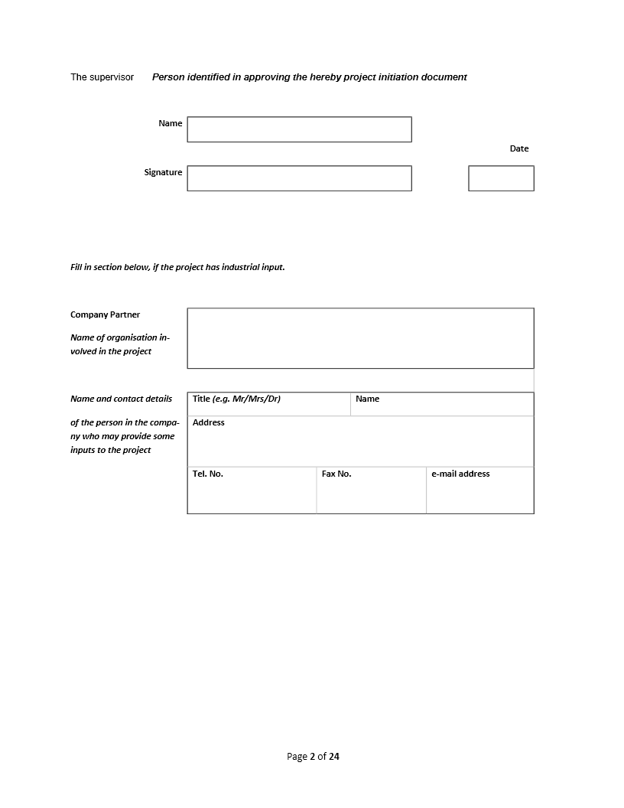



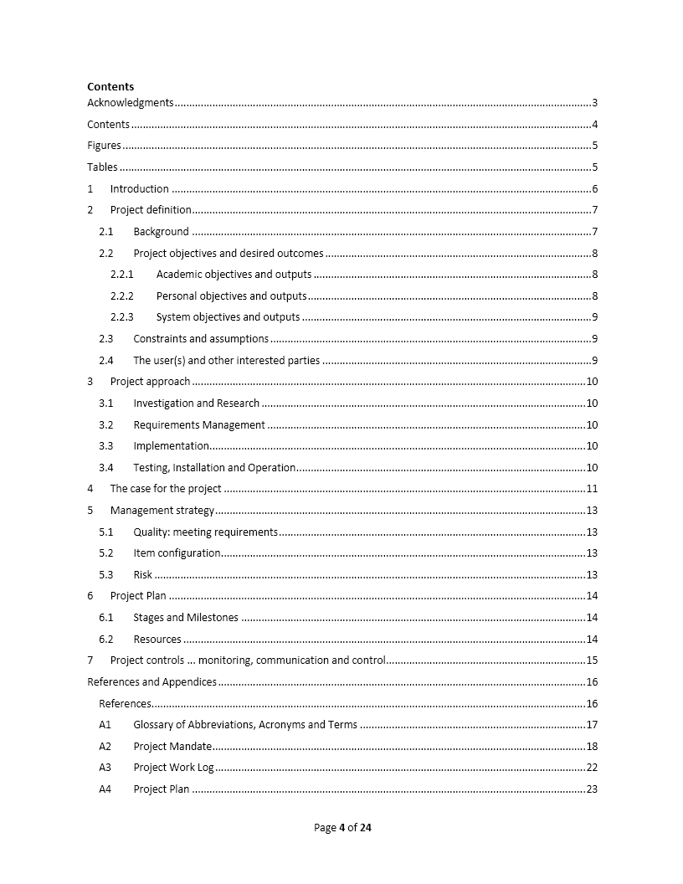

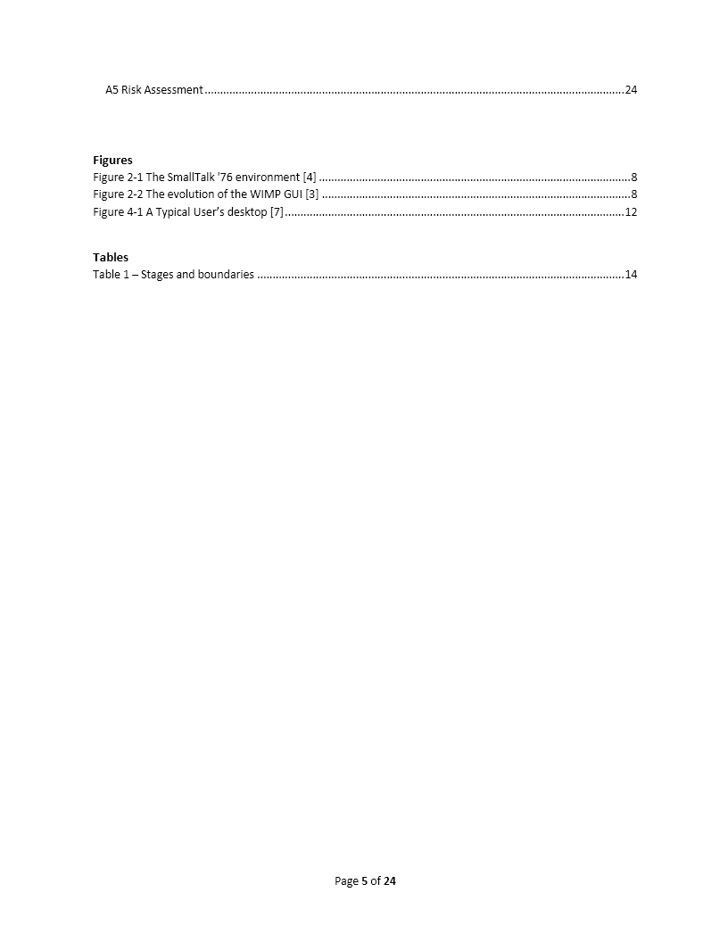

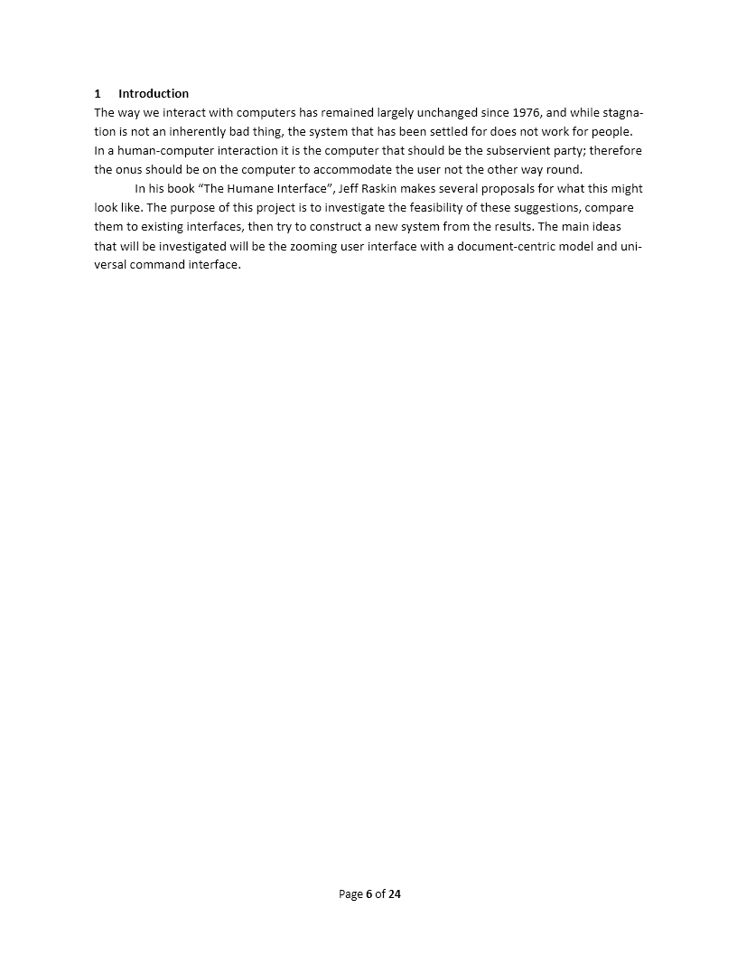

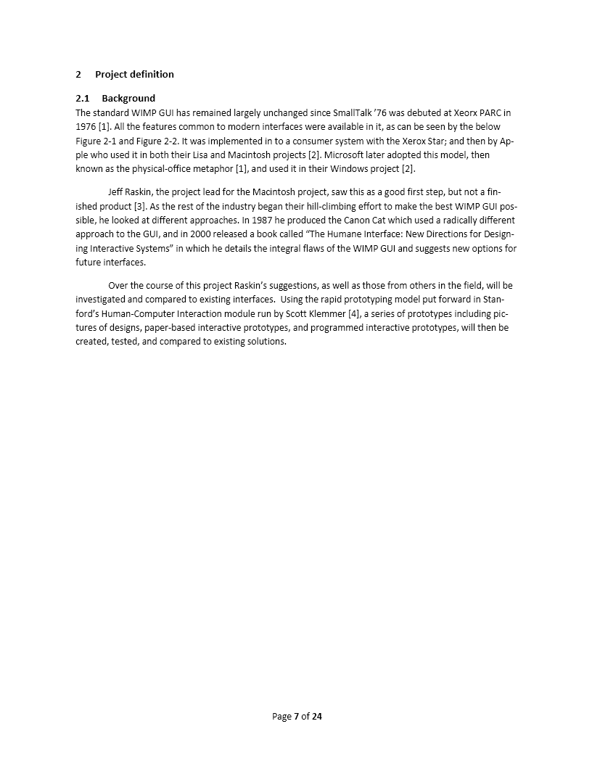

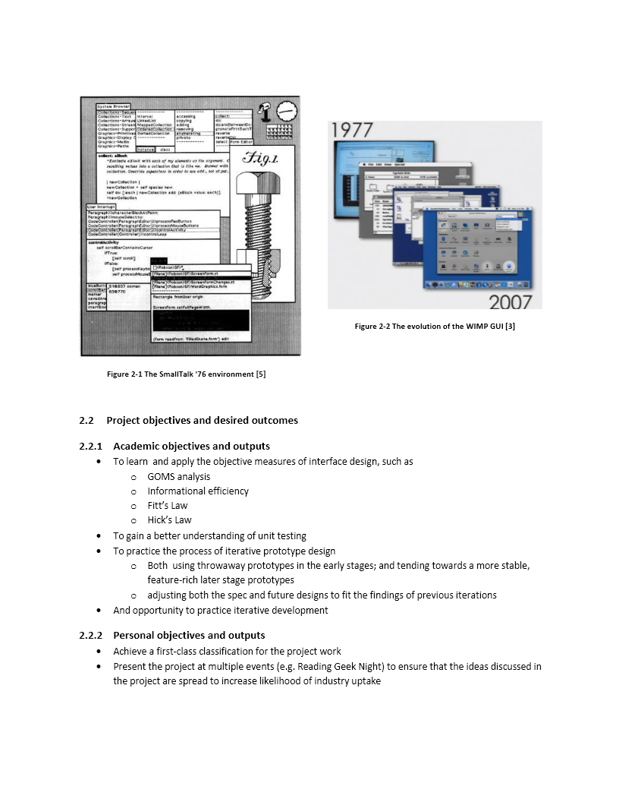

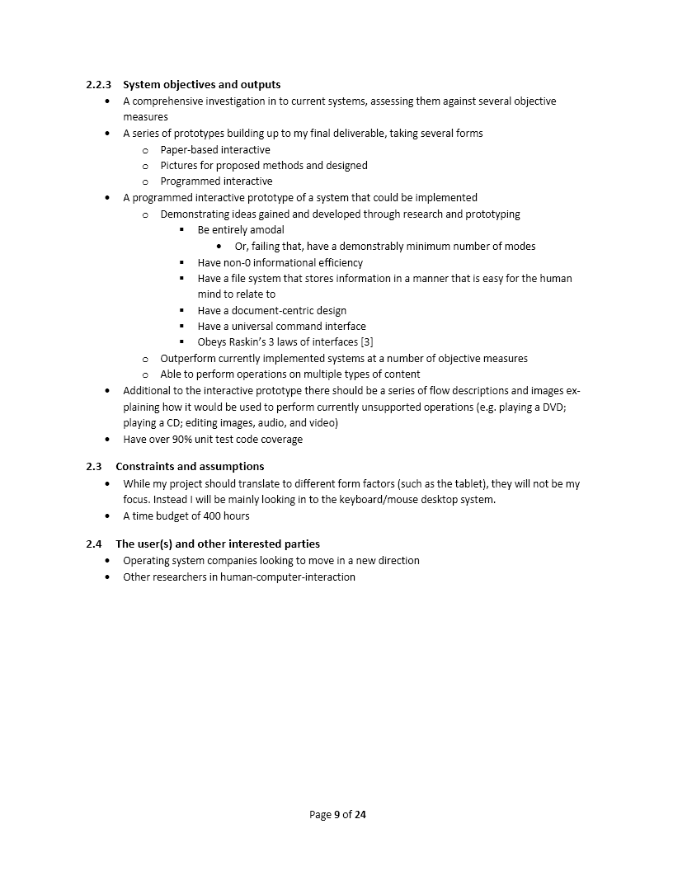

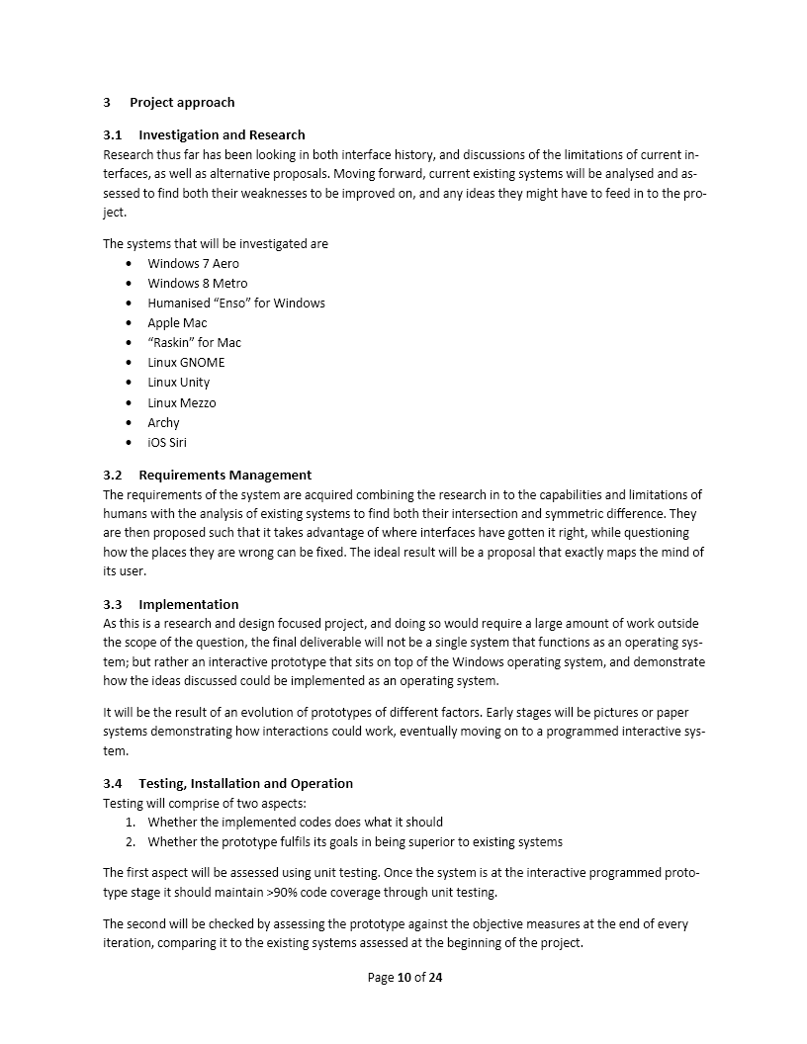

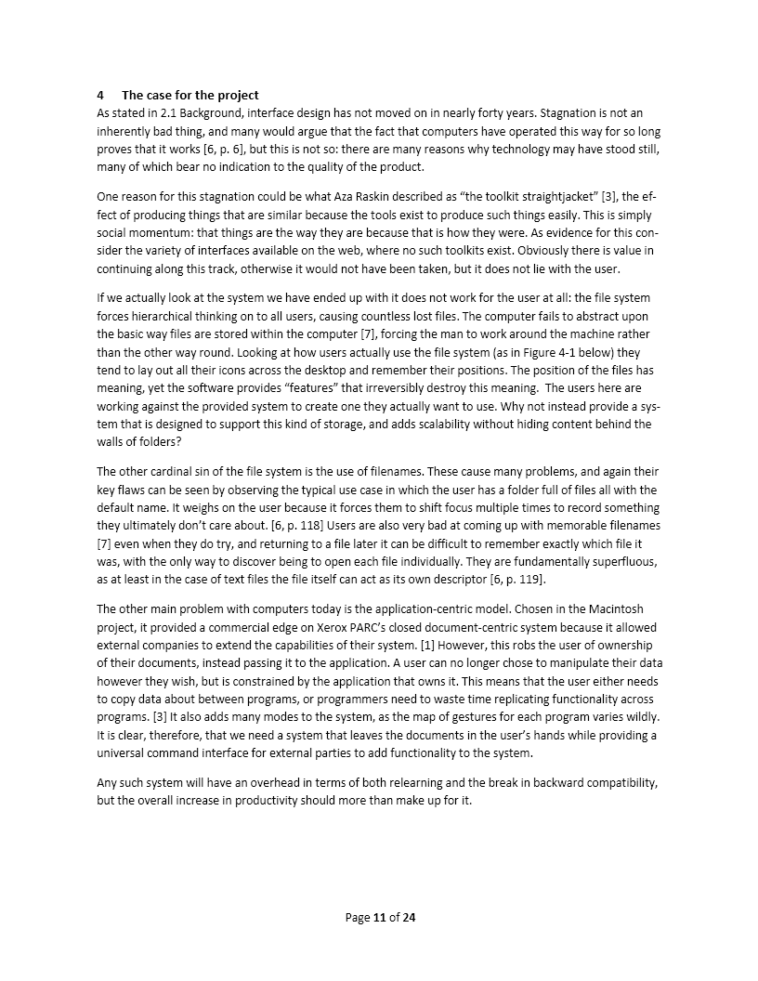

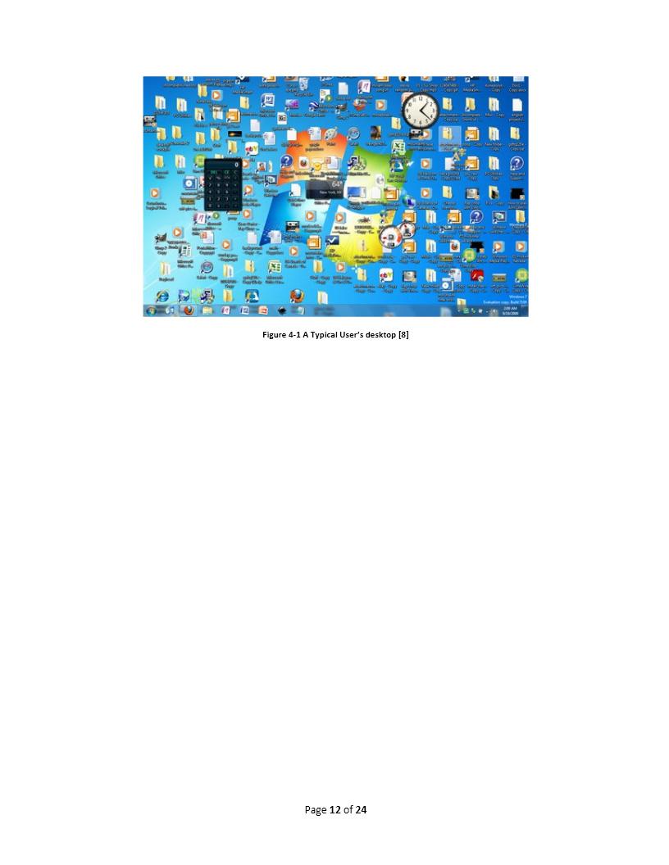

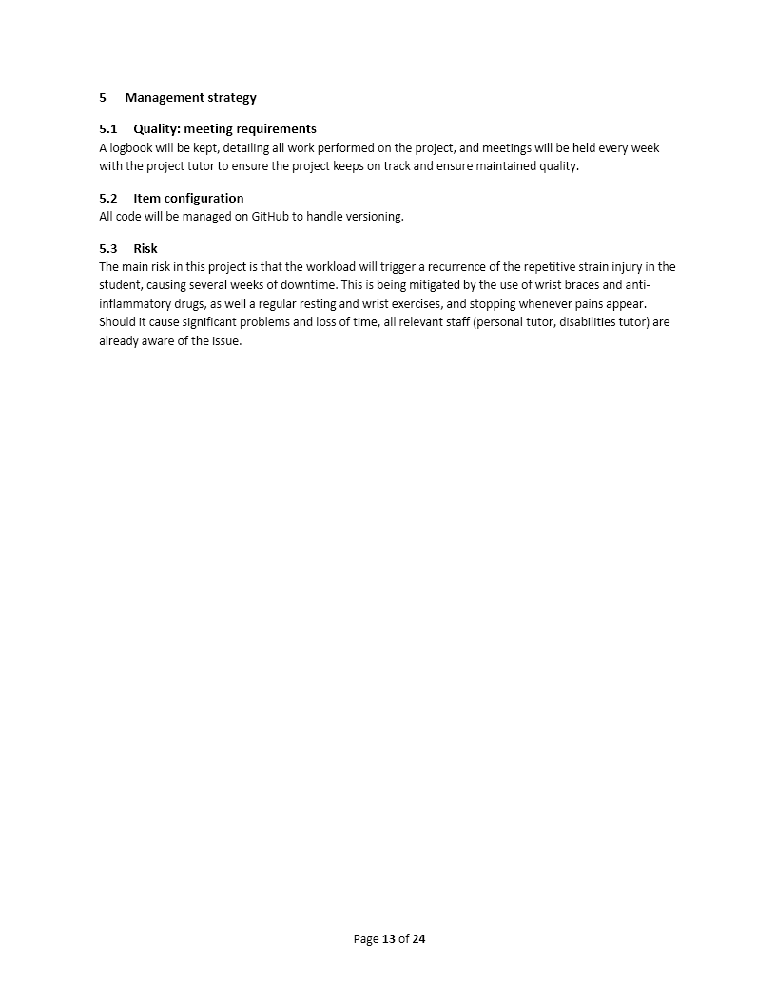

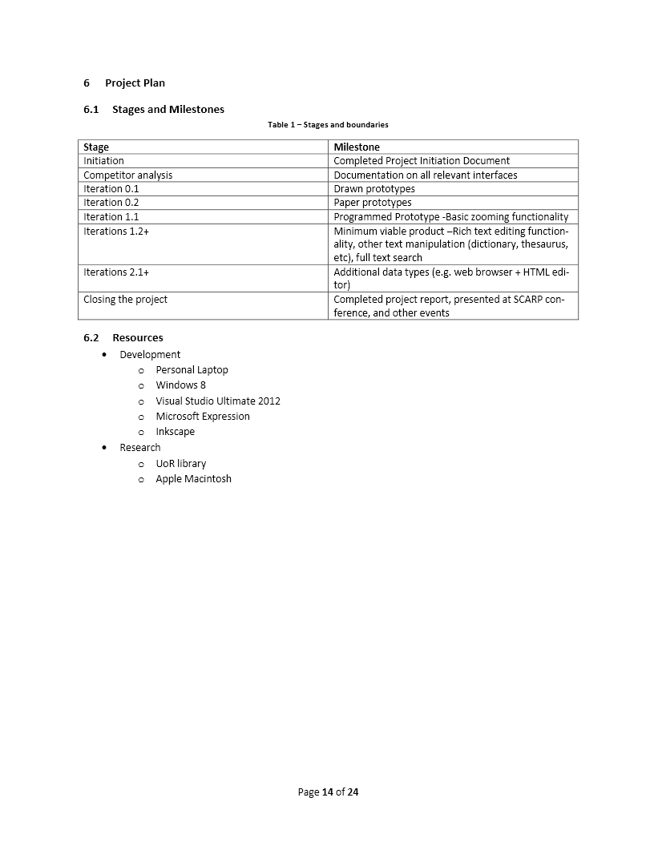

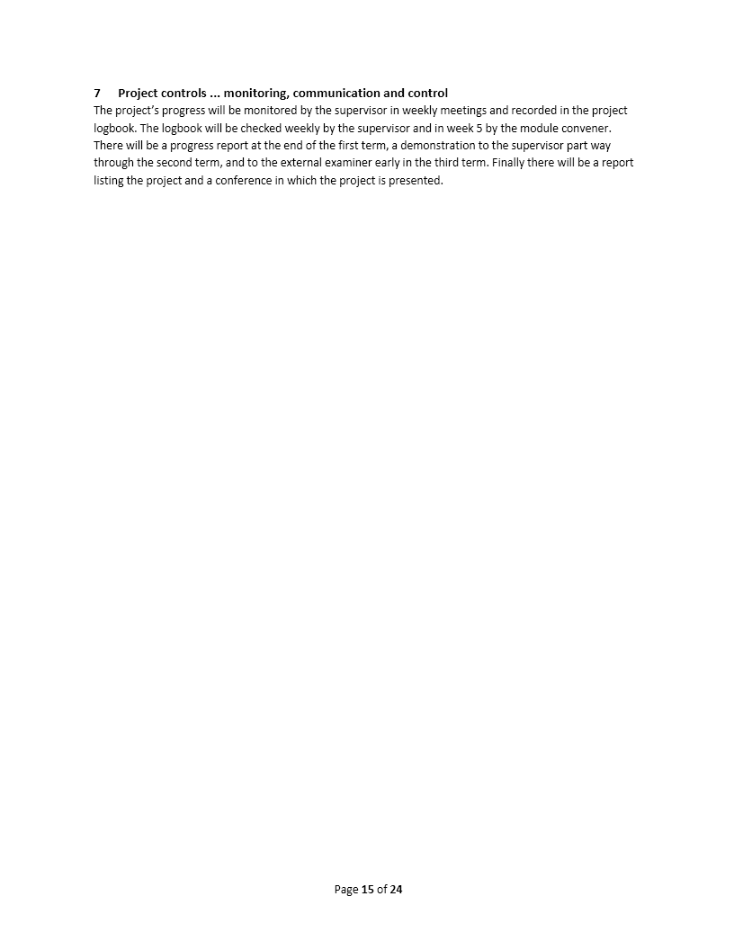

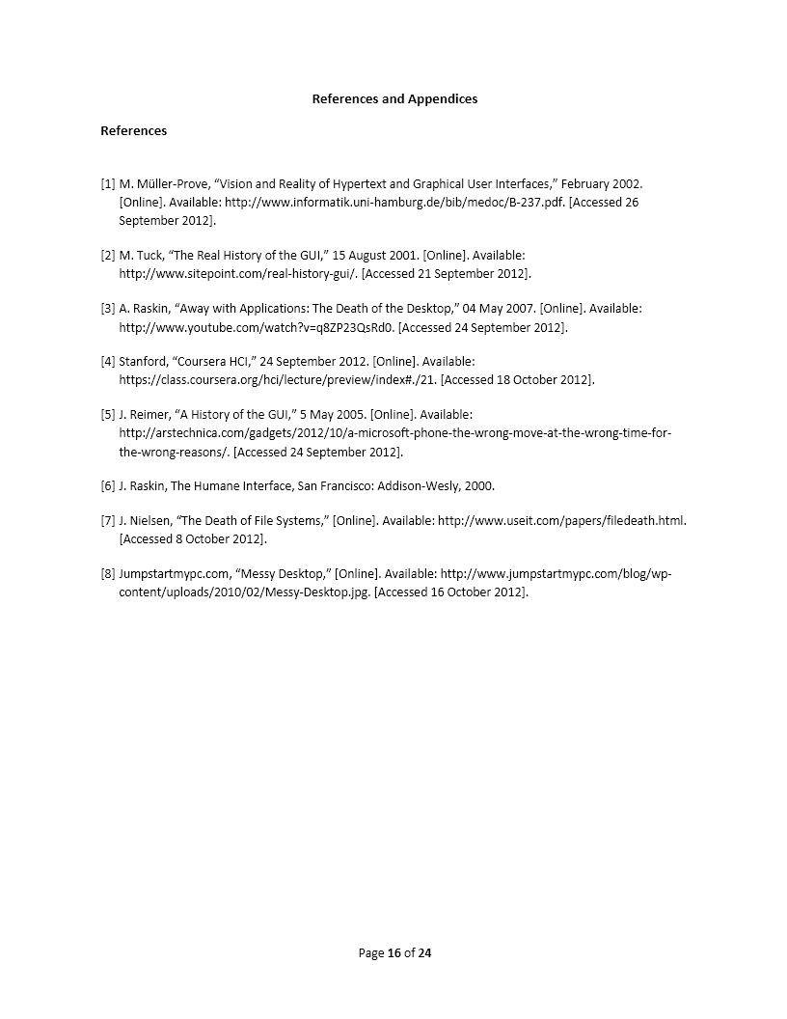





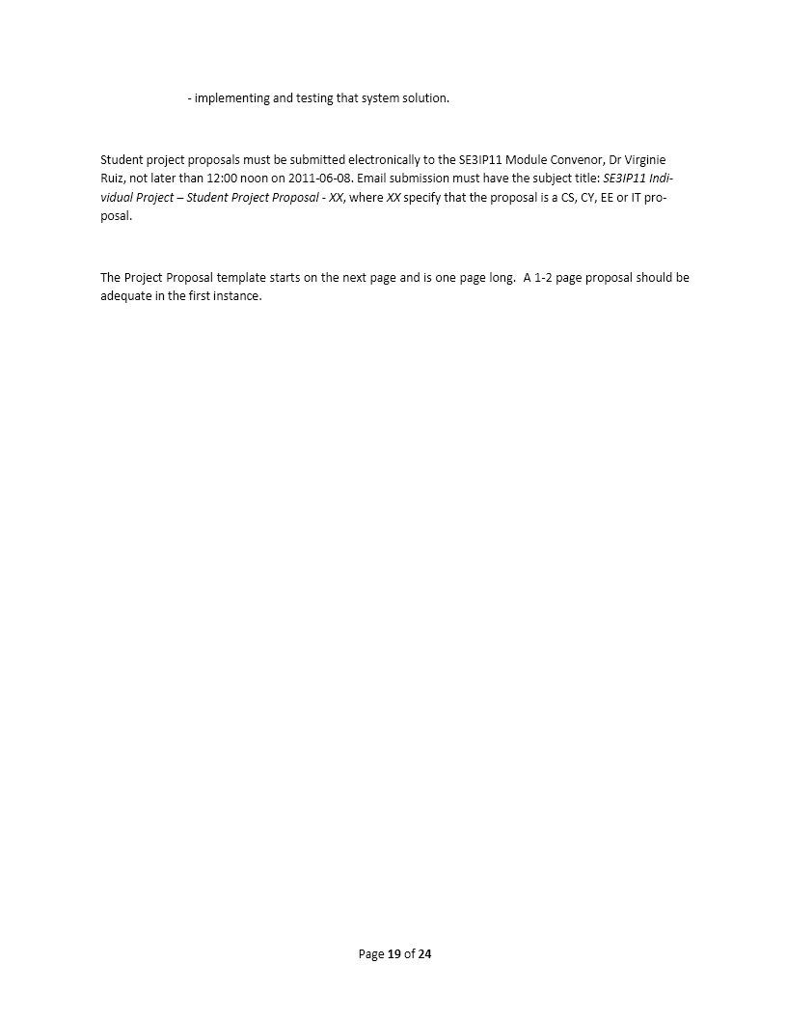

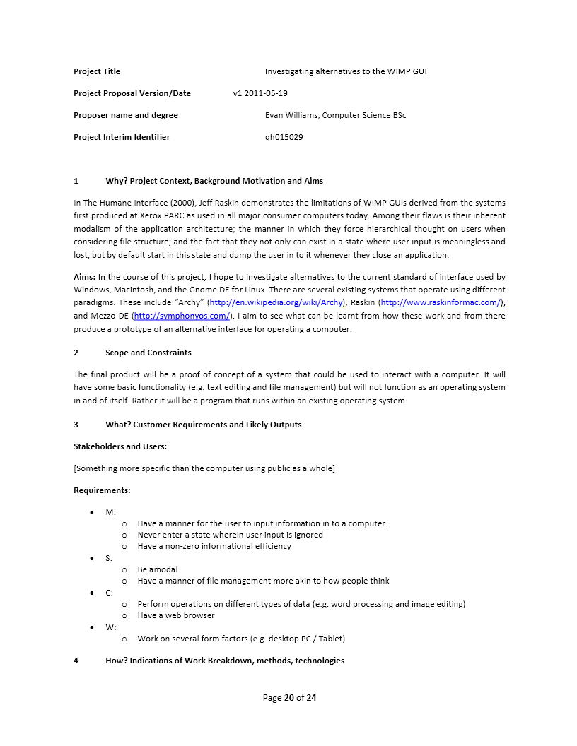

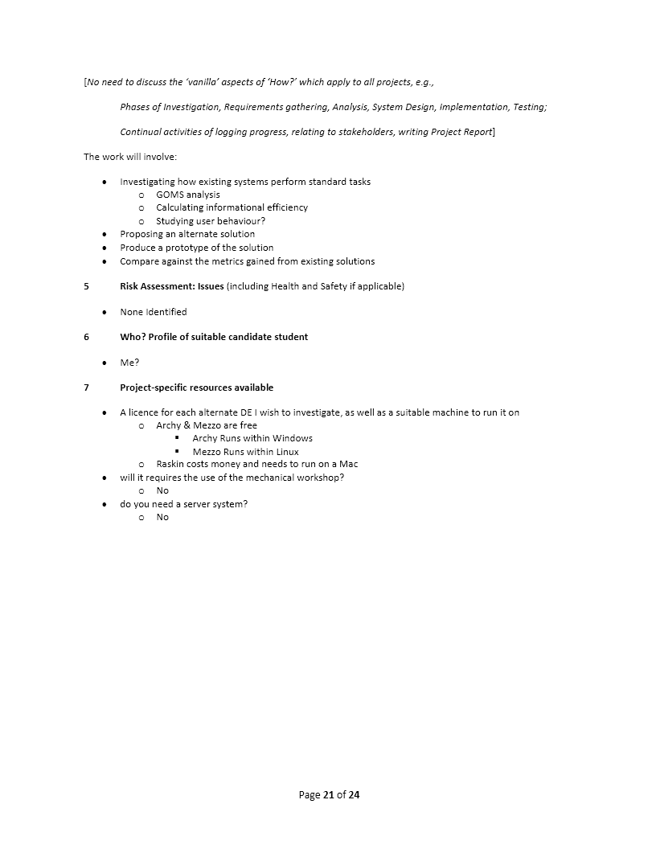

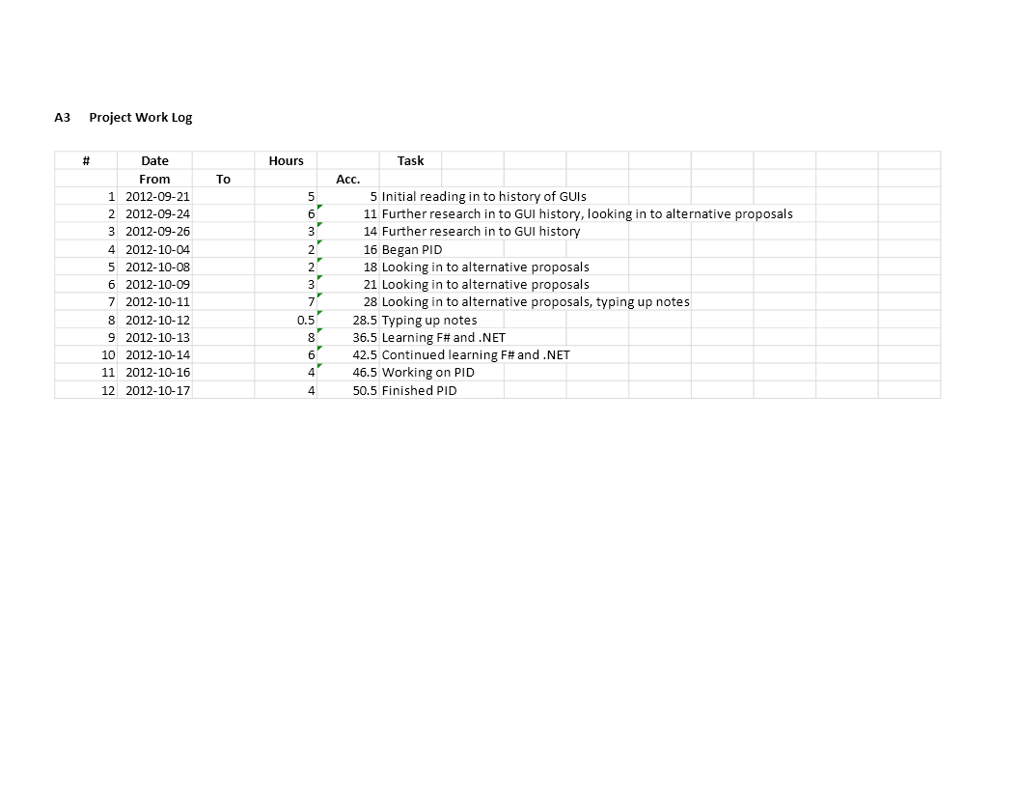

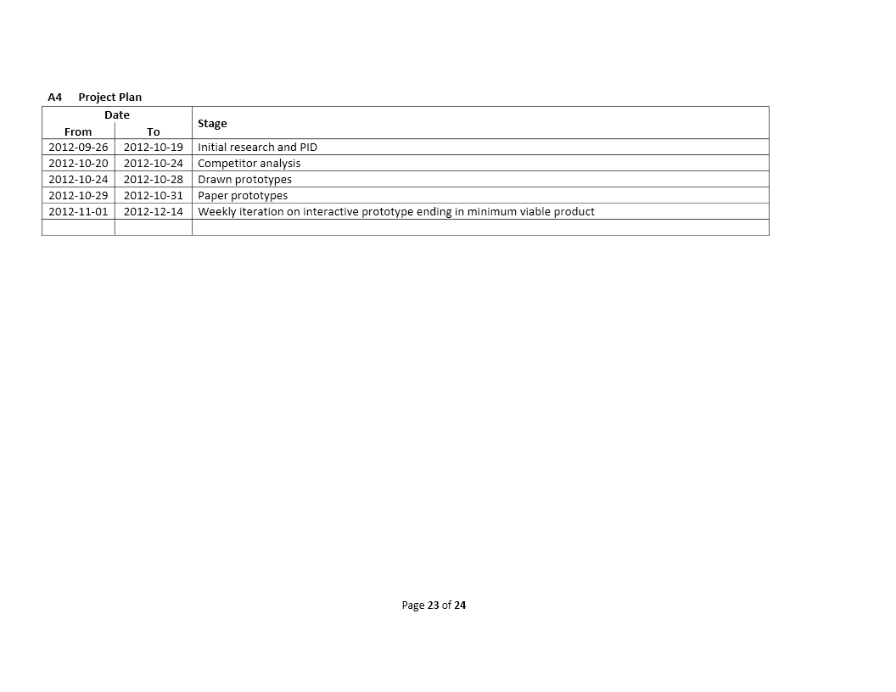

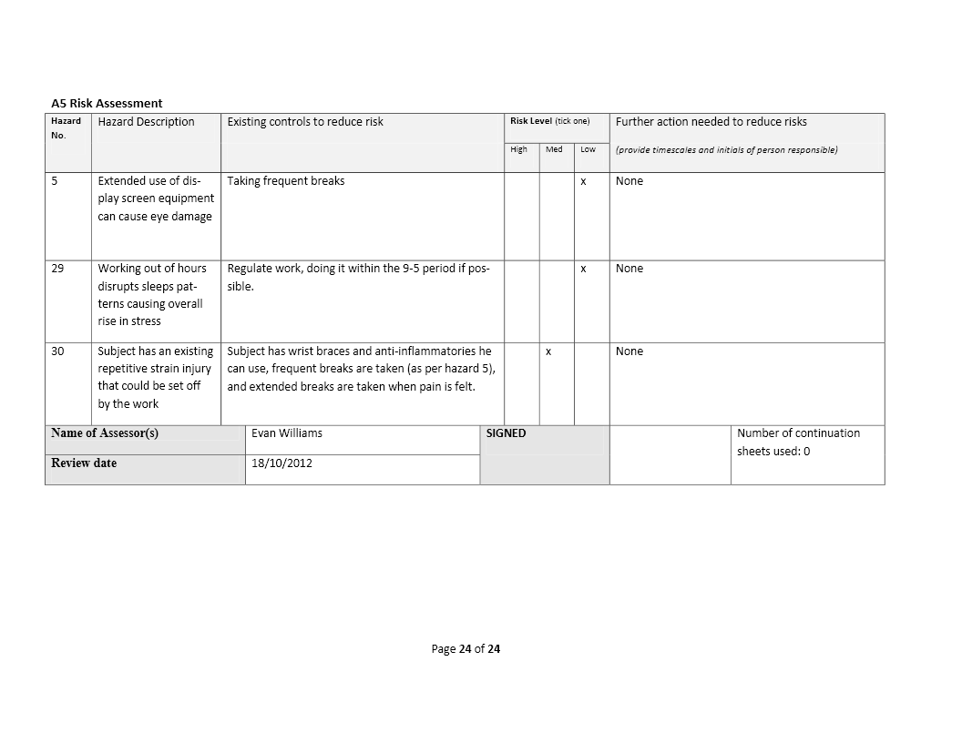

1. Additional Figures and Data Tables
   1. Figures

Figure B‑1 Catalogue of methods of launching applications in aero, likely options in italics

Figure B‑2 Finite State machine for procedural generation of documents

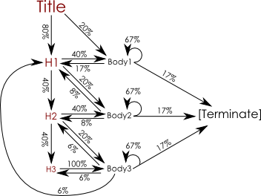

Figure B‑3 UML class diagram of the final product

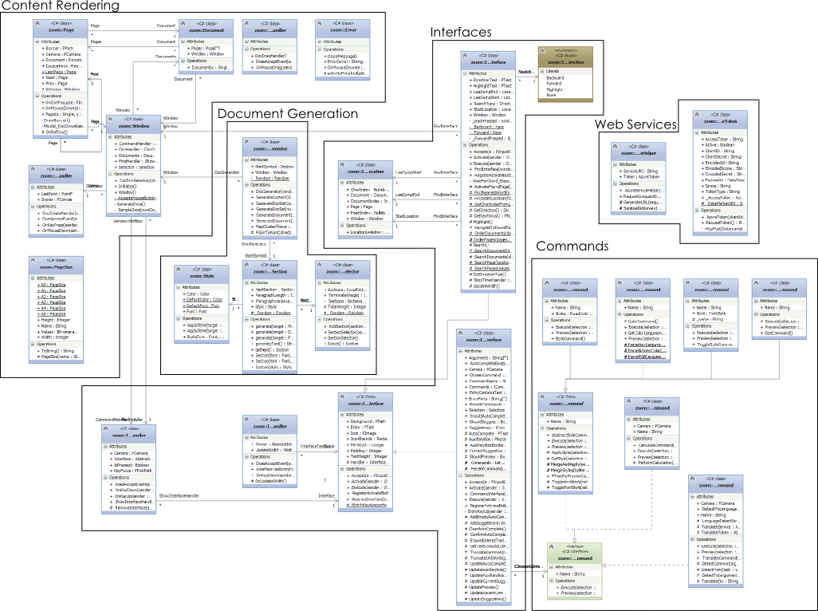

Figure B‑4 UML class diagram of the changes to PStyledText



* 1. Tables

Table B-1 Typical timings for GOMS analysis

|  |  |  |
| --- | --- | --- |
| Operator | Timing(ms) | Explanation |
| K | 0.2 | Time taken to tap a key on the keyboard or click the mouse |
| P | 1.1 | Time taken to point to a position on the display |
| H | 0.4 | Time taken to move between keyboard & mouse |
| M | 1.35 | Time it takes a user to prepare mentally for the next step |
| R | ??? | Time taken for a system to respond |

Table B-2 Properties of different methods of launching applications in Aero

|  |  |  |  |  |  |  |
| --- | --- | --- | --- | --- | --- | --- |
|  | **Desktop** | **Taskbar** | **Start Menu** | **"All Programs" Menu** | **Start then type** | **Run** |
| **Space** | Lots | Little | Little | Lots | Lots | Lots |
| **Visibility** | Almost always hidden | Always visible | Hidden until requested | Hidden behind 2 layers | Hidden until requested | Hidden until requested |
| **Click type** | Double | Single | Single | Single | n/a | n/a |
| **Icon position** | Persistent (Unless "arrange desktop icons" is used") | Persistent | Changes frequently | Persistent | Persistent/search (the same search will return the same results, in the same order | n/a |
| **Type of object** | Programs and files | Programs only | Programs only | Programs only | Programs and files | Programs and files |
| **Consistency** | Consistent | Consistent | Inconsistent - the space button sometimes selects, sometimes doesn't | Consistent | Consistent | Consistent |
| **Type of operation** | Browsing | Browsing | Browsing | Browsing | Navigating | Navigating |
| **Allows arguments** | Yes (If shortcut is defined with them) | No | No | No | No | Yes |

Table B-3 Word List from prototype 0.1

|  |  |  |  |  |  |
| --- | --- | --- | --- | --- | --- |
| Balaclava | Denmark | Beef | Pear | Happy | Cow |
| Cap | China | Lamb | Banana | Dog | Sheep |
| Boater | Turkey | Potato | Shortbread | Cat | Lion |
| Crown | Peru | Lettuce | Trifle | Mouse | Tiger |
| Fedora | Brazil | Tomato | Roulade | Rat | Elephant |
| Helmet | Dress | Carrot | Kayak | Hamster | Cow |
| Panama | Trousers | Tarragon | Madam | Guinea Pig | Sheep |
| Chile | Shirt | Basil | Noon | Gerbil | Lion |
| Argentina | Bacon | Apple | Radar | Horse | Tiger |

Table B-4 Timings from testing prototype 0.1

|  |  |  |  |  |  |  |  |  |  |  |
| --- | --- | --- | --- | --- | --- | --- | --- | --- | --- | --- |
|  |  | **Subject 1** | | | | **Subject 2** | | | |  |
|  | **Task** | **1** | **2** | **3** | **Average** | **1** | **2** | **3** | **Average** | **Average** |
| **Heirachy** | **Immediete** | 20 | 17 | 19 | 18.66667 | 18 | 18 | 19 | 18.33333 | 18.5 |
| **Other** | 64 | 20 | 18 | 34 | 62 | 25 | 30 | 39 | 36.5 |
| **Average** | 42 | 18.5 | 18.5 | 26.33333 | 40 | 21.5 | 24.5 | 28.66667 | 27.5 |
| **Spatial** | **Immediete** | 2 | 1 | 1 | 1.333333 | 2 | 2 | 1 | 1.666667 | 1.5 |
| **Other** | 2 | 4 | 2 | 2.666667 | 2 | 2 | 9 | 4.333333 | 3.5 |
| **Average** | 2 | 2.5 | 1.5 | 2 | 2 | 2 | 5 | 3 | 2.5 |

1. Source Code of Final Product
   1. Zoom.Commands

Zoom.Commands contains a set of classes used to execute commands fired by the command interface

* + 1. Zoom.Commands.ICommand

using System;

using System.Collections.Generic;

using System.Drawing;

using System.Linq;

using System.Text;

using System.Threading.Tasks;

using UMD.HCIL.Piccolo;

using UMD.HCIL.Piccolo.Nodes;

using UMD.HCIL.PiccoloX.Util.PStyledTextHelpers;

namespace zoom.Commands

{

/// <summary>

/// The ICommand interface provides the method signatures required for a command

/// </summary>

public interface ICommand

{

/// <summary>

/// The name of the command - the user needs to type this to execute the command

/// </summary>

string Name { get; }

/// <summary>

/// What to do when the user releases the command key

/// typically this will modify the text of the selection

/// </summary>

/// <param name="selection">The current selection, used as input, and modified for the output</param>

/// <param name="arguments">Anything added after the command name, used as input</param>

void Execute(Selection selection, string[] arguments);

/// <summary>

/// A preview of what will happen if the user releases the command key

/// </summary>

/// <param name="selection">The current selection, used as input</param>

/// <param name="arguments">Anything added after the command name, used as input</param>

/// <returns>A PText of what would happen to the selection, should the user release the key</returns>

PText Preview(Selection selection, string[] arguments);

}

}

* + 1. Zoom.Commands.CalculateCommand

using System;

using System.Collections.Generic;

using System.Linq;

using System.Text;

using System.Threading.Tasks;

using NCalc;

using UMD.HCIL.PiccoloX.Util.PStyledTextHelpers;

using UMD.HCIL.Piccolo;

using UMD.HCIL.Piccolo.Nodes;

using System.Drawing;

namespace zoom.Commands

{

/// <summary>

/// Parses the text of the selection, and attempts to execute it as a calculation

/// </summary>

class CalculateCommand : ICommand

{

/// <summary>

/// The name of the command - the user needs to type this to execute the command

/// </summary>

public string Name { get { return "calculate"; } }

/// <summary>

/// The PCamera object to attach errors to

/// </summary>

public PCamera Camera { get; protected set; }

/// <summary>

/// Create a new CalculateCommand with a given PCamera

/// </summary>

/// <param name="camera"></param>

public CalculateCommand(PCamera camera) { Camera = camera; }

/// <summary>

/// Replace the text of the selection with the answer to the calculation

/// </summary>

/// <param name="selection">The current selection, used as input, and modified for the output</param>

/// <param name="arguments">Anything added after the command name, used as input</param>

public void Execute(Selection selection, string[] arguments)

{

//Attempt to perform the calculation

try { selection.Text = PerformCalculation(selection.Text); }

//If it fails, raise an error to the user

catch { new Error(String.Format(@"Sum'{0}' is not formatted correctly", selection.Text), Camera); }

}

/// <summary>

/// Send the solution to the equation to the preview box

/// </summary>

/// <param name="selection">The current selection, used as input, and modified for the output</param>

/// <param name="arguments">Anything added after the command name, used as input</param>

/// <returns>The answer to the equation</returns>

public PText Preview(Selection selection, string[] arguments)

{

PText output = new PText();

//Format the text how it would appear

output.Font = selection.Font;

output.TextBrush = new SolidBrush(selection.Color);

//Attempt to perform the calcuation

try { output.Text = PerformCalculation(selection.Text); }

//If it fails, send an error to the preview box

catch { output.Text = String.Format(@"Sum'{0}' is not formatted correctly", selection.Text); }

return output;

}

/// <summary>

/// Parse a string and attempt to execute it as a calculation

/// </summary>

/// <remarks>If the calculation is poorly formed, it throws an exception</remarks>

/// <param name="text">The string to parse</param>

/// <returns>The result of the calculation</returns>

protected string PerformCalculation(string text)

{

text = text.Trim();

return new Expression(text).Evaluate().ToString();

}

}

}

* + 1. Zoom.Commands.TranslateCommand

using System;

using System.Collections.Generic;

using System.Linq;

using System.Text;

using System.Threading.Tasks;

using System.Net;

using Microsoft;

using System.Data.Services.Client;

using UMD.HCIL.Piccolo;

using System.Web;

using zoom.WebServiceHelpers;

using System.IO;

using UMD.HCIL.PiccoloX.Util.PStyledTextHelpers;

using UMD.HCIL.Piccolo.Nodes;

using System.Runtime.Serialization;

namespace zoom.Commands

{

/// <summary>

/// Translate the current text of the selection to another language

/// </summary>

class TranslateCommand : ICommand

{

/// <summary>

/// The name of the command - the user needs to type this to execute the command

/// </summary>

public string Name { get { return "translate"; } }

/// <summary>

/// The PCamera object to attach errors to

/// </summary>

public PCamera Camera { get; protected set; }

/// <summary>

/// The default language the text should be translated to, if none is specified

/// </summary>

public string DefaultToLanguage;

/// <summary>

/// The authorisation token for the Azure Bing translator service

/// </summary>

protected AzureToken TranslateToken;

/// <summary>

/// A hook for the Azure Bing translator service

/// </summary>

protected AzureServiceHelper TranslateService;

/// <summary>

/// A hook for the Azure Bing language detection service

/// </summary>

protected AzureServiceHelper LanguageDetectService;

/// <summary>

/// Create a new Translate command with a given default to language

/// </summary>

/// <param name="defaultToLanguage">The default language the command should be translated to</param>

public TranslateCommand(string defaultToLanguage, PCamera camera)

{

DefaultToLanguage = defaultToLanguage;

Camera = camera;

//Request a token from the Azure Bing Translate service

TranslateToken = new AzureToken(Resources.ClientSecrets.ClientID, Resources.ClientSecrets.ClientSecret, @"http://api.microsofttranslator.com");

//Create hooks for the translate and language detection services using the translate token for authorisation

TranslateService = new AzureServiceHelper(@"http://api.microsofttranslator.com/v2/Http.svc/Translate", TranslateToken);

LanguageDetectService = new AzureServiceHelper(@"http://api.microsofttranslator.com/v2/Http.svc/Detect", TranslateToken);

}

/// <summary>

/// Replace the text of the selection with the translated text

/// </summary>

/// <param name="selection">The current selection - the current text is sent to the translator and replaced with the translate text</param>

/// <param name="arguments">

/// The to and from languages are specified here -

/// it searches for the words "to" and "from" in the arguments array

/// and takes the value of the next item in the array for that language

/// </param>

public void Execute(Selection selection, string[] arguments)

{

//Detect which languages the translation is happening between

string to = DetectTo(arguments);

string from = DetectFrom(selection.Text, arguments);

//If it cannot detect a from language, throw an error

if (from == null) { new Error("No source language specified or detected", Camera); }

//Otherwise, translate the text

else { selection.Text = Translate(to, from, selection.Text); }

}

/// <summary>

/// Detect what langauge the text should be transated to

/// </summary>

/// <param name="arguments">The arguments provided to the command</param>

/// <returns>The language the text should be translated to</returns>

protected string DetectTo(string[] arguments)

{

//If the user specified a language in the arguments, get that

string detected = DetectCommon("to", arguments);

if (detected != null) { return detected; }

//Otherwise, translate to the default language

else { return DefaultToLanguage; }

}

/// <summary>

/// Detect what language the text should be translated from

/// </summary>

/// <param name="text">The text that needs to be translated</param>

/// <param name="arguments">The arguments provided to the command</param>

/// <returns>The language the text should be translated from</returns>

protected string DetectFrom(string text, string[] arguments)

{

//If the user specified a language in the arguments, get that

string detected = DetectCommon("from", arguments);

if (detected != null) { return detected; }

//Otherwise, detect the language using the Azure Bing Detection service

else

{

//Send a request to the service

Dictionary<string, string> args = new Dictionary<string, string>() { { "text", text } };

using (Stream stream = LanguageDetectService.Request(args))

{

//Read and return the service's response

DataContractSerializer dcs = new DataContractSerializer(Type.GetType("System.String"));

return (string)dcs.ReadObject(stream); ;

}

}

}

/// <summary>

/// The common logic for detecting languages in the arguments

/// </summary>

/// <param name="signal">The phrase to look out for in the arguments, eg "to", "from"</param>

/// <param name="arguments">The arguments sent to the command</param>

/// <returns>The language the user specified, or null if it isn't detected</returns>

protected string DetectCommon(string signal, string[] arguments)

{

//Check all of the arguments

for (int i = 0; i < arguments.Length; i += 1)

{

//If one of them matches the signal, and there's an argument after it, return that

if (signal == arguments[i] && i < arguments.Length - 1) { return arguments[i + 1]; }

}

//If nothing was detected return null

return null;

}

/// <summary>

/// Translate text between two languages using the Azure Bing Translate API

/// </summary>

/// <param name="to">The language to translate to</param>

/// <param name="from">The language to translate from</param>

/// <param name="text">The text to translate</param>

/// <returns>The translated text</returns>

protected string Translate(string to, string from, string text)

{

//Pack the arguments into a dictionary for use in the web service call

Dictionary<string, string> args = new Dictionary<string, string>()

{

{ "to", to },

{ "from", from },

{ "text", text }

};

//Send a request to the Translate service

using (Stream stream = TranslateService.Request(args))

{

//Read the result from the Translate service

DataContractSerializer dcs = new DataContractSerializer(Type.GetType("System.String"));

return (string)dcs.ReadObject(stream);

}

}

/// <summary>

/// Due to restriction in how frequently the web service can be called, preview is not enabled for the translate command

/// </summary>

/// <param name="selection"></param>

/// <param name="arguments"></param>

/// <returns></returns>

public UMD.HCIL.Piccolo.Nodes.PText Preview(Selection selection, string[] arguments)

{

return new PText();

}

}

}

* + 1. Zoom.Commands.AbstractStyleCommand

using System;

using System.Collections.Generic;

using System.Drawing;

using System.Linq;

using System.Text;

using System.Threading.Tasks;

using UMD.HCIL.Piccolo;

using UMD.HCIL.Piccolo.Nodes;

using UMD.HCIL.PiccoloX.Util.PStyledTextHelpers;

namespace zoom.Commands

{

/// <summary>

/// AbstractStyleCommand provides a set of hooks for manipulating the style of selected text

/// </summary>

public abstract class AbstractStyleCommand : ICommand

{

/// <summary>

/// The name of the command - the user needs to type this to execute the command

/// </summary>

public abstract string Name { get; }

/// <summary>

/// What to do when the user releases the command key

/// typically this will modify the text of the selection

/// </summary>

/// <param name="selection">The current selection, used as input, and modified for the output</param>

/// <param name="arguments">Anything added after the command name, used as input</param>

public abstract void Execute(Selection selection, string[] arguments);

/// <summary>

/// A preview of what will happen if the user releases the command key

/// </summary>

/// <param name="selection">The current selection, used as input</param>

/// <param name="arguments">Anything added after the command name, used as input</param>

/// <returns>A PText of what would happen to the selection, should the user release the key</returns>

public abstract PText Preview(Selection selection, string[] arguments);

/// <summary>

/// Gets the style of a given selection

/// </summary>

/// <param name="selection">The selection to get the style of</param>

/// <returns>The style of the given selection</returns>

protected Style GetStyle(Selection selection) { return new Style(selection.Font, selection.Color); }

/// <summary>

/// Creates a new style that matches the style of a selection, with a given FontStyle toggled

/// </summary>

/// <param name="selection">The selection to get the style from</param>

/// <param name="style">The FontStyle to toggle</param>

/// <returns>A new Style with the FontStyle toggled</returns>

protected Style ToggleFontStyle(Selection selection, FontStyle style)

{

//This cannot work on a null selection

if (selection != null)

{

//Get the current FontStyle of the selection

FontStyle curStyle = selection.Font.Style;

//If the specified style is active, deactivate it

if (curStyle.HasFlag(style)) { curStyle &= ~style; }

//If the specified style is inactive, activate it

else { curStyle |= style; }

//Merge the new FontStyle with the Selection's Style and return it

return MergeStyles(GetStyle(selection), style: curStyle, overwriteFontStyle: true);

}

return null;

}

/// <summary>

/// Adjust a given Style with other properties.

/// Any property left unspecified uses the value from the source Style

/// </summary>

/// <param name="toMerge">The source Style</param>

/// <param name="size">The size of the new style</param>

/// <param name="color">The color of the new style</param>

/// <param name="style">the FontStyle of the new style</param>

/// <param name="overwriteFontStyle">

/// If true - the new FontStyle should replace the source one.

/// If false - the new FontStyle should be or-ed with the source one

/// </param>

/// <param name="family">The font family of the new Style</param>

/// <returns>The new, merged style</returns>

protected Style MergeStyles(Style toMerge, float? size = null, Color? color = null, FontStyle? style = null, bool overwriteFontStyle = false, FontFamily family = null)

{

//Merge sizes

float newSize = toMerge.Font.Size;

if (size != null) { newSize = (float)size; }

//Merge FontStyles

FontStyle newStyle = toMerge.Font.Style;

if (style != null)

{

if (overwriteFontStyle) { newStyle = (FontStyle)style; }

else { newStyle |= (FontStyle)style; }

}

//Merge Colors

Color newColor = toMerge.Color;

if (color != null) { newColor = (Color)color; }

//Merge Families

FontFamily newFamily = toMerge.Font.FontFamily;

if (family != null) { newFamily = family; }

//Output the new Style

Font outFont = new Font(newFamily, newSize, newStyle);

return new Style(outFont, newColor);

}

/// <summary>

/// Replaces the style of a given selection with a specified style

/// </summary>

/// <param name="selection">The selection to change</param>

/// <param name="style">The style to change to</param>

protected void ApplyStyle(Selection selection, Style style)

{

//This only works if the selection exists

if (selection != null)

{

selection.Font = style.Font;

selection.Color = style.Color;

}

}

/// <summary>

/// Change some aspects of the style of the given selection

/// any fields left blank are left as it currently is

/// </summary>

/// <param name="selection">The selection to modify</param>

/// <param name="size">The new size of the selection text</param>

/// <param name="color">The new color of the selection text</param>

/// <param name="style">The new FontStyle of the selection text</param>

/// <param name="overwriteFontStyle">

/// If true - the new FontStyle should replace the source one.

/// If false - the new FontStyle should be or-ed with the source one

/// </param>

/// <param name="family">The new Font Family of the selection text</param>

protected void MergeAndApply(Selection selection, float? size = null, Color? color = null, FontStyle? style = null, bool overwriteFontStyle = false, FontFamily family = null)

{

ApplyStyle(selection, MergeStyles(GetStyle(selection), size, color, style, overwriteFontStyle, family));

}

/// <summary>

/// Toggle a FontStyle of the specified selection

/// </summary>

/// <param name="selection">The selection to modify</param>

/// <param name="style">The FontStyle to toggle</param>

protected void ToggleAndApply(Selection selection, FontStyle style) { ApplyStyle(selection, ToggleFontStyle(selection, style)); }

/// <summary>

/// Produce a PText containing the text of the current selection in a particular style

/// </summary>

/// <param name="style">The Style the text should be in</param>

/// <param name="selection">The selection to get the text from</param>

/// <returns>A PText containing the text of the selection in the specified style</returns>

protected PText PTextForPreview(Style style, Selection selection)

{

PText output = new PText(selection.Text);

output.Font = style.Font;

output.TextBrush = new SolidBrush(style.Color);

return output;

}

}

}

* + 1. Zoom.Commands.ColorCommand

using System;

using System.Collections.Generic;

using System.Linq;

using System.Text;

using System.Threading.Tasks;

using System.Drawing;

using UMD.HCIL.PiccoloX.Util.PStyledTextHelpers;

using UMD.HCIL.Piccolo.Nodes;

using System.Globalization;

namespace zoom.Commands

{

/// <summary>

/// ColorCommand changes the color of selected text

/// </summary>

class ColorCommand : AbstractStyleCommand

{

/// <summary>

/// The name of the command - the user needs to type this to execute the command

/// </summary>

public override string Name { get { return "color"; } }

/// <summary>

/// Replace the current selection's text color with the color specified in the argument

/// </summary>

/// <param name="selection">The selection to modify</param>

/// <param name="argument">The argument provided to the command</param>

public override void Execute(Selection selection, string[] arguments)

{

//Detect which color the user wanted

Color? color = GetColor(arguments);

//If there was a valid color and a valid selection, apply the color to the selection

if (color != null && selection != null) { MergeAndApply(selection, color: color); }

}

/// <summary>

/// Preview what the text would look like with the specified color

/// </summary>

/// <param name="selection">The selection to modify</param>

/// <param name="argument">The argument provided to the command</param>

/// <returns>A PText showing what the selection would look like if executed</returns>

public override PText Preview(Selection selection, string[] arguments)

{

//If nothing is selected, this cannot run

if (selection == null) { return new PText("Error: Text must be selected for this command to work"); }

//Attempt to get the color the user specified

Color? color = GetColor(arguments);

if (color == null) { return new PText(String.Format(@"Error: {0} is not a valid color", String.Join(" ", arguments))); }

//If the color did exist, create a new PText that matches the current selection with the new color

Style newStyle = MergeStyles(GetStyle(selection), color: GetColor(arguments));

return PTextForPreview(newStyle, selection);

}

/// <summary>

/// Detect what Color the user specified, in Hex, RGB, or named colors

/// </summary>

/// <param name="argument">The argument provided to the command</param>

/// <returns>The detected Color, null if no Color is detected</returns>

public Color? GetColor(string[] arguments)

{

//If the user supplied one argument then it's either a Hex code or a named color

if (arguments.Length == 1 && arguments[0].Length > 0)

{

// If it looks like a hex code, try to parse it as one

if (arguments[0][0].Equals('#') && arguments[0].Length == 7) { return ParseHex(arguments[0]); }

// Otherwise try to parse it as a name

else { return ParseNamedColor(arguments[0]); }

}

//If the user supplied three argument, then treat them as RGB values

else if (arguments.Length == 3) { return ParseRGB(arguments); }

//If it wasn't a recognised format, exit

return null;

}

/// <summary>

/// Attempt to parse the argument as a hex code

/// </summary>

/// <param name="argument">The hex code to try to parse</param>

/// <returns>A Color object represented by the specifed hex code, null if it was invalid</returns>

protected static Color? ParseHex(string argument)

{

int red = 0;

int green = 0;

int blue = 0;

CultureInfo culture = new CultureInfo("en-GB");

//Check that it matches what we expect from a hex code

bool isHexCode = argument.Length == 7

&& int.TryParse(argument.Substring(1, 2), NumberStyles.HexNumber, culture, out red)

&& int.TryParse(argument.Substring(3, 2), NumberStyles.HexNumber, culture, out green)

&& int.TryParse(argument.Substring(5, 2), NumberStyles.HexNumber, culture, out blue);

//Return it as a Color if it does

if (isHexCode) { return Color.FromArgb(red, green, blue); }

// If it doesn't actually look like a hex code, exit

else { return null; }

}

/// <summary>

/// Attempt to parse the argument as a named Color

/// </summary>

/// <param name="argument">The name of the color to parse</param>

/// <returns>The color specified by the name</returns>

protected static Color? ParseNamedColor(string argument)

{

//Ensure that the first letter is capitalised, and all others are lower case

string enteredName = char.ToUpper(argument[0]) + argument.Substring(1).ToLower();

KnownColor colorName;

//If it is actually a name, return that color

if (Enum.TryParse<KnownColor>(enteredName, out colorName)) { return Color.FromKnownColor(colorName); }

//Otherwise, exit

else { return null; }

}

/// <summary>

/// Attempt to parse the arguments as RGB values

/// </summary>

/// <param name="arguments">the arguments supplied to the command</param>

/// <returns>The color described by the RGB values</returns>

protected static Color? ParseRGB(string[] arguments)

{

int red = 0;

int green = 0;

int blue = 0;

//Check that it does match what we expect from RGB values

bool isRGB = int.TryParse(arguments[0], out red) && red >= 0 && red < 256

&& int.TryParse(arguments[1], out green) && green >= 0 && green < 256

&& int.TryParse(arguments[2], out blue) && blue >= 0 && blue < 256;

//If it was RGB values, return that color

if (isRGB) { return Color.FromArgb(red, green, blue); }

//Otherwise, exit

else { return null; }

}

}

}

* + 1. Zoom.Commands.SizeCommand

using System;

using System.Collections.Generic;

using System.Linq;

using System.Text;

using System.Threading.Tasks;

using System.Drawing;

using UMD.HCIL.PiccoloX.Util.PStyledTextHelpers;

using UMD.HCIL.Piccolo.Nodes;

namespace zoom.Commands

{

/// <summary>

/// Changes the size of the selected text

/// </summary>

class SizeCommand : AbstractStyleCommand

{

/// <summary>

/// The name of the command - the user needs to type this to execute the command

/// </summary>

public override string Name { get { return "size"; } }

/// <summary>

/// Change the size of the selected text to the one specified in the arguments

/// </summary>

/// <param name="selection">The current selection</param>

/// <param name="arguments">The arguments passed to the command</param>

public override void Execute(Selection selection, string[] arguments)

{

int size;

//If there is a valid selection, and the first argument is an integer

if (selection != null && arguments.Length > 0 && int.TryParse(arguments[0], out size))

{

//Change the size to the number specified in the first argument

MergeAndApply(selection, size: size);

}

}

/// <summary>

/// Preview what the text will look like with the new size

/// </summary>

/// <param name="selection">The current selection</param>

/// <param name="arguments">The arguments passed to the command</param>

/// <returns>A PText showing the selected text in the new size</returns>

public override PText Preview(Selection selection, string[] arguments)

{

int size;

//If there is no selection, abort

if (selection == null) { return new PText("Error: Text must be selected for this command to work"); }

//If there are no arguments, abort

if (arguments.Length == 0) { return new PText("Please enter a size for the text"); }

//If the first argument isn't an integer, abort

if (!int.TryParse(arguments[0], out size)) { return new PText(String.Format("Error: {0} is not a valid size", arguments[0])); }

//Change the style of the text to have the new size

Style newStyle = MergeStyles(GetStyle(selection), size: size);

return PTextForPreview(newStyle, selection);

}

}

}

* + 1. Zoom.Commands.StyleCommand

using System;

using System.Collections.Generic;

using System.Collections.ObjectModel;

using System.Linq;

using System.Text;

using System.Threading.Tasks;

using System.Drawing;

using UMD.HCIL.Piccolo.Nodes;

using UMD.HCIL.PiccoloX.Util.PStyledTextHelpers;

namespace zoom.Commands

{

/// <summary>

/// Change the style of the text to a pre-specified, named style

/// </summary>

class StyleCommand : AbstractStyleCommand

{

/// <summary>

/// The list of styles and their names

/// </summary>

public static readonly ReadOnlyDictionary<string, Style> Styles =

new ReadOnlyDictionary<string, Style>(

new Dictionary<string, Style>()

{

{"title", new Style(new Font("Century Gothic", 22), Color.FromArgb(128, 0, 0))},

{"h1", new Style(new Font("Century Gothic", 16), Color.FromArgb(128, 0, 0))},

{"h2", new Style(new Font("Century Gothic", 13), Color.FromArgb(128, 0, 0))},

{"h3", new Style(new Font("Century Gothic", 11, FontStyle.Bold), Color.FromArgb(128, 0, 0))},

{"normal", new Style(new Font("Century Gothic", 11), Color.FromArgb(0, 0, 0))}

});

/// <summary>

/// The name of the command - the user needs to type this to execute the command

/// </summary>

public override string Name { get { return "style"; } }

/// <summary>

/// Replace the style of the current text with the one the user specified

/// </summary>

/// <param name="selection">The current selection</param>

/// <param name="arguments">The arguments provided to the command</param>

public override void Execute(UMD.HCIL.PiccoloX.Util.PStyledTextHelpers.Selection selection, string[] arguments)

{

//If the selection exists, and the first argument is a style

if (selection != null && arguments.Length > 0 && Styles.ContainsKey(arguments[0]))

{

//Apply that style to the text

ApplyStyle(selection, Styles[arguments[0]]);

}

}

/// <summary>

/// Show what the selected text would look like with the specified style

/// </summary>

/// <param name="selection">The current selection</param>

/// <param name="arguments">The arguments provided to the command</param>

/// <returns>A PText containing the selection text, styled in the specified manner</returns>

public override PText Preview(Selection selection, string[] arguments)

{

string styleName = arguments[0];

//If the selection doesn't exist, abort

if (selection == null) { return new PText("Error: Text must be selected for this command to work"); }

//If no arguments were provided, abort

if (arguments.Length == 0) { return new PText("Please specify a style"); }

//If the style specified doesn't exist, abort

if (!Styles.ContainsKey(styleName)) { return new PText(String.Format(@"Error: {0} is not a valid style", styleName)); }

//Create and return a PText with the specified style

return PTextForPreview(Styles[styleName], selection);

}

}

}

* + 1. Zoom.Commands.ToggleStyleCommand

using System;

using System.Collections.Generic;

using System.Linq;

using System.Text;

using System.Threading.Tasks;

using System.Drawing;

using UMD.HCIL.Piccolo;

using UMD.HCIL.PiccoloX.Util.PStyledTextHelpers;

using UMD.HCIL.Piccolo.Nodes;

namespace zoom.Commands

{

/// <summary>

/// Toggles the value of a specified FontStyle in the font of the selected text

/// </summary>

public class ToggleStyleCommand : AbstractStyleCommand

{

/// <summary>

/// The name of the command - the user needs to type this to execute the command

/// </summary>

public override string Name

{

get { return _name; }

}

/// <summary>

/// The name of the command - the user needs to type this to execute the command

/// </summary>

protected readonly string _name;

/// <summary>

/// The FontStyle that this instance of ToggleStyleCommand will toggle

/// </summary>

public readonly FontStyle Style;

/// <summary>

/// Create a new ToggleStyleCommand with specified name and style

/// </summary>

/// <param name="name">The name of the command - the user needs to type this to execute the command</param>

/// <param name="style">The FontStyle that this instance of ToggleStyleCommand will toggle</param>

public ToggleStyleCommand(string name, FontStyle style)

{

_name = name;

Style = style;

}

/// <summary>

/// Toggle the value of a FontStyle in the selected text

/// </summary>

/// <param name="selection">The current selection</param>

/// <param name="arguments">The arguments provided to the command</param>

public override void Execute(Selection selection, string[] arguments) { ToggleAndApply(selection, Style); }

/// <summary>

/// Creates a PText showing what the selected text would look like with the relevant FontStyle toggled

/// </summary>

/// <param name="selection">The current selection</param>

/// <param name="arguments">The arguments provided to the command</param>

/// <returns>A PText showing what the text would look like with the relevant FontStyle toggled</returns>

public override PText Preview(Selection selection, string[] arguments)

{

//This only makes sense if there's a selection

if (selection == null) { return new PText("Error: Text must be selected for this command to work"); }

//Create a new PText with the relevant FontStyle toggled

Style newStyle = ToggleFontStyle(selection, Style);

return PTextForPreview(newStyle, selection);

}

}

}

* 1. Zoom.Generator

Zoom.Generator contains a set of classes used to randomly create documents for sample data

* + 1. Zoom.Generator.DocGenerator

using System;

using System.Collections.Generic;

using System.Drawing;

using System.Linq;

using System.Text;

using System.Threading.Tasks;

using UMD.HCIL.Piccolo;

using MathNet.Numerics.Distributions;

using MathNet.Numerics;

namespace zoom.Generator

{

/// <summary>

/// Generates random documents as sample data for the system using a finite state machine

/// </summary>

public class DocGenerator

{

/// <summary>

/// What symbol to startSymbol generation on

/// </summary>

public Section StartSymbol { get; protected set; }

/// <summary>

/// The Window object generated documents should be attached to

/// </summary>

public Window Window { get; protected set; }

/// <summary>

/// The random number generator used to randomise paths through the state machine

/// </summary>

private static Random _Random = new Random();

/// <summary>

/// Create a new DocGenerator with given start symbol and target window

/// </summary>

/// <param name="startSymbol">The symbol to start generation on</param>

/// <param name="window">The window to attach the documents to</param>

public DocGenerator(Section startSymbol, Window window)

{

StartSymbol = startSymbol;

Window = window;

}

/// <summary>

/// Generate an arbitrary number of documents

/// </summary>

/// <param name="numDocs">The number of documents to create</param>

/// <returns>The set of created documents</returns>

public Document[] GenerateDocSet(int numDocs)

{

//Get random locations for each document to be generated on

PointF[] coords = MapCluster(new Point(0, 0), 1000, 100, numDocs);

return GenerateDocSet(coords);

}

/// <summary>

/// Generate a set of documents on given coordinates

/// </summary>

/// <param name="coords">The coordinates of the top-left corner of each document</param>

/// <returns>The set of created documents</returns>

public Document[] GenerateDocSet(PointF[] coords)

{

List<Document> output = new List<Document>();

for (int i = 0; i < coords.Length; i += 1) { output.Add(GenerateDocument(coords[i])); }

return output.ToArray();

}

/// <summary>

/// Creates a cluster of points randomly, but evenly distributed around a focus

/// </summary>

/// <param name="focus">The focus the generated points should be distributed around</param>

/// <param name="lengthMean">The mean distance a generated point should be from the focus</param>

/// <param name="lengthDev">The standard deviation of the distance a generated point should be from the focus</param>

/// <param name="numPoints">The number of points to generate</param>

/// <returns>The set of generated Points</returns>

public PointF[] MapCluster(Point focus, double lengthMean, double lengthDev, int numPoints)

{

List<PointF> output = new List<PointF>();

//To distribute the points evenly, each should fall in a region angular size 2Pi/#points

double piRadsPerNode = 2.0 / numPoints;

for (int i = 0; i < numPoints; i += 1)

{

//Generate the new point in Polar coordinates

double direction = Normal.Sample(piRadsPerNode * i, piRadsPerNode / 3);

double magnitude = Normal.Sample(lengthMean, lengthDev);

//Convert the coordinates to a cartesean point

output.Add(PolarToPoint(direction * Math.PI, magnitude));

}

return output.ToArray();

}

/// <summary>

/// Convert Polar coordianates to a cartesean point

/// </summary>

/// <param name="direction">The direction the point is in</param>

/// <param name="magnitude">The distance from the origin of the point</param>

/// <returns>The point in polar coordinates</returns>

protected PointF PolarToPoint(double direction, double magnitude)

{

//C#'s only way of dealing with polar coordinates is as a complex number

//So we're going to create a new complex number, and read off its components

Complex32 comp = Complex32.FromPolarCoordinates((float)magnitude, (float)direction);

return new PointF(comp.Real, comp.Imaginary);

}

/// <summary>

/// Generate a document at a given location

/// </summary>

/// <param name="coords">The top-left corner of the new document</param>

/// <returns>The generated document</returns>

public Document GenerateDocument(PointF coords) { return GenerateDocument(coords.X, coords.Y); }

/// <summary>

/// Generate a document at given x,y coordinates

/// </summary>

/// <param name="x">The X coordinate of the top-left corner of the document</param>

/// <param name="y">The Y coordinate of the top-left corner of the document</param>

/// <returns>The generated document</returns>

public Document GenerateDocument(float x, float y)

{

Document output = new Document(x, y, ' ', Window, Window.Canvas.Camera);

GenerateContent(output);

return output;

}

/// <summary>

/// Fill the target document with random content

/// </summary>

/// <param name="doc"></param>

public void GenerateContent(Document doc)

{

//Starting with the start symbol, randomly navigate the Finite State Machine

//Filling the target document with content until it hits the terminate symbol

Section next = StartSymbol;

while ((next = next.generate(doc)) != null) { }

}

}

}

* + 1. Zoom.Generator.Section

using System;

using System.Collections.Generic;

using System.Drawing;

using System.Linq;

using System.Text;

using System.Threading.Tasks;

using MathNet.Numerics.Distributions;

using Faker;

using UMD.HCIL.PiccoloX.Util.PStyledTextHelpers;

using UMD.HCIL.PiccoloX.Nodes;

namespace zoom.Generator

{

/// <summary>

/// A paragraph of a dynamically generated document

/// </summary>

/// <remarks>

/// Each section acts as a state in the FSM that generates random documents.

/// The next state is determined non-deterministically by each Section's SectionSelector

/// </remarks>

public class Section

{

/// <summary>

/// The mean length that the generated paragraph should be

/// </summary>

public int ParagraphLength { get; protected set; }

/// <summary>

/// The standard deviation in the length of the generated paragraph

/// </summary>

public int ParagraphVariance { get; protected set; }

/// <summary>

/// A SectionSelector to randomly decide which state should follow this one

/// </summary>

public SectionSelector NextSection;

/// <summary>

/// The style the generated paragraph should be rendered in

/// </summary>

public Style Style { get; protected set; }

/// <summary>

/// A random number generator for varying paragraph length

/// </summary>

protected static Random _Random = new Random();

/// <summary>

/// Create a new Section with specified Font

/// </summary>

/// <param name="font">The font the generated paragraph should be rendered in</param>

/// <param name="paragraphLength">The mean length of the paragraph</param>

/// <param name="paragraphVariance">The standard deviation of paragraph length</param>

public Section(Font font, int paragraphLength, int paragraphVariance) : this(font, Color.FromArgb(0, 0, 0), paragraphLength, paragraphVariance) { }

/// <summary>

/// Create a new Section with specified Font and Color

/// </summary>

/// <param name="font">The font the generated paragraph should be rendered in</param>

/// <param name="color">The color the generated paragraph should be rendered in</param>

/// <param name="paragraphLength">The mean length of the paragraph</param>

/// <param name="paragraphVariance">The standard deviation of paragraph length</param>

public Section(Font font, Color color, int paragraphLength, int paragraphVariance) : this(new Style(font, color), paragraphLength, paragraphVariance) { }

/// <summary>

/// Create a new Section with specified Style

/// </summary>

/// <param name="style">The Style the generated paragraph should be rendered in</param>

/// <param name="paragraphLength">The mean length of the paragraph</param>

/// <param name="paragraphVariance">The standard deviation of paragraph length</param>

public Section(Style style, int paragraphLength, int paragraphVariance)

{

Style = style;

NextSection = new SectionSelector();

ParagraphLength = paragraphLength;

ParagraphVariance = paragraphVariance;

}

/// <summary>

/// Decide which symbol should follow this one

/// </summary>

/// <returns></returns>

public Section getNext() { return NextSection.Select(); }

/// <summary>

/// Generate text and insert it in to the specified Document

/// </summary>

/// <param name="target">The Document to insert the text into</param>

/// <returns>The symbol that follows this one</returns>

public Section generate(Document target) { return generate(target.Pages[target.Pages.Length - 1]); }

/// <summary>

/// Generate text and insert it in to the specified Page

/// </summary>

/// <param name="target">The Page to insert the text into</param>

/// <returns>The symbol that follows this one</returns>

public Section generate(Page target) { return generate(target.Model); }

/// <summary>

/// Generate text and insert it in to the specified Model

/// </summary>

/// <param name="target">The Model to insert the text into</param>

/// <returns>The symbol that follows this one</returns>

public Section generate(Model target)

{

//Add the styled text

target.Select(target.TextLength, 0);

Style.ApplyStyle(target);

target.SelectedText = generateText();

//Decide which type of paragraph goes next

return getNext();

}

/// <summary>

/// Generate a random paragraph of the appropriate length

/// </summary>

/// <returns>The text of the random paragraph</returns>

public string generateText()

{

int pLength = (int)Math.Ceiling(Normal.Sample((double)ParagraphLength, (double)ParagraphVariance));

return String.Join(" ", Lorem.Sentences(pLength)) + "\n";

}

}

}

* + 1. Zoom.Generator.SectionSelector

using System;

using System.Collections.Generic;

using System.Collections.ObjectModel;

using System.Linq;

using System.Text;

using System.Threading.Tasks;

namespace zoom.Generator

{

/// <summary>

/// SectionSelector declares the links between the states of the FSM,

/// and randomly determines which one should be followed at each step

/// </summary>

/// <remarks>

/// Rather than specifying probabilities, and having to ensure they all add up to 1

/// SectionSelector instead uses weights, where the probability of each result

/// is equal to w/W where 'w' is the weight of the result, and 'W' us the total weight of all results

/// </remarks>

public class SectionSelector

{

/// <summary>

///The list of sections and relevant weights

/// </summary>

private Dictionary<Section, int> _Sections;

/// <summary>

///The list of sections and relevant weights

/// </summary>

public ReadOnlyDictionary<Section, int> Sections { get { return new ReadOnlyDictionary<Section, int>(_Sections); } }

/// <summary>

/// The weight that the FSM will choose to terminate after this iteration

/// </summary>

public int TerminateWeight = 0;

/// <summary>

/// The total weight of all possible results

/// </summary>

protected int TotalWeight { get { return Sections.Values.Sum() + TerminateWeight; } }

/// <summary>

/// A random number generator for randomly selecting sections

/// </summary>

protected static Random _Random = new Random();

/// <summary>

/// Create a new SectionSelector with an empty list

/// </summary>

public SectionSelector() : this(new Dictionary<Section, int>()) { }

/// <summary>

/// Create a new SectionSelector from a dictionary of sections and weights

/// </summary>

/// <param name="sections"></param>

public SectionSelector(Dictionary<Section, int> sections) { _Sections = sections; }

/// <summary>

/// Add a new section to the SectionSelector

/// </summary>

/// <param name="section">The section to add</param>

/// <param name="weight">The weight to assign to it</param>

public void AddSection(Section section, int weight) { _Sections.Add(section, weight); }

/// <summary>

/// Randomly select a section from the list

/// </summary>

/// <returns>The selected section, null if it chose to terminate</returns>

public Section Select()

{

//Pick a random number strictly smaller than the total weight of all results

int value = _Random.Next(TotalWeight);

//Check each possible result in turn

//If the current value is less than the weight for that result, select that result

//Otherwise, subtract the weight of the result and check the next one

if (value < TerminateWeight) { return null; }

value -= TerminateWeight;

foreach (KeyValuePair<Section, int> sectionWeight in Sections)

{

if (value < sectionWeight.Value) { return sectionWeight.Key; }

else { value -= sectionWeight.Value; }

}

//If this is reached, my math was wrong

throw new Exception("The SectionSelector failed to pick a section");

}

}

}

* 1. Zoom.Interfaces

Zoom.Interfaces contains a set of classes that control the additional text-entry interfaces the user can summon with a quasimode

* + 1. Zoom.Interfaces.AbstractInterface

using System;

using System.Collections.Generic;

using System.Linq;

using System.Text;

using System.Threading.Tasks;

using UMD.HCIL.Piccolo;

using UMD.HCIL.Piccolo.Nodes;

using UMD.HCIL.Piccolo.Event;

using System.Drawing;

using System.Windows.Forms;

using UMD.HCIL.Piccolo.Util;

namespace zoom.Interfaces

{

/// <summary>

/// AbstractInterface handles the common logic for the text-entry interfaces

/// </summary>

public abstract class AbstractInterface : PNode

{

/// <summary>

/// The box that the user sees when they activate the interface

/// </summary>

public PPath Background { get; protected set; }

/// <summary>

/// The text box the user's input is placed into

/// </summary>

public PText Entry { get; protected set; }

/// <summary>

/// The icon that differentiates one interface from another

/// </summary>

public PImage Icon { get; protected set; }

/// <summary>

/// The smallest width the text entry section of the interface can take

/// </summary>

public virtual int MinWidth { get { return 320; } }

/// <summary>

/// The height of the text entry section of the interface

/// </summary>

public virtual int TextHeight { get { return 60; } }

/// <summary>

/// The size of the icon

/// </summary>

public virtual RectangleF IconBounds

{

get

{

GraphicsUnit pixel = GraphicsUnit.Pixel;

return Icon.Image.GetBounds(ref pixel);

}

}

/// <summary>

/// The padding between any two items in the interface

/// </summary>

public virtual int Padding { get { return 20; } }

/// <summary>

/// Handles text entry into the interface

/// </summary>

protected InterfaceTextEntryHandler Handler;

/// <summary>

/// Create a new interface with a specific icon

/// </summary>

/// <param name="icon"></param>

protected AbstractInterface(PImage icon)

{

//Create the icon

Icon = icon;

Icon.Bounds = new RectangleF(MinWidth + Padding, Padding, IconBounds.Width, IconBounds.Height);

AddChild(Icon);

//Create the background

Background = PPath.CreateRectangle(0, 0, MinWidth + IconBounds.Width + (Padding * 2), 100);

AddChild(Background);

//Create the text entry field

Entry = new PText();

Entry.ConstrainHeightToTextHeight = false;

Entry.Bounds = new RectangleF(Padding, Padding, 0, TextHeight);

Entry.Font = new Font("Century Gothic", 32);

AddChild(Entry);

//Create the text entry handler

Handler = new InterfaceTextEntryHandler(this);

Entry.AddInputEventListener(Handler);

}

/// <summary>

/// Fired when the user releases the key, performing the action of the interface

/// </summary>

/// <param name="sender"></param>

/// <param name="e"></param>

public abstract void Execute(object sender, PInputEventArgs e);

/// <summary>

/// Fired when the user first depresses the key

/// </summary>

/// <param name="sender"></param>

/// <param name="e"></param>

public abstract void Activate(object sender, PInputEventArgs e);

/// <summary>

/// Fired every time the user depresses the key

/// </summary>

/// <param name="sender"></param>

/// <param name="e"></param>

public abstract void RegisterActivateButtonPress(object sender, PInputEventArgs e);

/// <summary>

/// Based on the event args, should the interface be inititated / executed?

/// </summary>

/// <remarks>This is only for showing or executing the interface. Text entry is handled seperately</remarks>

/// <param name="e">The event to respond to</param>

/// <returns>Whether the interface should respond to the event</returns>

public abstract bool Accepts(PInputEventArgs e);

/// <summary>

/// Determine whether two Keys values are exactly equal

/// </summary>

/// <param name="expected">The expected value</param>

/// <param name="actual">The actual value</param>

/// <returns>Whether the expected value exactly matches the actual value</returns>

protected static bool MatchKeys(Keys expected, Keys actual) { return (expected & actual) == expected && (expected ^ actual) == 0; }

}

}

* + 1. Zoom.Interfaces.CommandInterface

using System;

using System.Collections.Generic;

using System.Linq;

using System.Text;

using System.Threading.Tasks;

using UMD.HCIL.Piccolo;

using UMD.HCIL.Piccolo.Nodes;

using UMD.HCIL.Piccolo.Util;

using System.Drawing;

using UMD.HCIL.Piccolo.Event;

using System.Windows.Forms;

using UMD.HCIL.PiccoloX.Nodes;

using System.Runtime.InteropServices;

using zoom.Command;

using UMD.HCIL.PiccoloX.Util.PStyledTextHelpers;

namespace zoom.Interfaces

{

/// <summary>

/// The command interface allows the user to execute _Commands that manipulate their data

/// </summary>

public class CommandInterface : AbstractInterface

{

#region Fields

/// <summary>

/// The list of commands that the interface can fire

/// </summary>

protected List<ICommand> _Commands = new List<ICommand>();

/// <summary>

/// The list of commands that the interface can fire

/// </summary>

public ICommand[] Commands { get { return _Commands.ToArray(); } }

/// <summary>

/// The most recently fired commands

/// </summary>

protected List<ICommand> _RecentCommands = new List<ICommand>();

/// <summary>

/// The most recently fired commands

/// </summary>

public ICommand[] RecentCommands

{

get

{

ICommand[] output = _RecentCommands.ToArray();

return output.Reverse().ToArray();

}

}

/// <summary>

/// The box that contains command suggestions and previews

/// </summary>

protected PNode AuxillaryBox;

/// <summary>

/// The border to the box that contains command suggestions and previews

/// </summary>

protected PPath AuxillaryBoxBorder;

/// <summary>

/// The displayed text suggesting what the user might be typing

/// </summary>

protected PText AutoComplete;

/// <summary>

/// Whether there is currently any text being suggested by AutoComplete

/// </summary>

public bool AutoCompleteExists { get { return AutoComplete != null && IndexOfChild(AutoComplete) >= 0; } }

/// <summary>

/// The Camera the interface is attached to

/// </summary>

public PCamera Camera { get; protected set; }

/// <summary>

/// The currently selecttion

/// </summary>

public Selection Selection { get { return ((Window)Camera.Canvas.FindForm()).Selection; } }

/// <summary>

/// Whether the system should suggest commands to the user

/// </summary>

public bool ShouldSuggest { get { return ShouldAutoComplete; } }

/// <summary>

/// Whether the entry field should provide an autocomplete

/// </summary>

public bool ShouldAutoComplete

{

get

{

if (!EntryContainsText) { return true; };

return !Entry.Text.Contains(" ");

}

}

/// <summary>

/// Whether the interface should display the preview

/// </summary>

protected bool ShouldPreview { get { return Suggestions.Length == 1; } }

/// <summary>

/// Whether the user has entered any text

/// </summary>

public bool EntryContainsText { get { return Entry.Text != null && Entry.Text.Length > 0; } }

/// <summary>

/// What the user has entered into the interface, split on spaces

/// </summary>

public string[] EntryParts

{

get

{

if (EntryContainsText) { return Entry.Text.Split(' '); }

else { return new string[0]; }

}

}

/// <summary>

/// The part of the entered text that is the name of the command

/// </summary>

public string CommandName

{

get

{

if (EntryContainsText) { return EntryParts[0]; }

else { return ""; }

}

}

/// <summary>

/// The command that the user has selected

/// </summary>

public ICommand ChosenCommand { get { return Commands.FirstOrDefault(x => x.Name == CommandName); } }

/// <summary>

/// The arguments to be passed to the command

/// </summary>

public string[] Arguments { get { return EntryParts.Skip(1).ToArray(); } }

/// <summary>

/// The list of suggestions

/// </summary>

public ICommand[] Suggestions

{

get

{

if (EntryContainsText)

{

return Commands.Where(x => x.Name.StartsWith(CommandName)).ToArray();

}

else { return RecentCommands; }

}

}

/// <summary>

/// The index of the suggestion the user is currently considering

/// </summary>

protected int CurrentSuggestion;

#endregion Fields

/// <summary>

/// Create a new CommandInterface attached to a specific camera

/// </summary>

/// <param name="camera"></param>

public CommandInterface(PCamera camera)

: base(new PImage(Properties.Resources.Gear))

{

Camera = camera;

//Add the Auxillary box

AuxillaryBox = new PNode();

AddChild(AuxillaryBox);

//Add the _Commands

_Commands.Add(new ToggleStyleCommand("bold", FontStyle.Bold));

_Commands.Add(new ToggleStyleCommand("italic", FontStyle.Italic));

_Commands.Add(new ToggleStyleCommand("underline", FontStyle.Underline));

_Commands.Add(new ToggleStyleCommand("strike", FontStyle.Strikeout));

_Commands.Add(new StyleCommand());

_Commands.Add(new SizeCommand());

_Commands.Add(new ColorCommand());

_Commands.Add(new CalculateCommand(Camera));

_Commands.Add(new TranslateCommand("En", Camera));

_RecentCommands = _Commands.OrderBy(x => x.Name).Take(4).Reverse().ToList();

Entry.KeyUp += EntryKeyUp;

}

#region Events

/// <summary>

/// Execute the command the user has chosen

/// </summary>

public override void Execute(object sender, PInputEventArgs e)

{

//If the user hasn't typed the entire command, fill out the rest for them

if (ShouldAutoComplete) { ConfirmAutoComplete(); }

//Find the appropriate command, push it to the stack of recent commands, and execute it

ICommand command = ChosenCommand;

UpdateRecentCommands(command);

command.Execute(Selection, Arguments);

}

/// <summary>

/// When activated, display the most recent four commands

/// </summary>

public override void Activate(object sender, PInputEventArgs e) { UpdateAuxillaryBox(); }

/// <summary>

/// Not used in this instance

/// </summary>

public override void RegisterActivateButtonPress(object sender, PInputEventArgs e) { }

/// <summary>

/// Accept only key events involving F1

/// </summary>

/// <param name="e">The details of the event</param>

/// <returns>Whether it was a key event that involved F1</returns>

public override bool Accepts(PInputEventArgs e) { return e.IsKeyEvent && MatchKeys(Keys.F1, e.KeyData); }

/// <summary>

/// Update the autocomplte, suggestions, and preview every time a key is pressed

/// </summary>

private void EntryKeyUp(object sender, PInputEventArgs e)

{

if (ShouldAutoComplete)

{

//Because the system autofills the rest of the command name when

//it becomes unambiguous (e.g. tr -> translate) to save the user

//unnecesery keypresses, pressing backspace should have a similar effect

//Therefore, any backspaces should delete until there are at least two

//different commands it could be

if (e.KeyCode == Keys.Back) { TruncateUntilAmbiguous(); }

//Prevent the user from entering text that isn't a command

else { EnsureEnteredTextMatchesCommand(); }

//If the name of the command the user is trying to type is unambiuous

//Or they have pressed tab, indicating they want to use the suggested command name

//Autofill the rest of the command name for them

if ((Suggestions.Length == 1 || e.KeyCode == Keys.Tab)) { ConfirmAutoComplete(); }

}

//Adjust which of the suggestions the user has selected

UpdateCurrentSuggestion(e);

//Update the suggestions or preview, as appropriate

UpdateAuxillaryBox();

}

#endregion Events

#region AutoComplete methods

/// <summary>

/// Change the currently suggested command name

/// </summary>

protected void UpdateAutoComplete()

{

//Do not attempt to autocomplete if the system is in the wrong state

if (ShouldAutoComplete)

{

//Create an autocomplete field if required

if (!AutoCompleteExists) { AddEmptyAutoComplete(); }

//Fill it with the appropriate text

AutoComplete.Text = GetTextForAutoComplete();

//Position the autocomplete so it immedietely follows the text the user entered

AutoComplete.Bounds = new RectangleF(Entry.Bounds.Right, Entry.Bounds.Top, 0, 0);

}

//If there shouldn't be an autocomplete, but is, remove it

else if (AutoCompleteExists) { ClearAutoComplete(); }

}

/// <summary>

/// Get to fill the autocomplete field with

/// </summary>

/// <returns>The rest of the command name the user is trying to enter</returns>

protected string GetTextForAutoComplete()

{

//Get the full name of the suggested command

string output = Suggestions[CurrentSuggestion].Name;

//If the user has already entered some characters, only display the ones they haven't entered

if (EntryContainsText) { output = output.Substring(Entry.Text.Length); }

return output;

}

/// <summary>

/// Create a new, blank autocomplete field

/// </summary>

protected void AddEmptyAutoComplete()

{

AutoComplete = new PText();

AddChild(AutoComplete);

AutoComplete.Font = Entry.Font;

AutoComplete.TextBrush = new SolidBrush(Color.FromArgb(200, 200, 200));

}

/// <summary>

/// Accept the suggested command, and fill the entry box with the required characters

/// </summary>

protected void ConfirmAutoComplete()

{

//This only makes sense to perform if there is a current suggestion

if (AutoCompleteExists)

{

//Ensure the current suggestion is up to date

UpdateAutoComplete();

//Finish the suggested command name

Entry.Text += AutoComplete.Text + " ";

//Remove the autocomplete field

ClearAutoComplete();

}

}

/// <summary>

/// Remove the autocomplete field

/// </summary>

protected void ClearAutoComplete()

{

if (AutoCompleteExists)

{

RemoveChild(AutoComplete);

AutoComplete = null;

}

}

#endregion AutoComplete methods

#region Suggestion methods

/// <summary>

/// Update the list of suggestions

/// </summary>

protected void UpdateSuggestions()

{

//This should only happen when the system is in the right state

if (ShouldSuggest)

{

//Remove any existing suggestion or preview

AuxillaryBox.RemoveAllChildren();

//Add all the suggestions to the box

AddSuggestionsToAuxillaryBox(Suggestions);

//Ensure the autocomplete is up to date

UpdateAutoComplete();

}

}

/// <summary>

/// Fill the auxillary box with suggestions

/// </summary>

/// <param name="suggestions">The suggestions to add to the box</param>

protected void AddSuggestionsToAuxillaryBox(ICommand[] suggestions)

{

//For each suggestion, create a PText with the name of the command in

//Each beneath the other

float curHeight = Background.Height;

foreach (ICommand suggestion in suggestions)

{

PText text = new PText(suggestion.Name);

text.Bounds = new RectangleF(Bounds.Left, curHeight, 0, 0);

text.Font = Entry.Font;

text.Brush = new SolidBrush(Color.Transparent);

AuxillaryBox.AddChild(text);

curHeight += text.Height;

}

}

/// <summary>

/// To prevent the user typing something that isn't a command, remove any text until it matches at least one command

/// </summary>

protected void EnsureEnteredTextMatchesCommand() { TruncateCommon(1); }

/// <summary>

/// Remove characters from the entered text until it could be multiple _Commands

/// </summary>

protected void TruncateUntilAmbiguous() { TruncateCommon(2); }

/// <summary>

/// Truncate the entered until there are at least this many suggestions

/// </summary>

/// <param name="numSuggestions">The minimum number of suggestions</param>

protected void TruncateCommon(int numSuggestions)

{

//If there are not enough suggestions, remove a character from the entered text, and recurse

if (EntryContainsText && Suggestions.Length < numSuggestions)

{

Entry.Text = Entry.Text.Substring(0, Entry.Text.Length - 1);

TruncateCommon(numSuggestions);

}

}

/// <summary>

/// Changes which suggestion is currently being selected

/// Based on whether the userr pressed up or down arrow

/// or another character

/// </summary>

/// <param name="e">The key press that triggered the chage</param>

protected void UpdateCurrentSuggestion(PInputEventArgs e)

{

switch (e.KeyCode)

{

//When the user presses down, select the next suggestion in the list if possible

case Keys.Down:

if (CurrentSuggestion < Suggestions.Length - 1) { CurrentSuggestion += 1; }

break;

//When the user presses up, select the previous suggestion in the list, if possible

case Keys.Up:

if (CurrentSuggestion > 0) { CurrentSuggestion -= 1; }

break;

//If the user presses anything else, the suggestion list probably changed

//So we want the first item in the list again

default:

CurrentSuggestion = 0;

break;

}

}

/// <summary>

/// Push a new command to the list of recent commands

/// </summary>

/// <param name="command">The command to push</param>

protected void UpdateRecentCommands(ICommand command)

{

//Attempt to remove the executed command from the list. If that fails, remove the first one

if (!_RecentCommands.Remove(command)) { _RecentCommands.RemoveAt(0); }

//Add the executed command to the list

_RecentCommands.Add(command);

}

#endregion Suggestion methods

#region Preview methods

/// <summary>

/// Updates the preview of the currently selected command to the new arguments

/// </summary>

protected void UpdatePreview()

{

//Only display if the system is in the correct state

if (ShouldPreview)

{

//Remove any existing preview or suggestions from the box

AuxillaryBox.RemoveAllChildren();

//Get the potential output from the selected command

PText preview = ChosenCommand.Preview(Selection, Arguments);

//Format the output for display

preview.ConstrainWidthToTextWidth = false;

preview.Width = Background.Width;

preview.X = Background.Bounds.Left;

preview.Y = Background.Bounds.Bottom;

//Display the output

AuxillaryBox.AddChild(preview);

}

}

#endregion Preview methods

#region Auxillary Box methods

/// <summary>

/// Show the suggestions, or previews, as appropriate

/// </summary>

protected void UpdateAuxillaryBox()

{

if (ShouldSuggest) { UpdateSuggestions(); }

else { UpdatePreview(); }

UpdateAuxillaryBoxBorder();

}

/// <summary>

/// Ensure the border to the auxillary box always contains the contents of the box

/// </summary>

protected void UpdateAuxillaryBoxBorder()

{

//If there is already a border, remove it

if (AuxillaryBoxBorder != null && AuxillaryBox.IndexOfChild(AuxillaryBoxBorder) > 0) { AuxillaryBox.RemoveChild(AuxillaryBoxBorder); }

//Create a new border that contains the contents of the box

AuxillaryBoxBorder = PPath.CreateRectangle(Background.Bounds.Left, Background.Bounds.Bottom, Background.Bounds.Width, AuxillaryBox.UnionOfChildrenBounds.Height);

AuxillaryBox.AddChild(AuxillaryBoxBorder);

AuxillaryBoxBorder.MoveToBack();

}

#endregion Auxillary Box methods

}

}

* + 1. Zoom.Interfaces.FindInterface

using System;

using System.Collections.Generic;

using System.Drawing;

using System.Linq;

using System.Text;

using UMD.HCIL.Piccolo;

using UMD.HCIL.Piccolo.Util;

using UMD.HCIL.PiccoloX.Nodes;

using UMD.HCIL.PiccoloX.Util.PStyledTextHelpers;

using System.Windows.Forms;

using UMD.HCIL.Piccolo.Nodes;

using UMD.HCIL.Piccolo.Activities;

using UMD.HCIL.Piccolo.Event;

namespace zoom.Interfaces

{

/// <summary>

/// The Find interface handles full-text searches of the entire document space

/// </summary>

public class FindInterface : AbstractInterface

{

/// <summary>

/// Which kind of search is being performed

/// </summary>

public enum Direction { Forward, Backward, Highlight, None };

/// <summary>

/// The window the interface is attached to

/// </summary>

public Window Window { get; protected set; }

/// <summary>

/// Where the search begins

/// </summary>

public Location StartLocation { get; protected set; }

/// <summary>

/// The text to display, telling the user whether they are searching

/// forwards, or backwards

/// </summary>

public PText DirectionText { get; protected set; }

/// <summary>

/// The text to display to the user when they are chosing to highlight the last jump

/// </summary>

public PText HighlightText { get; protected set; }

/// <summary>

/// A flag for whether the user has pressed the key indicating a backwards search

/// </summary>

private bool _BackPressed;

/// <summary>

/// A flag for whether the user has pressed the key indicating a forwards search

/// </summary>

private bool _ForwardPressed;

/// <summary>

/// The key used to initiate a forwards search

/// </summary>

private static readonly Keys _Forward = Keys.F3;

/// <summary>

/// The key used to initiate a backwards search

/// </summary>

private static readonly Keys _Backward = Keys.F2;

/// <summary>

/// The type of search currently being performed

/// </summary>

public Direction SearchType { get; protected set; }

/// <summary>

/// Where the previous search began

/// </summary>

public Location LastJumpStart { get; protected set; }

/// <summary>

/// Where the previous search ended

/// </summary>

public Location LastJumpEnd { get; protected set; }

/// <summary>

/// Create a new find interface attached to a specific window

/// </summary>

/// <param name="window"></param>

public FindInterface(Window window)

: base(new PImage(Properties.Resources.MagnifyingGlass))

{

Window = window;

SearchType = Direction.None;

//Initialise the text to indicate to the user which direction they're searching

DirectionText = new PText();

DirectionText.ConstrainHeightToTextHeight = false;

DirectionText.ConstrainWidthToTextWidth = false;

DirectionText.Bounds = new RectangleF(320, 20, 60, 60);

DirectionText.Font = new Font("Century Gothic", 16, FontStyle.Bold);

AddChild(DirectionText);

//Initilise the text to indicate to the user that they're going to highlight the last jump

HighlightText = new PText("Select last jump");

HighlightText.Font = Entry.Font;

HighlightText.Bounds = Entry.Bounds;

HighlightText.Visible = false;

AddChild(HighlightText);

//Hook the update width event up to the listener

Handler.UpdateWidth += UpdateWidth;

}

/// <summary>

/// Ensure that the direction text moves with the icon

/// </summary>

protected void UpdateWidth()

{

float basicWidth = MinWidth;

if (Entry.Width > MinWidth) { basicWidth = Entry.Width; }

DirectionText.X = basicWidth + Padding;

}

/// <summary>

/// Accept key events involving f2 or f3

/// </summary>

/// <param name="e">The event</param>

/// <returns>Whether the event is a key event that involves F2 or F3</returns>

public override bool Accepts(PInputEventArgs e) { return e.IsKeyEvent && (MatchKeys(Keys.F2, e.KeyData) || MatchKeys(Keys.F3, e.KeyData)); }

/// <summary>

/// When the activate key is first pressed, start the check of which buttons have been pressed

/// </summary>

public override void Activate(object sender, PInputEventArgs e)

{

//Wait a fraction of a second before continuing to allow for Chording

System.Timers.Timer WaitForChord = new System.Timers.Timer(20);

WaitForChord.Elapsed += delegate(object s, System.Timers.ElapsedEventArgs e2)

{

//The timer launches a new thread, but all interaction needs to happen on the UI thread

//So the timer tells the UI thread to do what it needs to do

Window.BeginInvoke((Action)delegate() { WaitForChord_Elapsed(s, e2); });

};

WaitForChord.Start();

}

/// <summary>

/// Whenever the activate key is pressed, raise the flag indicating that that key has been pressed

/// </summary>

public override void RegisterActivateButtonPress(object sender, PInputEventArgs e)

{

//Activate the relevant flag

if (MatchKeys(_Forward, e.KeyData)) { _ForwardPressed = true; }

else if (MatchKeys(_Backward, e.KeyData)) { _BackPressed = true; }

}

/// <summary>

/// Fires a fraction of a second after the user first presses an activate button

/// </summary>

/// <param name="sender">The time that fired the method</param>

/// <param name="e">The arguments of the timer tick</param>

private void WaitForChord_Elapsed(object sender, System.Timers.ElapsedEventArgs e)

{

//Make sure the timer only fires once

StopTimer(sender);

//If the user has release already, abort

if (!(_ForwardPressed || _BackPressed)) { return; }

//Work out which direction the user will be searching in

SearchType = GetDirection();

SetDirectionText();

//Find where the search is starting from

StartLocation = FindStartLocation(GetKeyFocus());

}

/// <summary>

/// Find where the search is starting from

/// </summary>

/// <param name="focused"></param>

/// <returns></returns>

protected Location FindStartLocation(PNode focused)

{

Document startDoc;

Page startPage;

int startLoc;

//If a page is currently in focus

//Start at the user's current location

if (focused is Page)

{

startPage = (Page)focused;

startDoc = startPage.Doc;

startLoc = startPage.Model.SelectionStart;

}

//If the background is in focus

//Start at the next document after the point of the background in focus

else if (focused is PCamera)

{

//Find where the user last clicked

PointF lastClick = Window.DocHandler.lastPoint;

//Get the first document to the right of the last clicked location

Document[] docs = Window.Documents;

startDoc = docs.FirstOrDefault(a => a.Pages[0].X >= lastClick.X);

if (startDoc == null) { startDoc = docs[0]; }

//Get the first character of the first page of that document

startPage = startDoc.Pages[0];

startLoc = 0;

}

//If neither is in focus, the system is in an invalid state

else { throw new Exception("Focus is on unexpected node"); }

return new Location(Window, startDoc, startPage, startLoc);

}

/// <summary>

/// Work out which node is currently taking keyboard input

/// </summary>

/// <returns>The node currently taking keyboard input</returns>

protected PNode GetKeyFocus()

{

PNode focused;

if (Page.LastPage != null) { focused = Page.LastPage; }

else { focused = Window.Canvas.Camera; }

return focused;

}

/// <summary>

/// Stop the timer

/// </summary>

/// <param name="sender">The timer to stop</param>

protected static void StopTimer(object sender)

{

//If the object is, in fact, a timer

//Stop it and safely dispose of any resources it owns

if (sender is System.Timers.Timer)

{

System.Timers.Timer timer = (System.Timers.Timer)sender;

timer.Stop();

timer.Dispose();

}

}

/// <summary>

/// Work out what kind of search is being peformed

/// </summary>

/// <returns>The kind of search being performed</returns>

protected Direction GetDirection()

{

//If both keys are pressed, the user is highlighting the last jump

if (_ForwardPressed && _BackPressed) { return Direction.Highlight; }

//If only the forward button is pressed, the user is searching forwards

else if (_ForwardPressed) { return Direction.Forward; }

//If only the backwards button is pressed, the user is searching backwards

else if (_BackPressed) { return Direction.Backward; }

throw new Exception("Invalid state. At least one of left and right alt must be depressed");

}

/// <summary>

/// Change the Direction Text to indicate to the user what kind of search is being performed

/// </summary>

protected void SetDirectionText()

{

if (SearchType == Direction.Highlight)

{

Entry.Visible = false;

HighlightText.Visible = true;

}

else if (SearchType == Direction.Forward)

{

DirectionText.Text = "Find\nNext";

}

else if (SearchType == Direction.Backward)

{

DirectionText.Text = "Find\nLast";

}

else

{

throw new ArgumentException("direction is an unexpected value");

}

}

/// <summary>

/// Perform the search

/// </summary>

public override void Execute(object sender, UMD.HCIL.Piccolo.Event.PInputEventArgs e)

{

//If the user is highlighting the last jump, do that

if (SearchType == Direction.Highlight) { Highlight(); }

//If the user is searching, perform the search

else if (SearchType == Direction.Forward || SearchType == Direction.Backward) { Search(); }

//Reset the direction detection flags

_ForwardPressed = _BackPressed = false;

SearchType = Direction.None;

}

/// <summary>

/// Highlight the last jump

/// </summary>

protected void Highlight()

{

//Reset the visibility of the direction and highlight texts

HighlightText.Visible = false;

Entry.Visible = true;

//If the last jump performed is stored, highlight it

if (LastJumpStart != null && LastJumpEnd != null)

{

Page startPage = LastJumpStart.Page;

Page endPage = LastJumpEnd.Page;

//The system can only highlight a jump that happened within a single page

if (startPage == endPage)

{

//Select the last jump

Selection select = startPage.Select((int)LastJumpStart.CharIndex, (int)LastJumpEnd.CharIndex);

startPage.ConfirmSelection(null, select);

}

}

}

/// <summary>

/// Search all the documents until the phrase has been found

/// </summary>

protected void Search()

{

string phrase = Entry.Text;

//Clear the direction text

DirectionText.Text = "";

//Decide which direction the search should happen in

bool reverse = (SearchType == Direction.Backward);

//Perform the search

Document[] documents = OrderDocuments(Window.Documents, StartLocation.DocumentIndex, reverse);

Location foundLocation = SearchDocuments(documents, StartLocation, phrase, reverse);

//If the phrase was found

if (foundLocation != null)

{

//Find the next space after the found location

Location wordEnd = FindNearestWordEnd(foundLocation, reverse);

//Point the camera at the space, and set the keyboard focus to it

NavigateToFoundPage(wordEnd);

ActivateFoundPage(wordEnd);

//Store the locations of this jump for possible later highlighting

LastJumpStart = StartLocation;

LastJumpEnd = wordEnd;

}

}

/// <summary>

/// Find the next space before or after a specific location

/// </summary>

/// <param name="location">Where to start searching</param>

/// <param name="reverse">True if it should search backwards, false if it should search forwards</param>

/// <returns>The location of the next space in the relevant direction</returns>

protected static Location FindNearestWordEnd(Location location, bool reverse)

{

//Try to find a space in the current page in the relevant direction

Location output = SearchPage(location, " ", reverse);

//If it fails take either the start, or end, of the document as appropriate

if (output == null)

{

int newCharIndex;

if (reverse) { newCharIndex = 0; }

else { newCharIndex = location.Page.Text.Length; }

output = new Location(location.Window, location.Document, location.Page, newCharIndex);

}

return output;

}

/// <summary>

/// Set the keyboard focus to be the found location

/// </summary>

/// <param name="foundLocation">The location to focus on</param>

protected void ActivateFoundPage(Location foundLocation)

{

Window.FindHandler.KeyFocus = foundLocation.Page.ToPickPath();

foundLocation.Page.Model.Select((int)foundLocation.CharIndex, 0);

}

/// <summary>

/// Move the camera so that its focusing on the found location

/// </summary>

/// <param name="foundLocation">The location to focus on</param>

protected void NavigateToFoundPage(Location foundLocation)

{

Page foundPage = foundLocation.Page;

//The camera should first zoom out so that it is looking at both the start location and the found page

//And then zoom in so that it is only looking at the found page

RectangleF planeBounds = RectangleF.Union(Window.Canvas.Camera.ViewBounds, foundPage.GlobalBounds);

RectangleF pageBounds = foundPage.GlobalBounds;

PTransformActivity zoomOut = Window.Canvas.Camera.AnimateViewToCenterBounds(planeBounds, true, 400);

PTransformActivity zoomIn = Window.Canvas.Camera.AnimateViewToCenterBounds(pageBounds, true, 400);

//The camera action can happen faster without causing the user to lose track of where they are

//or getting motion sick if the zoom accelerates toward the middle of each animation

//and decelerates toward the end of the animation than if the animation moves at constant speed

zoomOut.SlowInSlowOut = true;

zoomIn.SlowInSlowOut = true;

//Order the animations

zoomIn.StartAfter(zoomOut);

}

/// <summary>

/// Search a page for a specific phrase

/// </summary>

/// <param name="location">The location to begin the search at.</param>

/// <param name="phrase">The phrase to search for</param>

/// <param name="reverse">Whether the search should be forwards or backwards</param>

/// <returns>The location of the start of the phrase, or null if not found</returns>

protected static Location SearchPage(Location location, string phrase, bool reverse)

{

int startLoc = GetCharIndexFromLocation(location, reverse);

int phraseLocation, minFind;

if (reverse == false) //If the search is forwards

{

minFind = startLoc;

//Take the part of the text following the start location

string textPart = location.Page.Text.Substring(startLoc).ToLower();

//Find the first instance of the phrase within that text part

phraseLocation = startLoc + textPart.IndexOf(phrase);

}

else //If the search is backwards

{

minFind = 0;

//Take the part of the text preceding the start location

string textPart = location.Page.Text.Substring(0, startLoc).ToLower();

//Find the last instance of the phrase within that text part

phraseLocation = textPart.LastIndexOf(phrase);

}

//If the phrase was found, return the location of the

if (phraseLocation >= minFind) { return new Location(location.Window, location.Document, location.Page, phraseLocation); }

//IF the phrase wasn't found, return null

else { return null; }

}

/// <summary>

/// Find what character index the location object says to begin at

/// </summary>

/// <remarks>Because null is used as a wildcard, that can mean multiple things, it isn't as simple as just reading location.charindex</remarks>

/// <param name="location">The location to check</param>

/// <param name="reverse">Whether the search is backwards</param>

/// <returns>The location to begin searching at</returns>

protected static int GetCharIndexFromLocation(Location location, bool reverse)

{

//Ensure the user is searching a real page

if (location.Page == null) { throw new ArgumentException("Cannot find a character index from a null page"); }

//If an actual value has been provided, return that

if (location.CharIndex != null) { return (int)location.CharIndex; }

else //If the wildcard value was used

{

//If it's a forwards search, return the start of the document

if (reverse == false) { return 0; }

//If it's a backwards search, return the end of the document

else { return location.Page.Text.Length; }

}

}

/// <summary>

/// Reorders an array of pages to the correct order for searching through

/// </summary>

/// <param name="pages">The array of pages to search</param>

/// <param name="startPage">The page to start on. Null indicates all pages should be searched</param>

/// <param name="reverse">The direction the search should happen in</param>

/// <returns>The reorded array</returns>

protected static Page[] OrderPages(Page[] pages, int? startPage, bool reverse)

{

//If it needs to scan everything, make sure it starts in the right place

if (startPage == null)

{

if (!reverse) { startPage = 0; }

else { startPage = pages.Length - 1; }

}

//If the search is forwards, take only the start page and following pages

if (!reverse) { return pages.Skip((int)startPage).ToArray(); }

//If the search is backwards, take only the start page and preceding pages, then reverse the order

else { return pages.Take((int)startPage + 1).Reverse().ToArray(); }

}

/// <summary>

/// Search every page of a document for a specific phrase

/// </summary>

/// <param name="location">The location to start searching in</param>

/// <param name="phrase">The phrase to search for</param>

/// <param name="reverse">Whether the search should be backwards</param>

/// <returns>The found location, or null if nothing is found</returns>

protected static Location SearchDocument(Location location, string phrase, bool reverse)

{

//Get the list of pages of the document

Page[] pages = location.Document.Pages;

//If the document had no pages, exit

if (pages.Length == 0) { return null; }

//Put the pages in the correct order for searching

Page[] newPages = OrderPages(pages, location.PageIndex, reverse);

//Search the list of pages for the phrase

Location newLocation = new Location(location.Window, location.Document, newPages[0], location.CharIndex);

return SearchPages(newPages, newLocation, phrase, reverse);

}

/// <summary>

/// Recursively search every page in an array for a phrase, returning when it has been found

/// </summary>

/// <param name="pages">The list of pages to search</param>

/// <param name="location">Where to start the search</param>

/// <param name="phrase">The phrase to search for</param>

/// <param name="reverse">Whether the search should be backwards</param>

/// <returns>The location the phrase was found in, or null if it wasn't found</returns>

protected static Location SearchPages(Page[] pages, Location location, string phrase, bool reverse)

{

//Search for the phrase, and return it if found

Location output = SearchPage(location, phrase, reverse);

if (output != null) { return output; }

//Remove the first item of the array and return null if no pages remain

Page[] newPages = pages.Skip(1).ToArray();

if (newPages.Length == 0) { return null; }

//Start the next recursion

Location newLocation = new Location(location.Window, location.Document, newPages[0], null);

return SearchPages(newPages, newLocation, phrase, reverse);

}

/// <summary>

/// Order documents for searching

/// </summary>

/// <param name="documents">The list of documents to search</param>

/// <param name="startDoc">The index of the document to start searching at</param>

/// <param name="reverse">Whether the search should be backwards</param>

/// <returns></returns>

protected static Document[] OrderDocuments(Document[] documents, int startDoc, bool reverse)

{

//If the search is backwards, reverse the list

//And update the startDoc pointer to the new location

if (reverse)

{

documents = documents.Reverse().ToArray();

startDoc = documents.Length - startDoc - 1;

}

//Reorder the list such that all documents from before the start document

//are removed and added to the end of the list

return documents.Skip(startDoc).Concat(documents.Take(startDoc + 1)).ToArray();

}

/// <summary>

/// Recursively search all documents for a phrase

/// </summary>

/// <param name="documents">The list of documents to search</param>

/// <param name="location">The location to start searching in</param>

/// <param name="phrase">The phrase to search for</param>

/// <param name="reverse">Whether the search should be backwards</param>

/// <returns>The location of the phrase, or null if not found</returns>

protected static Location SearchDocuments(Document[] documents, Location location, string phrase, bool reverse)

{

//Search for the phrase, and return if found

Location output = SearchDocument(location, phrase, reverse);

if (output != null) { return output; }

//Remove the first document fro the array, and exit if no documents remain

Document[] newDocuments = documents.Skip(1).ToArray();

if (newDocuments.Length == 0) { return null; }

//Begin the next recursion

Location newLocation = new Location(location.Window, newDocuments[0], null, null);

return SearchDocuments(newDocuments, newLocation, phrase, reverse);

}

}

}

* + 1. Zoom.Interfaces.InterfaceTextEntryHandler

using System;

using System.Collections.Generic;

using System.Linq;

using System.Text;

using System.Threading.Tasks;

using System.Windows.Forms;

using UMD.HCIL.Piccolo.Event;

namespace zoom.Interfaces

{

/// <summary>

/// Handles text entry for interfaces

/// </summary>

public class InterfaceTextEntryHandler : PBasicInputEventHandler

{

/// <summary>

/// Handles any changes to the width of the input box

/// </summary>

public delegate void WidthUpdateHandler();

/// <summary>

/// Fires when the width of the entry box changes

/// </summary>

public WidthUpdateHandler UpdateWidth;

/// <summary>

/// The interface this is handling text entry for

/// </summary>

public AbstractInterface Owner { get; protected set; }

/// <summary>

/// Create a new InterfaceTextEntryHandler for a specific interface

/// </summary>

/// <param name="owner">The interface this is handling text entry for</param>

public InterfaceTextEntryHandler(AbstractInterface owner)

{

Owner = owner;

UpdateWidth += OnUpdateWidth;

}

/// <summary>

/// Accept key events

/// </summary>

/// <param name="e">The event it's deciding whether to accept</param>

/// <returns></returns>

public override bool DoesAcceptEvent(PInputEventArgs e) { return e.IsKeyEvent && base.DoesAcceptEvent(e); }

/// <summary>

/// When the user presses a key, handle it appropriately

/// </summary>

/// <param name="sender">The object that fired the event</param>

/// <param name="e">The key press</param>

public override void OnKeyDown(object sender, PInputEventArgs e)

{

base.OnKeyDown(sender, e);

char c = (char)e.KeyCode;

//Keydown seems to assume they're all caps

//All lower case looks better than all caps

//So we'll force them to lower case

if (c >= 'A' && c <= 'Z')

{

c = (char)(c + 32);

}

//If it's a letter or a number, add it to the text

if ((c >= 'a' && c <= 'z') || (c >= '0' && c <= '9')) { Owner.Entry.Text += c; }

else

{

//Deal with control characters

switch (c)

{

case (char)Keys.Back: //Backspace

Owner.Entry.Text = Owner.Entry.Text.Substring(0, Owner.Entry.Text.Length - 1);

break;

case ' ': //Space

Owner.Entry.Text += ' ';

break;

}

}

//Update the width of the entry box

UpdateWidth();

}

/// <summary>

/// Ensures the text is never wider than the box its supposed to be entered in to

/// </summary>

protected void OnUpdateWidth()

{

//Take the minimum width of the entry field, or the actual width of the entry field, whichever is larger

float basicWidth = Math.Max(Owner.MinWidth, Owner.Entry.Width);

//Move the icon and resize the box as appropriate

Owner.Background.Width = basicWidth + (Owner.Padding * 2) + Owner.IconBounds.Width;

Owner.Icon.X = basicWidth + Owner.Padding;

}

}

}

* + 1. Zoom.Interface.Location

using System;

using System.Collections.Generic;

using System.Linq;

using System.Text;

using System.Threading.Tasks;

namespace zoom.Interfaces

{

/// <summary>

/// Location represents a single location within a single page of a document

/// </summary>

public class Location

{

/// <summary>

/// The window the location exists within

/// </summary>

public readonly Window Window;

/// <summary>

/// The document the location exists within

/// </summary>

public readonly Document Document;

/// <summary>

/// The page the location exists within. Null is a wildcard value

/// </summary>

public readonly Page Page;

/// <summary>

/// The character index of the location. Null is a wildcard value

/// </summary>

public readonly int? CharIndex;

/// <summary>

/// The index of the page within the document.

/// </summary>

public int? PageIndex

{

get

{

//If a page is actually specified find the location within the document's pages

if (Page != null)

{

int output = Array.IndexOf(Document.Pages, Page);

if (output < 0) { throw new Exception(String.Format(@"Page {0} is not a member of Document {1}", Page.ToString(), Document.ToString())); }

return output;

}

else { return null; }

}

}

/// <summary>

/// The index of the document within the Window's list of documents

/// </summary>

public int DocumentIndex

{

get

{

int output = Array.IndexOf(Window.Documents, Document);

if (output < 0) { throw new Exception(String.Format(@"Document {0} is not a member of Window {1}", Document.ToString(), Window.ToString())); }

return output;

}

}

/// <summary>

/// Create a new Location

/// </summary>

/// <param name="window">The Window the location exists within</param>

/// <param name="document">The document the location exists within</param>

/// <param name="page">The page the location exists within, Null is a wildcard value</param>

/// <param name="charIndex">The character index of the location. Null is a wildcard value</param>

public Location(Window window, Document document, Page page, int? charIndex)

{

Window = window;

Document = document;

Page = page;

CharIndex = charIndex;

}

}

}

* + 1. Zoom.Interfaces.ShowInterfaceHandler

using System;

using System.Collections.Generic;

using System.Linq;

using System.Text;

using System.Threading.Tasks;

using System.Windows.Forms;

using UMD.HCIL.Piccolo;

using UMD.HCIL.Piccolo.Event;

using UMD.HCIL.Piccolo.Util;

namespace zoom.Interfaces

{

/// <summary>

/// Handles showing, hiding, and executing interfaces

/// </summary>

public class ShowInterfaceHandler : PBasicInputEventHandler

{

/// <summary>

/// The PCamera the interface should be attached to

/// </summary>

public PCamera Camera { get; protected set; }

/// <summary>

/// The interface to handle events for

/// </summary>

public AbstractInterface Interface { get; protected set; }

/// <summary>

/// Whether the key is currently pressed

/// </summary>

public bool IsPressed { get; protected set; }

/// <summary>

/// What to restore keyboard focus to when the

/// </summary>

public PPickPath KeyFocus;

/// <summary>

/// Create a new ShowInterfaceHandler for a specific Interface

/// </summary>

/// <param name="camera">The PCamera to attach the interface to</param>

/// <param name="showInterface">The interface this should control</param>

public ShowInterfaceHandler(PCamera camera, AbstractInterface showInterface)

{

Camera = camera;

IsPressed = false;

Interface = showInterface;

//This handler needs to be hooked in to the interface so it can listen for the keyup event

Interface.Entry.AddInputEventListener(this);

}

/// <summary>

/// Whether the handler fires for a specific event

/// </summary>

/// <param name="e">The event to test</param>

/// <returns>Whether it fires</returns>

public override bool DoesAcceptEvent(PInputEventArgs e)

{

//If either the user presses escape, or the interface will accept the event, accept the event

if ((Interface.Accepts(e) || (e.IsKeyEvent && e.KeyCode == Keys.Escape)) && base.DoesAcceptEvent(e))

{

e.Handled = true;

return true;

}

return false;

}

/// <summary>

/// Show the interface if it isn't already being shown

///

/// If it is being shown, and the user presses escape, remove it

/// </summary>

public override void OnKeyDown(object sender, PInputEventArgs e)

{

base.OnKeyDown(sender, e);

//If the interface isn't shown, and should be

if (IsPressed == false && Interface.Accepts(e))

{

//Clear the text from the last time it was used, and show it to the user

Interface.Entry.Text = "";

Camera.AddChild(Interface);

//Fetch the current keyboard focus to save for later, then shift the keyboard focus to the interface

if (Page.LastPage != null) { KeyFocus = Page.LastPage.ToPickPath(); }

else { KeyFocus = Camera.ToPickPath(); }

e.InputManager.KeyboardFocus = Interface.Entry.ToPickPath(e.Camera, Interface.Entry.Bounds);

//Activate the interface

IsPressed = true;

Interface.Activate(sender, e);

}

//If the user pressed ecape, remove the interface

else if (e.KeyCode == Keys.Escape) { RemoveInterface(e); }

//Register the Activate button press, if appropriate

if (Interface.Accepts(e)) { Interface.RegisterActivateButtonPress(sender, e); }

}

/// <summary>

/// Execute the code of the interface when the user releases the key

/// </summary>

public override void OnKeyUp(object sender, PInputEventArgs e)

{

//If the interface exists, execute its code then remove it

if (IsPressed)

{

base.OnKeyUp(sender, e);

Interface.Execute(sender, e);

RemoveInterface(e);

}

}

/// <summary>

/// Remove the interface from the camera and restore keyboard focus

/// </summary>

protected void RemoveInterface(PInputEventArgs e)

{

if (Camera.IndexOfChild(Interface) >= 0)

{

Camera.RemoveChild(Interface);

e.InputManager.KeyboardFocus = KeyFocus;

IsPressed = false;

}

}

}

}

* 1. Zoom.WebServiceHelpers

Zoom.WebServiceHelpers contains a set of classes designed to allow the system to access arbitrary Azure Web Services.

* + 1. Zoom.WebServiceHelpers.AzureServiceHelper

using System;

using System.Collections.Generic;

using System.IO;

using System.Linq;

using System.Net;

using System.Text;

using System.Threading.Tasks;

using System.Web;

namespace zoom.WebServiceHelpers

{

/// <summary>

/// AzureServiceHelper provides a set of hooks for interacting with a web service on the Azure data market

/// </summary>

public class AzureServiceHelper

{

/// <summary>

/// The token authorising the use of the service

/// </summary>

public readonly AzureToken Token;

/// <summary>

/// The URI of the service being called

/// </summary>

public readonly string ServiceURI;

/// <summary>

/// Create a new AzureServiceHelper

/// </summary>

/// <param name="serviceUri">The URI of the service being called</param>

/// <param name="token">The token authorising the use of the service</param>

public AzureServiceHelper(string serviceUri, AzureToken token)

{

ServiceURI = serviceUri;

Token = token;

}

/// <summary>

/// Send a request to the web service with specific arguments

/// </summary>

/// <param name="requestDetails">The arguments to pass with the request</param>

/// <returns>A stream of the response to the request</returns>

public Stream Request(Dictionary<string, string> requestDetails)

{

//Activate the token to authorise the request

Token.Active = true;

//Prepare the request

string requestUrl = GenerateURL(SanitiseDictionary(requestDetails));

string authToken = "Bearer" + " " + Token.AccessToken;

HttpWebRequest httpWebRequest = (HttpWebRequest)WebRequest.Create(requestUrl);

httpWebRequest.Headers.Add("Authorization", authToken);

//Attempt to perform the request, returning null if it failed

try

{

WebResponse response = httpWebRequest.GetResponse();

return response.GetResponseStream();

}

catch { return null; }

}

/// <summary>

/// Encode any special characters in the arguments dictionary so they can be safely transmitted over HTTP

/// </summary>

/// <param name="dictionary">The dictionary to sanitise</param>

/// <returns>A sanitised version of the dictionary</returns>

protected Dictionary<string, string> SanitiseDictionary(Dictionary<string, string> dictionary)

{

Dictionary<string, string> output = new Dictionary<string, string>();

foreach (KeyValuePair<string, string> entry in dictionary)

{

//For each item of the dictionary, encode both the key and the value

output.Add(HttpUtility.UrlEncode(entry.Key), HttpUtility.UrlEncode(entry.Value));

}

return output;

}

/// <summary>

/// Format a URL to create a request to the web service

/// </summary>

/// <param name="requestDetails">The arguments to the request</param>

/// <returns>The URL to make the request on</returns>

protected string GenerateURL(Dictionary<string, string> requestDetails)

{

string output = ServiceURI;

//Make sure the URI is set up to accept arguments

if (output.Last() != '?') { output += '?'; }

//Add the arguements

foreach (KeyValuePair<string, string> argument in requestDetails)

{

output += String.Format(@"{0}={1}&", argument.Key, argument.Value);

}

//Remove the final ampersand

output = output.Substring(0, output.Length - 1);

return output;

}

}

}

* + 1. Zoom.WebServiceHelpers.AzureToken

using System;

using System.Collections.Generic;

using System.Linq;

using System.Text;

using System.Threading.Tasks;

using TranslatorForAzure;

using System.Web;

using System.Net;

using System.IO;

using System.Runtime.Serialization.Json;

namespace zoom.WebServiceHelpers

{

/// <summary>

/// AzureToken handles everything to do with authorising requests on the Azure data market

/// </summary>

public class AzureToken

{

/// <summary>

/// The ID of the program making the request

/// </summary>

public string ClientID { get; protected set; }

/// <summary>

/// The secret of the program making the request

/// </summary>

public string ClientSecret { get; protected set; }

/// <summary>

/// The scope of what the token is authorising for

/// </summary>

public string Scope { get; protected set; }

/// <summary>

/// The ID, encoded for sending over HTTP

/// </summary>

public string EncodedId { get { return HttpUtility.UrlEncode(ClientID); } }

/// <summary>

/// The secret, encoded for sending over HTTP

/// </summary>

public string EncodedSecret { get { return HttpUtility.UrlEncode(ClientSecret); } }

/// <summary>

/// The scope, encoded for sending over HTTP

/// </summary>

public string EncodedScope { get { return HttpUtility.UrlEncode(Scope); } }

/// <summary>

/// The Token that an authourisation request returns. This class is built to abstract on this token

/// </summary>

protected AdmAccessToken _AccessToken;

/// <summary>

/// The URI to request authorisation from

/// </summary>

protected static readonly string _DataMarketURI = @"https://datamarket.accesscontrol.windows.net/v2/OAuth2-13";

/// <summary>

/// Gets the access token if it is currently active

/// </summary>

public string AccessToken

{

get

{

if (Active == true) { return _AccessToken.access_token; }

else { return null; }

}

}

/// <summary>

/// Gets the type of token if it is currently active

/// </summary>

public string TokenType

{

get

{

if (Active == true) { return _AccessToken.access_token; }

else { return null; }

}

}

/// <summary>

/// Determines whether the curren token is active

/// </summary>

public bool Active

{

get { return _AccessToken != null && ExpiresOn > DateTime.Now; }

set

{

//Only do anything if the value is changing

if (value != Active)

{

if (value == true) { RequestToken(); }

else { _AccessToken = null; }

}

}

}

/// <summary>

/// When the current token expires

/// </summary>

public DateTime ExpiresOn { get; protected set; }

/// <summary>

/// Create a new AzureToken

/// </summary>

/// <param name="clientId">The ID of the program accessing the web service</param>

/// <param name="clientSecret">The secret of the program accessing the web service</param>

/// <param name="scope">The scope of what the token is for</param>

public AzureToken(string clientId, string clientSecret, string scope)

{

ClientID = clientId;

ClientSecret = clientSecret;

Scope = scope;

}

/// <summary>

/// Request a new token from the azure data market

/// </summary>

/// <returns>Whether it succesfully aquired a token</returns>

public bool RequestToken()

{

//If there is already a _AccessToken, return true

if (Active == true) { return true; }

string request = String.Format("grant_type=client_credentials&client_id={0}&client_secret={1}&scope={2}", EncodedId, EncodedSecret, EncodedScope);

//If the RequestToken successfully executes and returns, return true, otherwise return false

try

{

_AccessToken = HttpPost(_DataMarketURI, request);

ExpiresOn = DateTime.Now.AddMinutes(Int32.Parse(_AccessToken.expires_in));

return true;

}

catch

{

_AccessToken = null;

return false;

}

}

//This method is sourced from http://msdn.microsoft.com/en-us/library/hh454950.aspx#csharpexample

private AdmAccessToken HttpPost(string DatamarketAccessUri, string requestDetails)

{

//Prepare OAuth RequestToken

WebRequest webRequest = WebRequest.Create(DatamarketAccessUri);

webRequest.ContentType = "application/x-www-form-urlencoded";

webRequest.Method = "POST";

byte[] bytes = Encoding.ASCII.GetBytes(requestDetails);

webRequest.ContentLength = bytes.Length;

using (Stream outputStream = webRequest.GetRequestStream())

{

outputStream.Write(bytes, 0, bytes.Length);

}

using (WebResponse webResponse = webRequest.GetResponse())

{

DataContractJsonSerializer serializer = new DataContractJsonSerializer(typeof(AdmAccessToken));

//Get deserialized object from JSON stream

AdmAccessToken token = (AdmAccessToken)serializer.ReadObject(webResponse.GetResponseStream());

return token;

}

}

}

}

* 1. Zoom

Zoom is the root namespace of the project.

* + 1. Zoom.DocCreateHandler

using System;

using System.Collections.Generic;

using System.Drawing;

using System.Linq;

using System.Text;

using System.Threading.Tasks;

using System.Windows.Forms;

using UMD.HCIL.Piccolo;

using UMD.HCIL.Piccolo.Event;

using UMD.HCIL.PiccoloX.Nodes;

namespace zoom

{

/// <summary>

/// DocCreateHandler handles all the input for the automatic generation of documents

/// when the user starts typing to the background

/// </summary>

public class DocCreateHandler : PBasicInputEventHandler

{

/// <summary>

/// The last location on the background that the user clicked

/// </summary>

public PointF LastPoint { get; protected set; }

/// <summary>

/// The canvas that the documents are created on

/// </summary>

public PCanvas Owner { get; protected set; }

/// <summary>

/// Create a new DocCreateHandler

/// </summary>

/// <param name="owner">The canvas that the documents are created on</param>

public DocCreateHandler(PCanvas owner)

{

//Initialise such that if the user starts typing right away

//The document will be created in the middle of their current view

RectangleF curView = owner.Camera.Bounds;

float x = curView.X + (curView.Width / 3);

float y = curView.Y + (curView.Height / 3);

LastPoint = new PointF(x, y);

Owner = owner;

}

/// <summary>

/// When the user clicks on the background, move the focus to the background

/// And update the last clicked location

/// </summary>

public override void OnMouseDown(object sender, PInputEventArgs e)

{

//Move the last clicked location

base.OnMouseDown(sender, e);

LastPoint = e.Position;

Page.LastPage = null;

//Move the keyboard focus to the background

Owner.Focus();

e.InputManager.KeyboardFocus = e.Path;

}

/// <summary>

/// When the user types, create a new document and put the input inside of it

/// </summary>

public override void OnKeyPress(object sender, PInputEventArgs e)

{

base.OnKeyPress(sender, e);

//Only fire if it isn't a control character

if (e.KeyChar >= ' ' && e.KeyChar <= '~')

{

//Create the document in the last clicked location

float x = LastPoint.X;

float y = LastPoint.Y;

Document created = new Document(x, y, e.KeyChar, (Window)Owner.FindForm(), Owner.Camera);

Owner.Layer.AddChild(created);

//Shift the keyboard focus to the newly created document

PStyledText firstPage = created.Pages[0];

e.InputManager.KeyboardFocus = firstPage.ToPickPath(e.Camera, firstPage.Bounds);

}

}

/// <summary>

/// Accept left clicks and all key events sent to the camera

/// </summary>

/// <param name="e">The event it's deciding whether to accept</param>

/// <returns>Whether the event is accepted</returns>

public override bool DoesAcceptEvent(PInputEventArgs e)

{

bool isLeftClick = e.IsMouseEvent && e.Button == MouseButtons.Left;

return base.DoesAcceptEvent(e) && (isLeftClick || e.IsKeyPressEvent) && e.PickedNode is PCamera;

}

}

}

* + 1. Zoom.DocDragHandler

using System;

using System.Collections.Generic;

using System.Drawing;

using System.Linq;

using System.Text;

using System.Threading.Tasks;

using System.Windows.Forms;

using UMD.HCIL.Piccolo;

using UMD.HCIL.Piccolo.Event;

namespace zoom

{

/// <summary>

/// DocDragHandler provides the event methods that allow a user to move the document around the plane

/// </summary>

public class DocDragHandler : PBasicInputEventHandler

{

/// <summary>

/// When the user drags with both mouse buttons, move the document

/// </summary>

public override void OnMouseDrag(object sender, PInputEventArgs e)

{

PNode aNode = (PNode)sender;

SizeF delta = e.GetDeltaRelativeTo(aNode);

aNode.TranslateBy(delta.Width, delta.Height);

aNode.MoveToFront();

}

/// <summary>

/// Accept all drag events performed with both mouse buttons

/// </summary>

/// <param name="e">The event to test</param>

/// <returns>Whether the event is accepted</returns>

public override bool DoesAcceptEvent(PInputEventArgs e)

{

bool output = (base.DoesAcceptEvent(e) && (e.Button == (MouseButtons.Left | MouseButtons.Right)));

e.Handled = output;

return output;

}

}

}

* + 1. Zoom.Document

using System;

using System.Collections.Generic;

using System.Drawing;

using UMD.HCIL.Piccolo;

using UMD.HCIL.Piccolo.Nodes;

using UMD.HCIL.PiccoloX.Nodes;

using UMD.HCIL.Piccolo.Util;

using UMD.HCIL.Piccolo.Event;

using System.Windows.Forms;

namespace zoom

{

/// <summary>

/// A Document is a set of pages that overflow to each other, and can be moved as one

/// </summary>

public class Document : PNode

{

/// <summary>

/// The Window the document is attached to

/// </summary>

public Window Window { get; protected set; }

/// <summary>

/// The list of pages owned by this Document

/// </summary>

public Page[] Pages

{

get

{

//Filter all children, adding any Pages to the list

List<Page> output = new List<Page>();

PNodeList children = ChildrenReference;

foreach (PNode node in children)

{

if (node is Page) { output.Add((Page)node); }

}

return output.ToArray();

}

}

/// <summary>

/// Create a new document

/// </summary>

/// <param name="x">The x coordinate of the top-left corner of the document</param>

/// <param name="y">The y coordinate of the top-left corner of the document</param>

/// <param name="c">The first character of the document</param>

/// <param name="window">The window the document is attached to</param>

public Document(float x, float y, char c, Window window)

{

Window = window;

Page first = new Page(x, y, c, this, null, null, Window.Canvas.Camera);

AddInputEventListener(new DocDragHandler());

}

}

}

* + 1. Zoom.Error

using System;

using System.Collections.Generic;

using System.Drawing;

using System.Linq;

using System.Text;

using UMD.HCIL.Piccolo;

using UMD.HCIL.Piccolo.Activities;

using UMD.HCIL.Piccolo.Nodes;

namespace zoom

{

/// <summary>

/// Error is a humane alternative to modal alert boxes.

///

/// Where the alert box captures user focus, and requires input before it dissapears,

/// despite not having any meaningful decisions, making it 0% efficient,

/// Error doesn't capture focus, and dissapears of its own accord

/// </summary>

class Error : PNode

{

/// <summary>

/// Create and show a new error

/// </summary>

/// <param name="error">The text to display to the user</param>

/// <param name="camera">The camera to display the error on</param>

/// <param name="duration">How long to display the error for</param>

public Error(string error, PCamera camera, int duration = 3000)

{

//Slightly shade the background to bring attention to the error

PPath background = PPath.CreateRectangle(0, 0, camera.ViewBounds.Width, camera.ViewBounds.Height);

background.Brush = new SolidBrush(Color.FromArgb(30, 220, 220, 220));

AddChild(background);

//Add the error text to the center of the screen

PText errorText = new PText(error);

errorText.ConstrainWidthToTextWidth = false;

errorText.Font = new Font("Century Gothic", 18);

errorText.TextAlignment = StringAlignment.Center;

float height = errorText.Font.Height;

float width = camera.Canvas.FindForm().Width;

float y = (camera.Canvas.FindForm().Height - height) / 2;

errorText.Bounds = new RectangleF(0, y, width, height);

AddChild(errorText);

//Display the error

camera.AddChild(this);

//Remove the error after the required time

PActivity dissapear = new PActivity(duration);

dissapear.ActivityFinished += activityFinished;

camera.Canvas.Root.AddActivity(dissapear);

}

/// <summary>

/// Once the time has expired, automatically remove the error

/// </summary>

protected void activityFinished(PActivity activity) { closeMessage(); }

/// <summary>

/// Remove the error

/// </summary>

public void closeMessage() { RemoveFromParent(); }

/// <summary>

/// If the user clicks anywhere, remove the error

/// </summary>

public override void OnMouseDown(UMD.HCIL.Piccolo.Event.PInputEventArgs e)

{

base.OnMouseDown(e);

closeMessage();

}

}

}

* + 1. Zoom.Page

using System;

using System.Collections.Generic;

using System.Linq;

using System.Text;

using System.Threading.Tasks;

using UMD.HCIL.Piccolo;

using UMD.HCIL.Piccolo.Nodes;

using UMD.HCIL.PiccoloX.Nodes;

using System.Drawing;

using UMD.HCIL.PiccoloX.Util.PStyledTextHelpers;

using System.Drawing.Drawing2D;

using UMD.HCIL.Piccolo.Event;

using System.Windows.Forms;

using zoom.Interfaces;

using System.Collections.ObjectModel;

using UMD.HCIL.Piccolo.Util;

namespace zoom

{

/// <summary>

/// Page extends PStyledText with logic for pagination, a border, and hooks for using the interfaces

/// </summary>

public class Page : PStyledText

{

/// <summary>

/// The Document the page belongs to

/// </summary>

public Document Document { get; protected set; }

/// <summary>

/// The border around the page

/// </summary>

public PPath Border { get; protected set; }

/// <summary>

/// The page before this one in the document

/// </summary>

public Page Prev { get; protected set; }

/// <summary>

/// The page after this one in the document

/// </summary>

public Page Next { get; protected set; }

/// <summary>

/// The primary camera linked to the page

/// </summary>

public PCamera Camera { get { return Window.Canvas.Camera; } }

/// <summary>

/// The page that currently has keyboard focus

/// </summary>

public static Page LastPage;

/// <summary>

/// The list of keys that cause an interface to launch, and the handler for launching that interface

/// </summary>

public static readonly ReadOnlyDictionary<Keys, ShowInterfaceHandler> EscapeKeys

= new ReadOnlyDictionary<Keys, ShowInterfaceHandler>(

new Dictionary<Keys, ShowInterfaceHandler>()

{

{Keys.F1, Window.CommandHandler},

{Keys.F2, Window.FindHandler},

{Keys.F3, Window.FindHandler}

});

/// <summary>

/// The Window this page is attached to

/// </summary>

public Window Window { get { return Document.Window; } }

/// <summary>

/// Create a new Page

/// </summary>

/// <param name="x">The x coordinate of the top-left corner of the page</param>

/// <param name="y">The y coordinate of the top-left corner of the page</param>

/// <param name="c">The character the page is initialised with</param>

/// <param name="document">The document the page is attached to</param>

/// <param name="pr">The previous page in the document</param>

/// <param name="nx">The next page in the document</param>

public Page(float x, float y, char c, Document document, Page pr, Page nx)

: base(c.ToString(), document.Window)

{

Document = document;

Prev = pr;

Next = nx;

//Set the size of the page

ConstrainHeightToTextHeight = false;

ConstrainWidthToTextWidth = false;

Bounds = new RectangleF(x, y, PageSize.A4.Width, PageSize.A4.Height);

DrawBorder();

//Add event listeners

AddInputEventListener(Window.CommandHandler);

AddInputEventListener(Window.FindHandler);

ConfirmSelection += Window.ConfirmSelection;

Reflow += OnReflow;

Model.KeyDown += Model_KeyDown;

}

/// <summary>

/// When the user clicks, record this as the page with focus

/// </summary>

/// <param name="e"></param>

public override void OnMouseDown(PInputEventArgs e)

{

LastPage = this;

base.OnMouseDown(e);

}

/// <summary>

/// When keyboard focus is assigned to this page, record this as the page with focus

/// </summary>

/// <param name="e"></param>

public override void OnGotFocus(PInputEventArgs e)

{

LastPage = this;

base.OnGotFocus(e);

}

/// <summary>

/// Draw around the outside of the page

/// </summary>

private void DrawBorder()

{

//Border = PPath.CreateRectangle(X, Y, PageSize.A4.Width, PageSize.A4.Height);

Border = PPath.CreateRectangle(X, Y, Width, Height);

Border.Pen = Pens.Black;

AddChild(Border);

}

/// <summary>

/// When the model recieves keyboard input, check if it was an escape key

/// And launch the appropriate interface if it was

/// </summary>

/// <param name="sender"></param>

/// <param name="e"></param>

void Model_KeyDown(object sender, KeyEventArgs e)

{

//Check each escape key

foreach (KeyValuePair<Keys, ShowInterfaceHandler> keyPair in EscapeKeys)

{

//If the key press is the escape key

if (e.KeyCode == keyPair.Key)

{

//Lose keyboard focus

Active = false;

//Fire the interface

PInputEventArgs eventArgs = new PInputEventArgs(Window.Canvas.Root.DefaultInputManager, e, PInputType.KeyDown);

eventArgs.Path = new PPickPath(Camera, this.Bounds);

eventArgs.Path.PushNode(Camera);

eventArgs.Path.PushNode(this);

keyPair.Value.OnKeyDown(this, eventArgs);

}

}

}

/// <summary>

/// When the layout updates, move any overflow to the next page and ensure the border still exists

/// </summary>

protected void OnReflow()

{

//Ensure the border still exists

if (IndexOfChild(Border) < 0)

{

AddChild(Border);

Border.MoveToBack();

}

//Move any overflow to the next page

if (Overflow != null)

{

//Create a new page if required

if (Next == null)

{

Next = new Page((int)X, (int)(Y + Height + 10), ' ', Document, this, null);

Document.AddChild(Next);

}

//Move the overflow to the next page

Next.AddRtfAt(Overflow.Rtf, 0);

ClearOverflow();

}

}

}

}

* + 1. Zoom.PageSize

using System;

using System.Collections.Generic;

using System.Linq;

using System.Text;

using System.Threading.Tasks;

namespace zoom

{

/// <summary>

/// PageSize represents the possible sizes a piece of paper can be.

/// The class is designed to mimic the functionality of a Java 5 enum

/// </summary>

public class PageSize

{

/// <summary>

/// Size A0

/// </summary>

public static readonly PageSize A0 = new PageSize("A0", 2380, 3368);

/// <summary>

/// Size A1

/// </summary>

public static readonly PageSize A1 = new PageSize("A1", 1684, 2380);

/// <summary>

/// Size A2

/// </summary>

public static readonly PageSize A2 = new PageSize("A2", 1190, 1164);

/// <summary>

/// Size A3

/// </summary>

public static readonly PageSize A3 = new PageSize("A3", 842, 1190);

/// <summary>

/// Size A4

/// </summary>

public static readonly PageSize A4 = new PageSize("A4", 595, 842);

/// <summary>

/// Size A5

/// </summary>

public static readonly PageSize A5 = new PageSize("A5", 421, 595);

/// <summary>

/// Iterate through all predefined sizes

/// </summary>

public static IEnumerable<PageSize> Values

{

get

{

yield return A0;

yield return A1;

yield return A2;

yield return A3;

yield return A4;

yield return A5;

}

}

/// <summary>

/// The name of the size

/// </summary>

public readonly string Name;

/// <summary>

/// The width of the size

/// </summary>

public readonly int Width;

/// <summary>

/// The height of the size

/// </summary>

public readonly int Height;

/// <summary>

/// Create a new page size

/// </summary>

/// <param name="name">The name of the size</param>

/// <param name="width">The width of the size</param>

/// <param name="height">The height of the size</param>

protected PageSize(string name, int width, int height)

{

Name = name;

Width = width;

Height = height;

}

public override string ToString() { return Name; }

}

}

* + 1. Zoom.Style

using System;

using System.Collections.Generic;

using System.Drawing;

using System.Linq;

using System.Text;

using System.Threading.Tasks;

using UMD.HCIL.PiccoloX.Nodes;

using UMD.HCIL.PiccoloX.Util.PStyledTextHelpers;

namespace zoom

{

/// <summary>

/// Style represents the Font and color of a piece of text

/// </summary>

public class Style

{

/// <summary>

/// The font to use if none is specified

/// </summary>

public static readonly Font DefaultFont = new Font("Century Gothic", 11);

/// <summary>

/// The Color to use if none is specified

/// </summary>

public static readonly Color DefaultColor = Color.FromArgb(0, 0, 0);

/// <summary>

/// The Font of the Style

/// </summary>

public Font Font { get; protected set; }

/// <summary>

/// The Color of the Style

/// </summary>

public Color Color { get; protected set; }

/// <summary>

/// Create a new Style

/// </summary>

/// <param name="font">The font of the style</param>

/// <param name="color">The color of the style</param>

public Style(Font font = null, Color? color = null)

{

if (font == null) { Font = DefaultFont; }

else { Font = font; }

if (color == null) { Color = DefaultColor; }

else { Color = (Color)color; }

}

/// <summary>

/// Sets the current selection of a PStyledText to the current style

/// </summary>

/// <param name="target"></param>

public void ApplyStyle(PStyledText target) { ApplyStyle(target.Model); }

/// <summary>

/// Sets the current selection of a Model to the current style

/// </summary>

/// <param name="target"></param>

public void ApplyStyle(Model target)

{

target.SelectionFont = Font;

target.SelectionColor = Color;

}

}

}

* + 1. Zoom.Window

using System;

using UMD.HCIL.Piccolo;

using UMD.HCIL.PiccoloX;

using UMD.HCIL.Piccolo.Event;

using System.Drawing;

using System.Windows.Forms;

using UMD.HCIL.Piccolo.Nodes;

using UMD.HCIL.PiccoloX.Util.PStyledTextHelpers;

using zoom.Generator;

using zoom.Interfaces;

using System.Collections.Generic;

using UMD.HCIL.Piccolo.Util;

using System.Linq;

using UMD.HCIL.PiccoloX.Nodes;

namespace zoom

{

/// <summary>

/// Window is the main Windows form form that everything is displayed within

/// </summary>

public class Window : PForm

{

/// <summary>

/// The current selection

/// </summary>

public Selection Selection { get; protected set; }

/// <summary>

/// Shows, hides, and executes the command interface on request

/// </summary>

public ShowInterfaceHandler CommandHandler { get; protected set; }

/// <summary>

/// Shows, hides, and executes the find interface on request

/// </summary>

public ShowInterfaceHandler FindHandler { get; protected set; }

/// <summary>

/// Automatically produces documents when the user enters text on the background

/// </summary>

public DocCreateHandler DocHandler { get; protected set; }

/// <summary>

/// The list of documents attached to the Window

/// </summary>

public Document[] Documents

{

get

{

//Filter all children, adding any documents to the list

List<Document> output = new List<Document>();

PNodeList children = Canvas.Layer.ChildrenReference;

foreach (PNode node in children)

{

if (node is Document) { output.Add((Document)node); }

}

//Sort the documents first by their X coordinate, then by their Y

return output.OrderBy(a => a.X).ThenBy(a => a.Y).ToArray();

}

}

/// <summary>

/// Set the form up first time it is run

/// </summary>

public override void Initialize()

{

base.Initialize();

//The point is to emulate an OS, so make the window full screen

WindowState = FormWindowState.Maximized;

//Shift keyboard focus to the background

Canvas.Root.DefaultInputManager.KeyboardFocus = Canvas.Camera.ToPickPath();

//Set up event listeners

Canvas.ZoomEventHandler.AcceptsEvent = delegate(PInputEventArgs e) { return e.PickedNode is PCamera && e.IsMouseEvent && AcceptsMouseButton(MouseButtons.Right, e.Button); };

Canvas.PanEventHandler.AcceptsEvent = delegate(PInputEventArgs e) { return e.PickedNode is PCamera && e.IsMouseEvent && AcceptsMouseButton(MouseButtons.Left | MouseButtons.Right, e.Button); };

CommandHandler = new ShowInterfaceHandler(Canvas.Camera, new CommandInterface(Canvas.Camera));

Canvas.Camera.AddInputEventListener(CommandHandler);

FindHandler = new ShowInterfaceHandler(Canvas.Camera, new FindInterface(this));

Canvas.Camera.AddInputEventListener(FindHandler);

DocHandler = new DocCreateHandler(Canvas);

Canvas.AddInputEventListener(DocHandler);

//Generate sample documents

GenerateDocs();

}

/// <summary>

/// Return true if the expected and actual values exactly match

/// </summary>

/// <param name="expected">The expected value</param>

/// <param name="actual">The actual value</param>

/// <returns></returns>

private static bool AcceptsMouseButton(MouseButtons expected, MouseButtons actual)

{

return (expected & actual) == expected && (expected ^ actual) == 0;

}

/// <summary>

/// Generate a set of documents, and add them to the window

/// </summary>

private void GenerateDocs()

{

Document[] docs = SampleDocs(4);

foreach (Document doc in docs) { Canvas.Layer.AddChild(doc); }

}

/// <summary>

/// Generate a set of documents

/// </summary>

/// <param name="numDocs">How many documents to create</param>

/// <returns>The documents</returns>

private Document[] SampleDocs(int numDocs)

{

//Generate Sections

Section title = new Section(new Font("Century Gothic", 22), Color.FromArgb(128, 0, 0), 1, 0);

Section h1 = new Section(new Font("Century Gothic", 16), Color.FromArgb(128, 0, 0), 1, 0);

Section h2 = new Section(new Font("Century Gothic", 13), Color.FromArgb(128, 0, 0), 1, 0);

Section h3 = new Section(new Font("Century Gothic", 11, FontStyle.Bold), Color.FromArgb(128, 0, 0), 1, 0);

Section text1 = new Section(new Font("Century Gothic", 11), 4, 2);

Section text2 = new Section(new Font("Century Gothic", 11), 4, 2);

Section text3 = new Section(new Font("Century Gothic", 11), 4, 2);

//Fill out selectors

//Title Selector

title.NextSection.TerminateWeight = 0;

title.NextSection.AddSection(h1, 4);

title.NextSection.AddSection(text1, 1);

//H1 Selector

h1.NextSection.TerminateWeight = 0;

h1.NextSection.AddSection(text1, 2);

h1.NextSection.AddSection(text2, 1);

h1.NextSection.AddSection(h2, 2);

//H2 Selector

h2.NextSection.TerminateWeight = 0;

h2.NextSection.AddSection(text2, 2);

h2.NextSection.AddSection(text3, 1);

h2.NextSection.AddSection(h3, 2);

//H3 Selector

h3.NextSection.TerminateWeight = 0;

h3.NextSection.AddSection(text3, 1);

//Text1 Selector

text1.NextSection.TerminateWeight = 1;

text1.NextSection.AddSection(text1, 4);

text1.NextSection.AddSection(h1, 1);

//Text2 Selector

text2.NextSection.TerminateWeight = 2;

text2.NextSection.AddSection(text2, 8);

text2.NextSection.AddSection(h1, 1);

text2.NextSection.AddSection(h2, 1);

//Text3 Selector

text3.NextSection.TerminateWeight = 3;

text3.NextSection.AddSection(text3, 12);

text3.NextSection.AddSection(h1, 1);

text3.NextSection.AddSection(h2, 1);

text3.NextSection.AddSection(h3, 1);

//Generate the documents

DocGenerator docGen = new DocGenerator(title, this);

return docGen.GenerateDocSet(numDocs);

}

/// <summary>

/// Ensure there is only one selection active on the entire window

/// </summary>

/// <remarks>Hooked in to each PStyledText's ConfirmSelection listener</remarks>

/// <param name="oldSelection">The selection that was removed</param>

/// <param name="newSelection">The selection that replaced it</param>

public void ConfirmSelection(Selection oldSelection, Selection newSelection)

{

//If there is currently a selection, remove it

if (Selection != null)

{

Selection.Active = false;

if (Selection.Parent != null)

{

Selection.RemoveFromParent();

}

}

//Add the new selection

Selection = newSelection;

}

}

}

1. Source Code of the changes to Piccolo.NET
   1. UMD.HCIL.PiccoloX.Nodes.PStyledText

using System;

using System.Collections.Generic;

using System.Drawing;

using System.Linq;

using System.Text;

using System.Threading.Tasks;

using System.Windows.Forms;

using UMD.HCIL.Piccolo;

using UMD.HCIL.Piccolo.Nodes;

using UMD.HCIL.PiccoloX;

using UMD.HCIL.PiccoloX.Events;

using UMD.HCIL.PiccoloX.Util.PStyledTextHelpers;

namespace UMD.HCIL.PiccoloX.Nodes

{

/// <summary>

/// PStyledText allows _Editable rich text to be rendered in active Piccolo scene

/// </summary>

public class PStyledText : PNode

{

#region Fields

/// <summary>

/// The form that this PStyledText will attach its Model to. Should be the form the PStyledText itself is in

/// </summary>

public PForm Form { get; protected set; }

/// <summary>

/// Model is an extention of RichTextBox, providing the logic for the class.

/// Because it has some major differences to Java'start Document class,

/// many of the details of the implementation differ from the Java version

/// </summary>

public Model Model { get; set; }

/// <summary>

/// Contains active set of SegmentInfos each representing one styled section of each line

/// </summary>

protected List<SegmentInfo> TextParts { get { return Model.GetStyledSections(); } }

/// <summary>

/// Whether the text can be edited

/// </summary>

private bool _Editable;

/// <summary>

/// Whether the text can be edited

/// </summary>

public bool Editable

{

get { return _Editable; }

set

{

//If the text isn't editable, it can't be Active

if (value == false) { Active = false; }

_Editable = value;

}

}

/// <summary>

/// Whether the PStyledText is currently active

/// </summary>

public bool Active

{

get { return Model.Focused; }

set

{

//If the text isn't editable, it can't be Active

if (value == true && Editable == true)

{

Model.Visible = true;

Model.Focus();

}

else

{

Form.Canvas.Focus();

}

}

}

/// <summary>

/// The text of the PStyledText in plain-text format

/// </summary>

public string Text

{

get { return Model.Text; }

set

{

Model.Text = value;

UpdateCarat();

}

}

/// <summary>

/// The text of the PStyledText in rich-text format

/// </summary>

public string Rtf

{

get { return Model.Rtf; }

set

{

Model.Rtf = value;

UpdateCarat();

}

}

/// <summary>

/// The text of the PStyledText that does not fit within its bounds

/// </summary>

public SegmentInfo Overflow { get; protected set; }

/// <summary>

/// If true the width of the PStyledText is determined by the width of the longest line.

/// If false it is determined by the node'start bounds

/// </summary>

public bool ConstrainWidthToTextWidth

{

get { return !WordWrap; }

set { WordWrap = !value; }

}

/// <summary>

/// If true the width of the PStyledText is determined by number of lines.

/// If false it is determined by the node'start bounds

/// </summary>

public bool ConstrainHeightToTextHeight { get; set; }

/// <summary>

/// Whether the text should wrap at the end of active line or not

/// </summary>

public bool WordWrap

{

get { return Model.WordWrap; }

set { Model.WordWrap = value; }

}

/// <summary>

/// A rectangle describing the size and position of the PStyledText

/// </summary>

public override RectangleF Bounds

{

get { return base.Bounds; }

set

{

base.Bounds = value;

//Update the bounds of the underlying Model to match the size of the PStyledText

Model.Width = (int)(value.Width * Model.PiccoloWinFormsScaleFactor);

Model.Height = (int)value.Height;

RecomputeLayout();

}

}

/// <summary>

/// The Width of the PStyledText

/// </summary>

public override float Width

{

get { return base.Width; }

set

{

base.Width = value;

//Update the bounds of the underlying Model to match the size of the PStyledText

Model.Width = (int)(value * Model.PiccoloWinFormsScaleFactor);

RecomputeLayout();

}

}

/// <summary>

/// The Height of the PStyledText

/// </summary>

public override float Height

{

get { return base.Height; }

set

{

base.Height = value;

//Update the bounds of the underlying Model to match the size of the PStyledText

Model.Height = (int)value;

RecomputeLayout();

}

}

/// <summary>

/// Indicates where the text is being entered

/// </summary>

public Carat Carat { get; protected set; }

/// <summary>

/// Handles text selection. It isn't tied to any particular PStyledText, so there'start no reason to have one instance per class

/// </summary>

protected static PStyledTextSelectEventHandler SelectHandler = new PStyledTextSelectEventHandler();

/// <summary>

/// What text is currently selected

/// </summary>

public Selection Selection { get; protected set; }

/// <summary>

/// Handles changes in the selection

/// </summary>

/// <param name="oldSelection">The previous selection</param>

/// <param name="newSelection">The new selection</param>

public delegate void SelectionChangeHandler(Selection oldSelection, Selection newSelection);

/// <summary>

/// Fires whenever active new selection is made,

/// including the "temporary" selections used to show where the user is currently selecting

/// </summary>

public SelectionChangeHandler ChangeSelection;

/// <summary>

/// Fires when active Selection is finalised by releasing the mouse

/// </summary>

public SelectionChangeHandler ConfirmSelection;

/// <summary>

/// Handles changes in text rendering

/// </summary>

public delegate void ReflowHandler();

/// <summary>

/// Fires when the displayed text is rerendered

/// </summary>

public ReflowHandler Reflow;

#endregion Fields

#region Constructors

/// <summary>

/// Creates active new, empty PStyledText

/// </summary>

/// <param name="form">The form that the PStyledText'start Model should attatch itself to</param>

public PStyledText(PForm form) : this("", form) { }

/// <summary>

/// Creates active new PStyledText containing specific text

/// </summary>

/// <param name="startText">The text the PStyledText should start with</param>

/// <param name="form">The form that the PStyledText'start Model should attatch itself to</param>

public PStyledText(string startText, PForm form)

{

Form = form;

//Add the model & required handles

Model = new Model(this, startText);

Model.TextChanged += Model_TextChanged;

Model.SelectionChanged += Model_SelectionChanged;

Model.GotFocus += Model_GotFocus;

Model.LostFocus += Model_LostFocus;

Model.KeyDown += Model_KeyDown;

//Add the Model to the Form so that it can take focus

Form.Controls.Add(Model);

//Add Selection events

AddInputEventListener(SelectHandler);

ChangeSelection += OnChangeSelection;

ConfirmSelection += OnConfirmSelection;

//Set default values

ConstrainWidthToTextWidth = false;

Editable = true;

}

/// <summary>

/// Finaliser removes the Model from the form, to stop memory leaks

/// </summary>

~PStyledText()

{

//Remove the Model from the form

Form.Controls.Remove(Model);

}

#endregion Constructors

#region Events

/// <summary>

/// When the user clicks on the PStyledText,

/// Activate it, clear any selection, and move the carat to the nearest character that they clicked on

/// </summary>

/// <param name="end">The MouseDown event arguments</param>

public override void OnMouseDown(UMD.HCIL.Piccolo.Event.PInputEventArgs e)

{

base.OnMouseDown(e);

if (e.Button == MouseButtons.Left)

{

Active = true;

if (ChangeSelection != null) { ChangeSelection(Selection, null); }

Model.SelectionStart = Model.GetCharIndexFromPosition(Model.GlobalToModel(e.Position));

UpdateCarat();

}

}

/// <summary>

/// If the PStyledText is assigned keyboard focus, direct it instead to the Model

/// </summary>

/// <param name="end">The GotFocus event arguments</param>

public override void OnGotFocus(UMD.HCIL.Piccolo.Event.PInputEventArgs e)

{

base.OnGotFocus(e);

Active = true;

}

/// <summary>

/// When the Model receives foucs, display the Carat

/// </summary>

/// <param name="sender">The object that triggered the Focus shit</param>

/// <param name="end">The Focus event arguments</param>

protected void Model_GotFocus(object sender, EventArgs e)

{

Carat = new Carat(Model, 500);

AddChild(Carat);

}

/// <summary>

/// When the Model loses focus, hide the Carat and disable the Model

/// </summary>

/// <param name="sender"></param>

/// <param name="end"></param>

protected void Model_LostFocus(object sender, EventArgs e)

{

RemoveChild(Carat);

Carat = null;

//Hidden models cannot take focus, therefore hiding inactive models reduces the chances of errors

//occcuring through incorrect focus

Model.Visible = false;

}

/// <summary>

/// Makes sure the Carat stays in the right place when the user presses keys that don't change the layout

/// </summary>

protected void Model_SelectionChanged(object sender, EventArgs e)

{

UpdateCarat();

}

/// <summary>

/// Remove the selection if the user presses active navigation key

/// </summary>

protected void Model_KeyDown(object sender, EventArgs e)

{

KeyEventArgs args = (KeyEventArgs)e;

if (args.KeyCode == Keys.Left

|| args.KeyCode == Keys.Right

|| args.KeyCode == Keys.Up

|| args.KeyCode == Keys.Down)

{

ChangeSelection(Selection, null);

}

}

/// <summary>

/// Used to subscribe RecomputeLayout to the Model TextChanged event

/// </summary>

protected void Model_TextChanged(object sender, EventArgs e)

{

RecomputeLayout();

}

#endregion Events

#region Layout Methods

/// <summary>

/// Lays out all of the text as it is in the underlying Model

/// </summary>

protected void RecomputeLayout()

{

//Clear the contents of the PStyledText so that it doesn't layer old copies of text over the new

RemoveAllChildren();

//Add all the text segments as children of the PStyledText

foreach (SegmentInfo s in TextParts)

{

PText next = s.toPText();

//If it is outside the bounds of the PStyledText, and stop printing to screen, and update the overflow

if (!ConstrainHeightToTextHeight && s.Bounds.Bottom > Bounds.Bottom)

{

Overflow = new SegmentInfo(s.StartIndex, Model.TextLength - s.StartIndex, Model, Model.DefaultFont, Model.DefaultForeColor);

break;

}

AddChild(s.toPText());

}

//If the PStyledText takes the shape of the contained text, resize it now

if (UnionOfChildrenBounds.Width > Width && ConstrainWidthToTextWidth)

{ Width = UnionOfChildrenBounds.Width; }

if (UnionOfChildrenBounds.Height > Height && ConstrainHeightToTextHeight)

{ Height = UnionOfChildrenBounds.Height; }

//Trigger any events subscribed to changes in text flow

if (Reflow != null) { Reflow(); }

UpdateCarat();

}

/// <summary>

/// Moves the carat in line with the current position in the underlying model

/// </summary>

public void UpdateCarat()

{

if (Active)

{

if (IndexOfChild(Carat) < 0) { AddChild(Carat); }

Carat.Update();

}

}

#endregion Layout Methods

#region Select Methods

/// <summary>

/// Create active text selection between two locations on the document

/// </summary>

/// <param name="start">Where the user first clicked</param>

/// <param name="end">Where the user released</param>

/// <returns>The Selection that was created</returns>

public Selection Select(PointF start, PointF end)

{

//Turn the click locations in to locations in the text

int startChar = Model.GetCharIndexFromPosition(Model.GlobalToModel(start));

int endChar = Model.GetCharIndexFromPosition(Model.GlobalToModel(end));

//Sort the text locations, then add one to the end character

//because the GetCharIndexFromPosition method gets the position

//to the left of the selected character, thereby excluding it

int startChar2 = Math.Min(startChar, endChar);

int endChar2 = Math.Max(startChar, endChar) + 1;

//Create active selection from the Character locations

return Select(startChar2, endChar2);

}

/// <summary>

/// Create active text selection between two character indexes on the document

/// </summary>

/// <param name="start">Where the selection should start</param>

/// <param name="end">Where the selection should end</param>

/// <returns>The created selection</returns>

public Selection Select(int start, int end)

{

//Create the selection

Selection newSelection = new Selection(this, start, end);

//Fire any events subscribed to the selection changing

if (ChangeSelection != null) { ChangeSelection(Selection, newSelection); };

return Selection;

}

/// <summary>

/// Remove the old selection and replace it with the new one

/// </summary>

/// <param name="oldSelection">The selection being replaced</param>

/// <param name="newSelection">The selection replacing it</param>

public virtual void OnChangeSelection(Selection oldSelection, Selection newSelection)

{

if (oldSelection != null)

{

oldSelection.Active = false;

if (oldSelection.Parent == this)

{

RemoveChild(oldSelection);

}

}

Selection = newSelection;

if (newSelection != null) { AddChild(Selection); }

}

/// <summary>

/// Activate the selection once confirmed

/// </summary>

/// <param name="oldSelection">The last confirmed selection</param>

/// <param name="newSelection">The new confirmed selection</param>

public virtual void OnConfirmSelection(Selection oldSelection, Selection newSelection)

{

if (newSelection != null) { newSelection.Active = true; }

}

#endregion Methods

#region Other Methods

/// <summary>

/// Add rich text to active specific location on the PStyledText

/// </summary>

/// <param name="rtf">The rtf-formatted rich text</param>

/// <param name="location">The character index to add it at</param>

public void AddRtfAt(string rtf, int location)

{

Model.SaveSelection();

Model.Select(location, 0);

Model.SelectedRtf = rtf;

Model.RestoreSelection();

}

/// <summary>

/// Remove any text that couldn't fit inside the PStyledText

/// </summary>

public void ClearOverflow()

{

Model.SaveSelection();

Model.Select(Overflow.StartIndex, Overflow.Length);

Model.SelectedText = "";

Model.RestoreSelection();

}

#endregion Other Methods

}

}

* 1. UMD.HCIL.PiccoloX.Events.PStyledTextSelectEventHandler

using System;

using System.Collections.Generic;

using System.Drawing;

using System.Linq;

using System.Text;

using System.Threading.Tasks;

using System.Windows.Forms;

using UMD.HCIL.Piccolo.Event;

using UMD.HCIL.PiccoloX.Nodes;

using UMD.HCIL.PiccoloX.Util.PStyledTextHelpers;

namespace UMD.HCIL.PiccoloX.Events

{

/// <summary>

/// Handles creating selections on PStyledText objects

/// </summary>

public class PStyledTextSelectEventHandler : PDragSequenceEventHandler

{

/// <summary>

/// Where the drag action started

/// </summary>

protected PointF DragStart;

/// <summary>

/// The last selection created

/// </summary>

protected Selection LastSelection;

/// <summary>

/// The selection currently in progress

/// </summary>

protected Selection CurrentSelection;

/// <summary>

/// Accept only unhandled mouse events that invlove the left mouse button

/// </summary>

/// <param name="e"></param>

/// <returns></returns>

public override bool DoesAcceptEvent(PInputEventArgs e)

{

if (base.DoesAcceptEvent(e) && !e.Handled && e.IsMouseEvent && e.Button == MouseButtons.Left)

{

e.Handled = true;

return true;

}

return false;

}

/// <summary>

/// When the drag is started, record the location it started at

/// </summary>

/// <param name="sender"></param>

/// <param name="e"></param>

protected override void OnStartDrag(object sender, PInputEventArgs e)

{

base.OnStartDrag(sender, e);

if (sender is PStyledText)

{

DragStart = e.Position;

CurrentSelection = null;

}

}

/// <summary>

/// Each time the mouse is moved, create a new selection so the user

/// can see that they are affecting the system

/// </summary>

/// <param name="sender"></param>

/// <param name="e"></param>

protected override void OnDrag(object sender, PInputEventArgs e)

{

base.OnDrag(sender, e);

if (sender is PStyledText) // Only fire if this is being sent by a PStyledText

{

CurrentSelection = ((PStyledText)sender).Select(DragStart, e.Position);

}

}

/// <summary>

/// When the user finishes dragging, tell the PStyledText that this is the

/// selection the user wanted to create

/// </summary>

/// <param name="sender"></param>

/// <param name="e"></param>

protected override void OnEndDrag(object sender, PInputEventArgs e)

{

base.OnEndDrag(sender, e);

if (sender is PStyledText) // Only fire if this is being sent by a PStyledText

{

PStyledText text = (PStyledText)sender;

if (text.ConfirmSelection != null) { text.ConfirmSelection(LastSelection, CurrentSelection); }

LastSelection = CurrentSelection;

}

}

}

}

* 1. UMD.HCIL.PiccoloX.Util.PStyledTextHelpers.Carat

namespace UMD.HCIL.PiccoloX.Util.PStyledTextHelpers

{

/// <summary>

/// A small, blinking line to indicate where the user is currently trying to input text

/// </summary>

public class Carat : PNode

{

/// <summary>

/// The Model that the Carat is representing

/// </summary>

public Model Model { get; protected set; }

/// <summary>

/// The PRoot at the source of the scene graph

/// </summary>

public override PRoot Root { get { return Model.Subject.Form.Canvas.Root; } }

/// <summary>

/// The actual shape of the Carat

/// </summary>

public PPath Path { get; protected set; }

/// <summary>

/// The PActivity that controls the blinking of the line

/// </summary>

public PActivity BlinkActivity { get; protected set; }

/// <summary>

/// How long the Carat should blink for

/// </summary>

public int BlinkDuration;

/// <summary>

/// Whether the line is currently visible or not

/// </summary>

public override bool Visible

{

get { return Path != null && Path.Visible; }

set { if (Path != null) { Path.Visible = value; } }

}

/// <summary>

/// Create a new Carat linked to a specific model

/// </summary>

/// <param name="model">The Model the Carat is linked to</param>

/// <param name="blinkDuration">How long the Carat should take for each iteration of its blink animation</param>

public Carat(Model model, int blinkDuration)

{

Model = model;

BlinkDuration = blinkDuration;

Blink();

}

/// <summary>

/// Move the Carat so that it's in the correct place

/// </summary>

public void Update()

{

//Destroy the current path representing the line

if (Path != null) { RemoveChild(Path); }

//Find the size and position the Carat needs to be

int charIndex = Model.SelectionStart;

PointF topLeft = Model.ModelToLocalF(Model.GetPositionFromCharIndex(charIndex));

int height = Model.SelectionFont.Height;

//Draw the carat, and add it to the scene graph

Path = PPath.CreateLine(topLeft.X, topLeft.Y, topLeft.X, topLeft.Y + height);

AddChild(Path);

}

/// <summary>

/// Start the blinking animation

/// </summary>

/// <returns>The PActivity driving the blinking</returns>

public PActivity Blink()

{

//Create an activity that runs forever

PActivity blink = new PActivity(-1, BlinkDuration);

//Hook a method to ActivityStepped so it knows what to do

blink.ActivityStepped = new ActivitySteppedDelegate(ActivityStepped);

//Add the activity to Root, so that it can start

Root.AddActivity(blink);

return blink;

}

//Toggle the Carat's visibility each time the animation iterates

protected void ActivityStepped(PActivity activity) { Visible = !Visible; }

}

}

* 1. UMD.HCIL.PiccoloX.Util.PStyledTextHelpers.Model

using System;

using System.Collections.Generic;

using System.Drawing;

using System.Linq;

using System.Text;

using System.Threading.Tasks;

using System.Windows.Forms;

using UMD.HCIL.PiccoloX.Nodes;

namespace UMD.HCIL.PiccoloX.Util.PStyledTextHelpers

{

/// <summary>

/// A utility class to expose the document model of the RichTextBox to the PStyledText

/// </summary>

public class Model : RichTextBox

{

#region Fields

/// <summary>

/// The PStyledText this is modelling

/// </summary>

public PStyledText Subject { get; protected set; }

/// <summary>

/// Piccolo and WinForms have a slightly different understanding of the size of a pixel

/// varying by a factor of ~1.042

///

/// This value is used to convert wherever the discrepency causes display errors

/// </summary>

public static readonly double PiccoloWinFormsScaleFactor = 94 / 98.0;

/// <summary>

/// Polling the document model requires manipulating the current selection

/// This Field store the start of the selection so it can be restored after polling

/// </summary>

private int _LastSelectionStart;

/// <summary>

/// Polling the document model requires manipulating the current selection

/// This Field store the length of the selection so it can be restored after polling

/// </summary>

private int _LastSelectionLength;

#endregion Fields

#region Constructors

/// <summary>

/// Create a new model containing specified text

/// </summary>

/// <param name="subject">The PStyledText the instance is modelling</param>

/// <param name="startText">The text it should contain</param>

public Model(PStyledText subject, string startText)

{

Subject = subject;

Text = startText;

Select(Text.Length, 0);

}

#endregion Constructors

#region Layout

/// <summary>

/// Gets a list of the independently styled groups

/// </summary>

/// <returns></returns>

public List<SegmentInfo> GetStyledSections()

{

//Store the current selection so it can be restored after the operation

SaveSelection();

List<SegmentInfo> output = new List<SegmentInfo>();

int start = 0;

//Get the style and position of the first character so the process has something to compare to

int lastYPos = GetPositionFromCharIndex(0).Y;

Select(0, 1);

Font lastFont = SelectionFont;

Color lastColor = SelectionColor;

//Check the style and position each character in turn

for (int i = 1; i <= Text.Length; i += 1)

{

//Get the position and style of the next character in question

Select(i, 1);

Font font = SelectionFont;

Color color = SelectionColor;

int yPos = GetPositionFromCharIndex(i).Y;

//If this is the last character,

//or the style or position of the compared character differ from the previous character

//then the section compared up until now is a complete, contiguous group

//so create a SegmentInfo describing it

if (yPos > lastYPos || i == Text.Length || !font.Equals(lastFont) || !color.Equals(lastColor))

{

output.Add(new SegmentInfo(start, i, this, lastFont, lastColor));

start = i;

lastYPos = yPos;

lastFont = font;

lastColor = color;

}

}

//Restore the selection to what it was before polling

RestoreSelection();

return output;

}

/// <summary>

/// Polling the document model requires manipulating the current selection

/// This method stores the selection info so it can be restored after polling

/// </summary>

public void SaveSelection()

{

_LastSelectionStart = SelectionStart;

_LastSelectionLength = SelectionLength;

}

/// <summary>

/// Polling the document model requires manipulating the current selection

/// This method restore the selection info from saved values

/// </summary>

public void RestoreSelection()

{

SelectionStart = _LastSelectionStart;

SelectionLength = _LastSelectionLength;

}

/// <summary>

/// Retrieves the index of the character nearest to the specified location

/// </summary>

/// <param name="position">The location</param>

/// <returns>The character closest to that position</returns>

public int GetCharIndexFromPosition(PointF position) { return base.GetCharIndexFromPosition(PointFToPoint(position)); }

#endregion Layout

#region Line Management

/// <summary>

/// Gets the height of the line that a given character is in

/// </summary>

/// <param name="index">The character index</param>

/// <returns>The height of the line</returns>

public int GetLineHeightOfCharacter(int index)

{

SaveSelection();

Select(index, 1);

int height = SelectionFont.Height;

RestoreSelection();

return height;

}

/// <summary>

/// Gets the dimesions of the smallest box that contains the entire line

/// </summary>

/// <param name="index">The index of the line to check</param>

/// <returns>The dimensions of the smallest box that can contain the line in question</returns>

public RectangleF GetLineBounds(int index)

{

int startIndex = GetFirstCharIndexFromLine(index);

PointF topLeft = ModelToLocalF(GetPositionFromCharIndex(startIndex));

int height = GetLineHeightOfCharacter(startIndex);

SizeF size = new SizeF(Width, height);

return new RectangleF(topLeft, size);

}

#endregion Line Management

#region Coordinate System modifiers

/// <summary>

/// Create a Point from a PointF

/// </summary>

/// <param name="point">The PointF to convert</param>

/// <returns>The PointF as a Point</returns>

public static Point PointFToPoint(PointF point) { return new Point((int)point.X, (int)point.Y); }

/// <summary>

/// Create a PointF from a Point

/// </summary>

/// <param name="point">The Point to convert</param>

/// <returns>The Point as a PointF</returns>

public static PointF PointToPointF(Point point) { return new PointF(point.X, point.Y); }

/// <summary>

/// Convert coordinates from Model space to local space

/// </summary>

/// <param name="point">The PointF in Model space</param>

/// <returns>The PointF in local space</returns>

public PointF ModelToLocalF(PointF point) { return ModelLocalCommon(point, true); }

/// <summary>

/// Convert coordinates from local space to model space

/// </summary>

/// <param name="point">The PointF in local space</param>

/// <returns>The PointF in model space</returns>

public PointF LocalToModelF(PointF point) { return ModelLocalCommon(point, false); }

/// <summary>

/// The common logic used in converting between Model and local space

/// </summary>

/// <param name="point">The PointF in the initial space</param>

/// <param name="isModel">Whether the initial space is Model</param>

/// <returns>The PointF in the output space</returns>

public PointF ModelLocalCommon(PointF point, bool isModel)

{

//Get the input point relative to the top-left corner of the input object

PointF normalisedPoint = NormaliseToTopLeft(point, isModel);

//Get the sizes of the starting and ending regions

SizeF regionIn, regionOut;

if (isModel)

{

regionIn = Bounds.Size;

regionOut = Subject.Bounds.Size;

}

else

{

regionIn = Subject.Bounds.Size;

regionOut = Bounds.Size;

}

//Find what % of the way through the starting region the point is

PointF proportion = GetProportion(normalisedPoint, regionIn);

//Create a point that % of the way through the ending region

PointF output = SetProportion(proportion, regionOut);

//Move the point to Local space

return NormaliseFromTopLeft(output, !isModel);

}

/// <summary>

/// Converts a point in local space to one relative to the top-left corner of the Model or the Subject

/// </summary>

/// <param name="point">The point in local space</param>

/// <param name="isModel">True if it should be relative to the model, False if it should be relative to the Subject</param>

/// <returns>The point relative to the top left corner of the Model or the Subject</returns>

public PointF NormaliseToTopLeft(PointF point, bool isModel) { return NormaliseToFromTopLeftCommon(point, isModel, -1); }

/// <summary>

/// Converts a point relative to the top-left corner of the Model or Subject to local space

/// </summary>

/// <param name="point">The point relative to the top left corner of the Model or the Subject</param>

/// <param name="isModel">True if it should be relative to the model, False if it should be relative to the Subject</param>

/// <returns>The point in local space</returns>

public PointF NormaliseFromTopLeft(PointF point, bool isModel) { return NormaliseToFromTopLeftCommon(point, isModel, 1); }

/// <summary>

/// Handles the common logic for NormaliseToTopLeft and NormaliseFromTopLeft

/// </summary>

/// <param name="point">The point in the original space</param>

/// <param name="isModel">True if it should be relative to the model, False if it should be relative to the Subject</param>

/// <param name="direction">1 if normalising from, -1 if normalising to</param>

/// <returns>The point in the new space</returns>

public PointF NormaliseToFromTopLeftCommon(PointF point, bool isModel, int direction)

{

//We use direction to turn an addition in to a subtraction by multiplying it through

//Therefore, it only makes sense if it is exactly 1 or -1

if ((direction == 1 || direction == -1) == false)

{

throw new ArgumentOutOfRangeException("direction", "Direction can only take the value of ±1");

}

//Find the appropriate point to compare against

PointF topLeft;

if (isModel) { topLeft = Bounds.Location; }

else { topLeft = Subject.Bounds.Location; }

//Compare against the point

PointF output = new PointF();

output.X = point.X + (direction * topLeft.X);

output.Y = point.Y + (direction * topLeft.Y);

return output;

}

/// <summary>

/// Calculates the distance a point is into a region as a proportion of the region's total size

/// </summary>

/// <param name="point">The point</param>

/// <param name="region">The region</param>

/// <returns>A new PointF indicating the proportional distance through the regionIn the input PointF was</returns>

public static PointF GetProportion(PointF point, SizeF region) { return GetSetProportionCommon(point, region, -1); }

/// <summary>

/// Takes a point measured as a % of the way through a region and converts it to a pixel measurement

/// </summary>

/// <param name="point">The % of the way through the region</param>

/// <param name="region">The region</param>

/// <returns>The point, measured in pixels</returns>

public static PointF SetProportion(PointF point, SizeF region) { return GetSetProportionCommon(point, region, 1); }

/// <summary>

/// Handles the common logic for GetProportion and SetProportion

/// </summary>

/// <param name="point">The starting point</param>

/// <param name="region">The region</param>

/// <param name="direction">1 for SetProportion, -1 for GetProportion</param>

/// <returns>The ending point</returns>

public static PointF GetSetProportionCommon(PointF point, SizeF region, int direction)

{

//We use direction to turn an mulotiplication in to a division by raising a number by it

//Therefore, it only makes sense if it is exactly 1 or -1

if ((direction == 1 || direction == -1) == false)

{

throw new ArgumentOutOfRangeException("direction", "Direction can only take the value of ±1");

}

PointF output = new PointF();

output.X = (float)(point.X * Math.Pow(region.Width, direction));

output.Y = (float)(point.Y * Math.Pow(region.Height, direction));

return output;

}

/// <summary>

/// Converts a PointF from Model space to global space

/// </summary>

/// <param name="point">The PointF in Model space</param>

/// <returns>The PointF in global space</returns>

public PointF ModelToGlobalF(PointF point)

{

point = ModelToLocalF(point);

return Subject.LocalToGlobal(point);

}

/// <summary>

/// Converts a Point in Model space to a PointF in global space

/// </summary>

/// <param name="point">The Point in Model space</param>

/// <returns>The PointF in global space</returns>

public PointF ModelToGlobalF(Point point) { return ModelToGlobalF(PointToPointF(point)); }

/// <summary>

/// Converts a PointF in Model space to a Point in global space

/// </summary>

/// <param name="point">The PointF to in Model space</param>

/// <returns>The Point in global space</returns>

public Point ModelToGlobal(PointF point) { return PointFToPoint(ModelToGlobalF(point)); }

/// <summary>

/// Converts a Point in Model space to a Point in global space

/// </summary>

/// <param name="point">The point in Model space</param>

/// <returns>The point in global space</returns>

public Point ModelToGlobal(Point point) { return ModelToGlobal(PointToPointF(point)); }

/// <summary>

/// Converts a PointF in global space to a PointF in Model space

/// </summary>

/// <param name="point">The PointF in global space</param>

/// <returns>The pointF in Model space</returns>

public PointF GlobalToModelF(PointF point)

{

point = Subject.GlobalToLocal(point); return LocalToModelF(point);

}

/// <summary>

/// Converts a Point in global space to a PointF in Model space

/// </summary>

/// <param name="point">The Point in global space</param>

/// <returns>The PointF in Model space</returns>

public PointF GlobalToModelF(Point point) { return GlobalToModelF(PointToPointF(point)); }

/// <summary>

/// Converts a PointF in global space to a Point in Model space

/// </summary>

/// <param name="point">The PointF in global space</param>

/// <returns>The Point in Model space</returns>

public Point GlobalToModel(PointF point) { return PointFToPoint(GlobalToModelF(point)); }

/// <summary>

/// Converts a Point in global space to a Point in Model space

/// </summary>

/// <param name="point">The Point in global space</param>

/// <returns>The point in Model space</returns>

public Point GlobalToModel(Point point) { return GlobalToModel(PointToPointF(point)); }

#endregion Coordinate System modifiers

}

}

* 1. UMD.HCIL.PiccoloX.Util.PStyledTextHelpers.RunInfo

using System;

using System.Collections.Generic;

using System.Linq;

using System.Text;

using System.Threading.Tasks;

namespace UMD.HCIL.PiccoloX.Util.PStyledTextHelpers

{

/// <summary>

/// Simple class to represent a range within the document

/// </summary>

public class RunInfo

{

/// <summary>

/// Where the run begins

/// </summary>

public int StartIndex { get; protected set; }

/// <summary>

/// Where the run ends

/// </summary>

public int EndIndex { get; protected set; }

/// <summary>

/// The length of the run

/// </summary>

public int Length

{

get { return EndIndex - StartIndex; }

}

/// <summary>

/// Whether the run is of 0 length

/// </summary>

public bool IsEmpty

{

get { return Length == 0; }

}

/// <summary>

/// Constructs a RunInfo representing the range within the document from runStart to runLimit

/// </summary>

/// <param name="runStart">Starting index of the range</param>

/// <param name="runLimit">Ending index of the range</param>

public RunInfo(int runStart, int runLimit)

{

StartIndex = Math.Min(runStart, runLimit);

EndIndex = Math.Max(runStart, runLimit);

}

}

}

* 1. UMD.HCIL.PiccoloX.Util.PStyledTextHelpers.SegmentInfo

using System;

using System.Collections.Generic;

using System.Linq;

using System.Text;

using System.Threading.Tasks;

using UMD.HCIL.PiccoloX.Nodes;

using System.Drawing;

using UMD.HCIL.Piccolo.Nodes;

namespace UMD.HCIL.PiccoloX.Util.PStyledTextHelpers

{

/// <summary>

/// Utility class that allows one to poll the PStyledText object on the details of a Run

/// </summary>

public class SegmentInfo : RunInfo

{

/// <summary>

/// The Model that the Segment references

/// </summary>

protected Model Model { get; set; }

/// <summary>

/// The Font of the segment

/// </summary>

public Font SegmentFont { get; protected set; }

/// <summary>

/// The Color of the segment

/// </summary>

public Color SegmentColor { get; set; }

/// <summary>

/// The text from the segment

/// </summary>

public string Text { get { return Model.Text.Substring(StartIndex, Length); } }

/// <summary>

/// The text from the segment, in rich-text format

/// </summary>

public string Rtf

{

get

{

Model.SaveSelection();

Model.Select(StartIndex, Length);

string output = Model.SelectedRtf;

Model.RestoreSelection();

return output;

}

}

/// <summary>

/// The bounds of the segment

/// </summary>

public RectangleF Bounds

{

get

{

//Find where the Model reports the characters from the segment being

Point topLeft = Model.GetPositionFromCharIndex(StartIndex);

Point topRight = Model.GetPositionFromCharIndex(EndIndex);

//Convert that location to local space

PointF localTopLeft = Model.ModelToLocalF(topLeft);

SizeF size = new SizeF(topRight.X - topLeft.X, SegmentFont.Height);

//Create a rectangle describing the bounds

return new RectangleF(localTopLeft, size);

}

}

/// <summary>

/// Creates a new segmentInfo for a segment

/// </summary>

/// <param name="runStart">The Start of the segment</param>

/// <param name="runLimit">The End of the segment</param>

/// <param name="model">The PStyledText the segment belongs to</param>

public SegmentInfo(int runStart, int runLimit, Model model, Font font, Color color)

: base(runStart, runLimit)

{

Model = model;

SegmentFont = font;

SegmentColor = color;

}

/// <summary>

/// Creates a PText object of the Segment

/// </summary>

/// <returns>The segment as a PText</returns>

public PText toPText()

{

PText output = new PText(Text);

output.Bounds = Bounds;

output.Font = SegmentFont;

output.TextBrush = new SolidBrush(SegmentColor);

return output;

}

}

}

* 1. UMD.HCIL.PiccoloX.Util.PStyledTextHelpers.Selection

using System;

using System.Collections.Generic;

using System.Drawing;

using System.Drawing.Drawing2D;

using System.Linq;

using System.Text;

using System.Threading.Tasks;

using UMD.HCIL.Piccolo;

using UMD.HCIL.Piccolo.Nodes;

using UMD.HCIL.PiccoloX.Nodes;

namespace UMD.HCIL.PiccoloX.Util.PStyledTextHelpers

{

/// <summary>

/// This class describes and renders the selection on active PStyledText

/// </summary>

public class Selection : PNode

{

/// <summary>

/// The PStyledText the selection refers to

/// </summary>

public readonly PStyledText Owner;

/// <summary>

/// The character index of the start of the selection

/// </summary>

public int Start { get; protected set; }

/// <summary>

/// The character index of the end of the selection

/// </summary>

public int End { get; protected set; }

/// <summary>

/// The length of the selection

/// </summary>

public int Length

{

get { return End - Start; }

set { End = Start + value; }

}

/// <summary>

/// The visible selection that the user will see

/// </summary>

protected PPath _Path;

/// <summary>

/// The Model of the PStyledText the selection refers to

/// </summary>

protected Model Model { get { return Owner.Model; } }

/// <summary>

/// How the selection should look

/// </summary>

public Brush Brush

{

get

{

return _Path.Brush;

}

set

{

_Path.Brush = value;

}

}

/// <summary>

/// The text of the selection

/// </summary>

public string Text

{

get

{

Active = true;

return Model.SelectedText;

}

set

{

Active = true;

Model.SelectedText = value;

Length = value.Length;

UpdatePath();

}

}

/// <summary>

/// The text of the selection, in rich text format

/// </summary>

public string Rtf

{

get

{

Active = true;

return Model.SelectedRtf;

}

set

{

Active = true;

Model.SelectedRtf = value;

}

}

/// <summary>

/// The font of the text of the selection

/// </summary>

public Font Font

{

get

{

Active = true;

return Model.SelectionFont;

}

set

{

Active = true;

Model.SelectionFont = value;

}

}

/// <summary>

/// The color of the text of the selection

/// </summary>

public Color Color

{

get

{

Active = true;

return Model.SelectionColor;

}

set

{

Active = true;

Model.SelectionColor = value;

}

}

/// <summary>

/// Whether the selection is currently selected within the Owner

/// </summary>

public bool Active

{

get { return Start == Model.SelectionStart && Length == Model.SelectionLength; }

set

{

//Only act if the state is changing

if (value != Active)

{

if (value) { Model.Select(Start, Length); }

else { Model.Select(Start, 0); }

}

}

}

/// <summary>

/// Creates a new Selection object

/// </summary>

/// <param name="owner">The PStyledText the selection will refer to</param>

/// <param name="start">The index of the first character of the selection</param>

/// <param name="end">The index of the last character of the selection</param>

/// <param name="active">Whether the selection should start active</param>

public Selection(PStyledText owner, int start, int end, bool active)

: base()

{

Owner = owner;

Start = Math.Min(start, end);

End = Math.Max(start, end);

Active = active;

UpdatePath();

}

/// <summary>

/// Creates a new, active, selection object

/// </summary>

/// <param name="owner">The PStyledText the selection will refer to</param>

/// <param name="start">The index of the first character of the selection</param>

/// <param name="end">The index of the last character of the selection</param>

public Selection(PStyledText owner, int start, int end) : this(owner, start, end, true) { }

protected PPath UpdatePath()

{

if (_Path != null) { _Path.RemoveFromParent(); }

_Path = DrawSelection();

AddChild(_Path);

return _Path;

}

/// <summary>

/// Creates active PPath describing the selection

/// </summary>

/// <returns>A PPath that describes the selection</returns>

protected PPath DrawSelection()

{

PointF[] corners = GetSelectionCorners();

//Create the array of what kind of point each step is

//start by initialising an array of the right length to all lines, then swap the first to active start

byte[] types = Enumerable.Repeat((byte)PathPointType.Line, corners.Length).ToArray();

types[0] = (byte)PathPointType.Start;

return new PPath(corners, types);

}

/// <summary>

/// Calculates where the corners of the selection should be

/// </summary>

/// <returns>The corners of the selection</returns>

protected PointF[] GetSelectionCorners()

{

//Find what lines the start and end characters are on

int[] lines = new int[2];

lines[0] = Model.GetLineFromCharIndex(Start);

lines[1] = Model.GetLineFromCharIndex(End);

PointF[] corners;

//Find the location of the start and end characters

PointF startPos = Model.ModelToLocalF(Model.GetPositionFromCharIndex(Start));

PointF endPos = Model.ModelToLocalF(Model.GetPositionFromCharIndex(End));

//If the selection spans multiple rows make an 8-cornered shape enclosing the entire selection and nothing else

if (lines[0] != lines[1])

{

//Get the bounds of each of the lines

RectangleF[] lineBounds = new RectangleF[lines.Length];

for (int i = 0; i < lineBounds.Length; i += 1)

{

lineBounds[i] = Model.GetLineBounds(lines[i]);

}

//Draw an 8-sided shape that contains all of the characters of the selection

//and no others

corners = new PointF[8];

corners[0] = new PointF(startPos.X, lineBounds[0].Top);

corners[1] = new PointF(Owner.Bounds.Right, lineBounds[0].Top);

corners[2] = new PointF(Owner.Bounds.Right, lineBounds[1].Top);

corners[3] = new PointF(endPos.X, lineBounds[1].Top);

corners[4] = new PointF(endPos.X, lineBounds[1].Bottom);

corners[5] = new PointF(Owner.Bounds.Left, lineBounds[1].Bottom);

corners[6] = new PointF(Owner.Bounds.Left, lineBounds[0].Bottom);

corners[7] = new PointF(startPos.X, lineBounds[0].Bottom);

}

else //If the selection is all on the same row, make active rectangle

{

int lineHeight = Model.GetLineHeightOfCharacter(Start);

corners = new PointF[4];

corners[0] = new PointF(startPos.X, startPos.Y);

corners[1] = new PointF(endPos.X, endPos.Y);

corners[2] = new PointF(endPos.X, endPos.Y + lineHeight);

corners[3] = new PointF(startPos.X, startPos.Y + lineHeight);

}

return corners;

}

}

}

1. Project work log

Table E-5 – Project work log

| **Entry #** | **Date of Entry** | **Work since last entry** | **Cumulative work** |
| --- | --- | --- | --- |
| **1** | 2012-09-21 | 5 | 5 |
| **2** | 2012-09-24 | 6 | 11 |
| **3** | 2012-09-26 | 3 | 14 |
| **4** | 2012-10-04 | 2 | 16 |
| **5** | 2012-10-08 | 2 | 18 |
| **6** | 2012-10-09 | 3 | 21 |
| **7** | 2012-10-11 | 7 | 28 |
| **8** | 2012-10-12 | 0.5 | 28.5 |
| **9** | 2012-10-13 | 8 | 36.5 |
| **10** | 2012-10-14 | 6 | 42.5 |
| **11** | 2012-10-16 | 4 | 46.5 |
| **12** | 2012-10-17 | 4 | 50.5 |
| **13** | 2012-10-23 | 2.5 | 53 |
| **14** | 2012-10-25 | 3 | 56 |
| **15** | 2012-10-30 | 6 | 62 |
| **16** | 2012-10-31 | 5 | 67 |
| **17** | 2012-11-01 | 2 | 69 |
| **18** | 2012-11-02 | 3 | 72 |
| **19** | 2012-11-03 | 5 | 77 |
| **20** | 2012-11-06 | 5 | 82 |
| **21** | 2012-11-07 | 5 | 87 |
| **22** | 2012-11-28 | 20 | 107 |
| **23** | 2012-11-29 | 5 | 112 |
| **24** | 2012-12-02 | 20 | 132 |
| **25** | 2013-06-11 | 1.5 | 133.5 |
| **26** | 2013-06-13 | 5.5 | 139 |
| **27** | 2013-06-14 | 4 | 143 |
| **28** | 2013-06-20 | 6 | 149 |
| **29** | 2013-09-25 | 1 | 150 |
| **30** | 2014-01-25 | 5 | 155 |
| **31** | 2014-03-30 | 1 | 156 |
| **32** | 2014-03-31 | 4 | 160 |
| **33** | 2014-04-01 | 3 | 163 |
| **34** | 2014-04-05 | 4 | 167 |
| **35** | 2014-04-12 | 2 | 169 |
| **36** | 2014-04-19 | 3 | 172 |
| **37** | 2014-04-21 | 5 | 177 |
| **38** | 2014-05-05 | 5 | 182 |
| **39** | 2014-06-11 | 6 | 188 |
| **40** | 2014-06-12 | 2 | 190 |
| **41** | 2014-06-13 | 2 | 192 |
| **42** | 2014-06-24 | 2 | 194 |
| **43** | 2014-06-27 | 2 | 196 |
| **44** | 2014-08-13 | 4 | 200 |
| **45** | 2014-08-14 | 6 | 206 |
| **46** | 2014-08-18 | 5 | 211 |
| **47** | 2014-09-02 | 5 | 216 |
| **48** | 2014-09-03 | 4 | 220 |
| **49** | 2014-09-04 | 5 | 225 |
| **50** | 2014-09-05 | 4 | 229 |
| **51** | 2014-09-06 | 3 | 232 |
| **52** | 2014-09-08 | 2 | 234 |
| **53** | 2014-09-09 | 4 | 238 |
| **54** | 2014-09-10 | 6 | 244 |
| **55** | 2014-09-12 | 4 | 248 |
| **56** | 2014-09-15 | 3 | 251 |
| **57** | 2014-09-17 | 6 | 257 |
| **58** | 2014-09-18 | 5 | 262 |
| **59** | 2014-09-19 | 4 | 266 |
| **60** | 2014-09-26 | 20 | 286 |
| **61** | 2014-10-01 | 40 | 326 |
| **62** | 2014-10-02 | 5 | 331 |
| **63** | 2014-10-05 | 3 | 334 |
| **64** | 2014-10-06 | 5 | 339 |
| **65** | 2014-10-07 | 4 | 343 |
| **66** | 2014-10-13 | 10 | 353 |
| **67** | 2014-10-14 | 3 | 356 |
| **68** | 2014-10-15 | 5 | 361 |
| **69** | 2014-10-20 | 20 | 381 |
| **70** | 2014-10-22 | 10 | 391 |
| **71** | 2014-10-23 | 7 | 398 |
| **72** | 2014-10-25 | 14 | 412 |